STATE OF SOUTH CAROLINA
SOUTH CAROLINA PUBLIC EMPLOYEE BENEFIT AUTHORITY
202 ARBOR LAKE DRIVE
COLUMBIA, SOUTH CAROLINA 29223

Intent to Award
Posting Date: September 11, 2015

This is a statement of intent to award a contract and becomes final effective 5:00:00 PM local time, Monday, September 21, 2015, with performance to commence at 8:00:00 AM local time Tuesday, September 22, 2015, unless otherwise suspended or canceled. Vendors are cautioned not to begin work on the contract or incur any costs associated with the contract prior to the date for commencement of performance of the contract. The State assumes no liability for the expenses incurred by vendors prior to that date.

Any actual bidder, offeror, contractor, or subcontractor who is aggrieved in connection with the intended award or award of a contract shall protest within ten (10) days of the date notification of award is posted in accordance with this Code. A protest shall be in writing, shall set forth the grounds of the protest and the relief requested with enough particularity to give notice of the issues to be decided, and must be received by the appropriate Chief Procurement Officer within the time provided. [Section 11-35- 4210]
SAP
PROTEST - CPO ADDRESS - MMO: Any protest must be addressed to the Chief Procurement Officer, Materials Management Office, and submitted in writing (a) by email to protest-mmo@mmo.sc.gov (b) by facsimile at 803-737-0639, or (c) by post or delivery to 1201 Main Street, Suite 600, Columbia, SC 29201.

SUSPENSION NOTICE
The above notification of contract award is hereby suspended pending the administrative review in response to a protest from METLIFE. SUSPENSION EFFECTIVE 5:00 P.M. SEPTEMBER 21, 2015.

Solicitation: Provide Claims Administration Services for the Self-Funded State Dental Plan, and Accompanying Insurance for the State’s Voluntary Supplemental Dental Product, Dental Plus

Issue Date: 06/24/2015
Opening Date: 08/12/2015
Awarded To: Blue Cross Blue Shield of South Carolina
I20 at Alpine Road
Columbia SC 29219-001
Initial Contract Period: January 1, 2016 through December 31, 2017
Maximum Contract Period: January 1, 2016 through December 31, 2019
Total Potential Value: $262,131,091.20

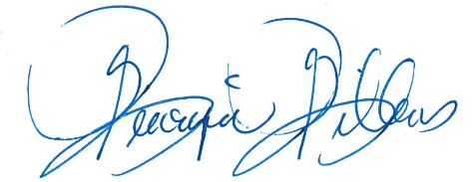

Georgia Gillens, CPPO, CPPB
Procurement Officer

