STATE OF SOUTH CAROLINA
STATE FISCAL ACCOUNTABILITY AUTHORITY
DIVISION OF PROCUREMENT SERVICES
1201 MAIN STREET, SUITE 600
COLUMBIA, SOUTH CAROLINA 29201

Intent to Award
Posting Date: January 25, 2021
Solicitation PEBA0202018RFP

The State intends to award the contract noted below. Unless otherwise suspended or canceled, this document becomes the final Statement of Award effective February 4, 2021.
SAP
Contractor should not perform work on or incur any costs associated with the contract prior to the effective date of the contract. The State assumes no liability for any expenses incurred prior to the effective date of the contract.

If you are aggrieved in connection with the award of the contract, you may be entitled to protest, but only as provided in Section 11-35-4210. To protest an award, you must (i) submit notice of your intent to protest within seven business days of the date the award notice is posted, and (ii) submit your actual protest within fifteen days of the date the award notice is posted. Days are calculated as provided in Section 11-35-310(13). Both protests and notices of intent to protest must be in writing and must be received by the appropriate Chief Procurement Officer within the time provided. The grounds of the protest and the relief requested must be set forth with enough particularity to give notice of the issues to be decided.

Any protest must be addressed to the Chief Procurement Officer, Information Technology Management Office, and submitted in writing:
(a) by email to protest-itmo@itmo.sc.gov , or
(b) by post or delivery to 1201 Main Street, Suite 601, Columbia, SC 29201.

Contract Number: 4400024493

Awarded To: Morneau Shepell Limited
115 Perimeter Center Place NE, Suite 1050
Atlanta, GA 30346

Initial Term (Proof of Concept): August 17, 2020 through November 9, 2020 (3 months).

Maximum Contract Term: February 4, 2021 through October 31, 2027 (81 months).

The total of Column E – Milestone Payment Amount: $40,763,815.00

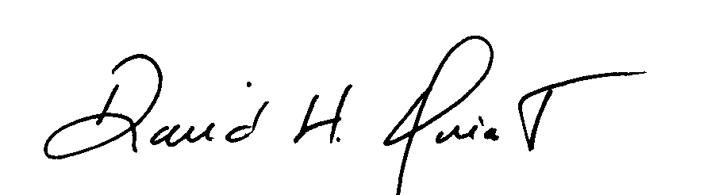
David H Quiat
Procurement Officer

