**PART 3**

**SCOPE OF WORK**

The Contractor will provide a new BAS in accordance with all requirements outlined in this Request for Proposal (including all attachments) and with Offeror’s response thereto. Contractor will comply with all laws and regulations applicable to it in its performance of the services under the resulting contract.

PEBA is seeking solutions-oriented proposals that comply with each of the material and essential requirements described in Part 3, Scope of Work, Section 3.2 through Section 3.20 below. Offerors may propose alternate solutions for achieving the stated technical and/or functional requirements in Part 3, Scope of Work, Section 3.2 through Section 3.20 below, if the proposed solution(s) will achieve the required result(s) without sacrificing the stated technical and/or functional needs.

Any deviations, modifications, or clarifications to the technical and/or functional requirements in Part 3, Scope of Work, Section 3.2 through Section 3.20 below, or the terms and conditions in Part 6, Terms and Conditions, however modest, MUST be presented during the question and answer phase. PEBA will provide responses before the submission date for all proposals so that all prospective Offerors will have a common and uniform basis upon which to submit their proposals.

The requirements in Part 3, Scope of Work, Section 3.2 through Section 3.20 will be met fully, satisfactorily, and performed in their entirety in a first-class manner.

**Project Objectives**

* PEBA expects the new system will provide a unified, one-stop, improved customer experience for Members, participants, and employers with respect to all programs administered by PEBA, and will provide secure portals (member portal and employer portal) through which customers can conduct business with PEBA.
* PEBA desires to obtain the system and services in the most cost-efficient manner possible. PEBA is willing to take advantage of service delivery models and business processes that have proven effective in other organizations.
* PEBA desires to select a solution that has been successfully implemented in similar organizations.
* During the Operational Assessment, PEBA concluded that a minimum two Phase implementation of the new BAS was the desired approach. PEBA is open to alternative approaches so long as the following key implementation approach goals are addressed:
* The System is deployed in Phases as evenly as possible over the course of the Project – no “Big Bang” approach will be accepted;
* Consider the impact of change management on Employers;
* Minimize data bridging and “throw-away” programming/system development;
* Minimize any partial decommissioning of legacy applications;
* Minimize overall Project risk;
* Not compromise the security and privacy of PEBA’s information assets; and
* Not compromise existing data exchange functionality with all appropriate third parties, including all TPAs.
* PEBA intends to be an active partner and co-implementor of the proposed BAS solution. PEBA intends to be operationally self-sufficient post final Phase Go Live and be capable of supporting and enhancing all components of the solution with minimal Contractor involvement.
* PEBA intends to continue to internally administer its defined benefit and health and welfare plans. PEBA is not interested in entertaining a proposed solution that includes outsourcing or co-sourcing of the administration of the plans.

**3.1 SCOPE OF NEW SYSTEM**

It is PEBA’s intent to purchase a new Benefits Administration System (BAS) that will meet PEBA’s needs. PEBA is looking for a solution that has been successfully implemented in similar organizations. It is also PEBA’s intent to assume the operational responsibility for the new system and be substantially self-sufficient at the end of the implementation period.

The following definitions will be used throughout this RFP when discussing configurations and customizations to the BAS’s existing functionality:

1. **Configuration**. Existing system functionality will be configured to deliver the requirement. This includes setting of parameter values, updates to factor and value tables, updating rules engines, and selection from any available configuration options within the existing software release. Configuration changes would not be expected to have any impact on future software updates.
2. **Minor Customization**. To meet the requirement, existing functionality will be modified to incorporate unique PEBA customizations not within the existing software release. This includes customization within well-defined exit/entry points within the system, interface file format definitions, custom formulas, custom SQL or SQR code for queries or reports, and addition/modification of data fields. Minor Customizations would not be expected to have an impact on future software updates.
3. **Major Customization**. Existing functionality to meet the requirement does not currently exist within an existing module, feature, or system component. This includes PEBA-specific extensions/enhancements/customizations to existing functionality, PEBA-specific APIs, protocols, or standards, and back-porting features from another version of the system. These are customizations that would not normally be reviewed or tested by the Contractor as part of their general release testing and validation. Special care would be required to ensure compatibility with future software updates.
4. **Other**. Existing functionality to meet the requirement does not currently exist and would require either a new functionality be added to the system, e.g. a new module, feature, or system component, the use of third-party technology specifically to meet PEBA’s requirement, or the requirement will be met outside of the system either manually or with a standalone tool.
   * 1. **Glossary**

This section provides a reference for terms and acronyms that may require explanation or additional PEBA-specific context within the Functional and Technical Requirements.

| **Term / Acronym** | **Definition or Explanation** |
| --- | --- |
| 30 Day Break in Service | A SCRS or PORS Member must take a thirty-day break from covered employment at time of retirement to be eligible to return to covered employment. There are exceptions for elected and certain appointed officials. |
| Accidental Death Program (ADP) | A benefit of the PORS system for participating employers that will pay a monthly benefit equal to half of a Member’s active salary, payable to the surviving spouse, children, or parents of a Member that is killed in the line of duty. The employer must have this coverage and the Member must not have been willfully negligent in their death. |
| Affordable Care Act (ACA) | The landmark health reform legislation passed by the 111th Congress and signed into law by President Barack Obama in March 2010. The legislation includes a long list of health-related provisions that began taking effect in 2010. Key provisions are intended to extend coverage to millions of uninsured Americans, to implement measures that will increase the quality and affordability of health insurance, lower the uninsured rate by expanding public and private insurance coverage, eliminate industry practices that include rescission and denial of coverage due to pre-existing conditions, and improve system efficiency. |
| Affordable Care Act (ACA) Reporting | Reporting required by the IRS to show: (i) that PEBA meets the minimum essential coverage, (ii) who is covered by PEBA health insurance, and (iii) when they were covered. The reporting is done with IRS forms 1094 and 1095. |
| Average Final Compensation (AFC) | As set forth in state statute, AFC is part of the formula used to determine a Member’s monthly retirement benefit. |
| Beneficiary | For a defined benefit retirement program, “Beneficiary” means a person designated by a member of a PEBA retirement system to receive a retirement benefit after the death of the Member. For the State Optional Retirement Program or the State Deferred Compensation Program, “Beneficiary” means a person designated to receive a benefit from the participant’s State ORP or Deferred Compensation account after the death of the participant. For insurance purposes, “Beneficiary” means the person named to receive the proceeds of an insurance policy offered by PEBA. |
| Benefit Program | Any enrollment-based benefit program for which a Member or participant must qualify to enroll, and for which premium must be paid either by the individual or employer. Examples are health care insurance, life insurance, vision, dental, disability, etc. |
| Center for Medicare and Medicaid Services (CMS) match file | A data file that is sent to a federal agency within the U.S. Department of Health and Human Services that administers Medicare and governs governmental health plans (such as those offered by PEBA). |
| Class I | Class of employees whose membership began with any SCRS employer before July 1, 1964, and employees who began membership on and after July 1, 1964, with an employer that elected to remain a Class I employer.  Class of employees whose membership began with any PORS employer before July 1, 1974, and employees who began employment after that date with an employer electing to remain Class I. |
| Class II | Class of employees whose membership began with any SCRS employer on / after July 1, 1964, and prior to July 1, 2012, if their employer elected to be a Class II employer.  Class of employees whose membership began with any PORS employer on / after July 1, 1974, and prior to July 1, 2012, if their employer was a Class II employer. |
| Class III | Class of employees whose membership began with any SCRS or PORS employer on / after July 1, 2012. |
| Comprehensive Annual Financial Report (CAFR) | A set of government financial statements comprising the financial report of a state, municipal, or other governmental entity that complies with the accounting requirements promulgated by the Governmental Accounting Standards Board (GASB). |
| Concurrent Service | Retirement service credit in correlated systems that is earned during the same period. |
| Consolidated Omnibus Budget Reconciliation Act (COBRA) | A federal law that may allow participants to temporarily keep health coverage after their employment ends, they lose coverage as a dependent of the covered employee, or another qualifying event. COBRA covered participants pay 100% of the premiums, including the share the employer used to pay, plus a small administrative fee. |
| Continuing Disability Review (CDR) | The process used when a Member is approved for disability retirement with the stipulation of a re-evaluation. |
| Correlated Systems / Correlated Service | Retirement systems that have a complementary relationship as defined by statute. Within PEBA, SCRS, PORS, and GARS are correlated systems.  If a Member has service credit in more than one of these retirement systems, all the Member’s service credit in the systems may be combined for determining eligibility for benefits, but not for calculating the amount of benefits, in each of the systems. |
| Deferred Compensation Participant | An employee who participates in the State Deferred Compensation Program. |
| Deferred Retirement Option Program (DROP) | This program allows Members of JSRS to continue to serve in their position as judge, solicitor, administrative law judge, or circuit public defender while receiving both wages as an employee and having their monthly retirement benefit accumulate on a deferred basis until the member reaches age 60, at which time the balance can be distributed. The benefits earn no interest while they accumulate in the DROP account. |
| Department of Health and Environmental Control (DHEC) | A South Carolina agency whose mission is to improve the quality of life for all South Carolinians by protecting and promoting the health of the public and the environment |
| Department of Health and Human Services (DHHS) | A South Carolina agency in charge of the Medicaid program for South Carolina. |
| Dependent | A person added by a Subscriber to their coverage under the State Health Plan. A Dependent must be the legally-recognized spouse, child, or incapacitated dependent child of the Subscriber who adds the Dependent to their State Health Plan coverage. |
| Designated Governmental Entity (DGE) | A governmental entity that is willing to perform Affordable Care Act (ACA) reporting on behalf of another entity. |
| Designated Representative | A person who can receive information about another person’s account. This could be through a Member giving written permission, a court appointing a representative, or other means. Examples include an authorized representative, power of attorney, guardian, conservator, and personal representative. |
| Direct Pay Mailer (DPM) | A payment method in which a participant receives a physical insurance premium bill through the mail and sends the payment and remittance back to PEBA through the mail. |
| Dual Employment | When a Member works in more than one position that is covered by PEBA Retirement or Insurance.  If both positions are covered under the same retirement system, the Member can only earn one total year of retirement service credit. If the positions are covered under separate retirement systems, full service credit can be earned in both systems. If a Member has service credit in more than one of these retirement systems, all the Member’s service credit in the systems may be combined for determining eligibility for benefits, but not for calculating the amount of benefits, in each of the systems. |
| Effective Date of Membership (EDOM) | The date a Member begins participation in a PEBA retirement plan. This is typically the Member’s date of hire. |
| Employee | A person employed by a governmental entity participating in the retirement and insurance programs administered by PEBA who is eligible to participate in PEBA’s programs. |
| Employer Group Waiver Plan (EGWP) | A Medicare Part D Plan with additional wrap-around benefits for Medicare-eligible retirees. |
| Enrolled | Currently participating in an insurance or retirement benefit program. |
| Experience Rating | A method under which a group’s recorded health care costs (claims) are analyzed and the group’s premium is calculated partly or completely according to the group’s claims experience. |
| Fully-Insured | A plan where the agency contracts with another TPA to assume financial responsibility for the participant’s claims and for all incurred administrative costs. For example, Tricare Health, Dental Plus, Vision, Basic Life/Dependent Life/Optional Life, Supplemental Long Term Disability. |
| Governmental Accounting Standards Board (GASB) | The source of generally accepted accounting principles used by State and Local governments in the United States. |
| Imputed Income | The value of a service or benefit provided by employers to employees, which must be treated as income. For PEBA, the cost of life insurance over $50,000 must be reported as imputed income when the premiums are paid pre-tax. |
| Incapacitated Child | An incapacitated, unmarried child who is incapable of self-sustaining employment because of mental illness, retardation, or physical handicap and who is principally dependent (more than 50 percent) on the covered employee, retiree, survivor, or COBRA member for maintenance and support is eligible for PEBA insurance benefits. |
| Incidental Death Benefit (IDB) | For active Members who have more than one year of service in a PEBA retirement plan, a benefit equal to one year of the Member’s salary is payable at Member’s death if the employer is covered under the IDB program at the time of the Member’s death. Retired Members may be eligible for retired IDB of pre-determined legislatively defined amounts based on service credit at retirement and system. |
| Installment Account | A record in the Installment Accounting system on UNIX, which summarizes a Member’s service purchase installment, including principal and interest. Installment payments are deducted from the Member’s paycheck by the employer and remitted to PEBA Retirement. |
| Interdepartmental Transfer (IDT) | An electronic transfer of funds between South Carolina State agencies. |
| IRC 401(a) annual salary limit | A calendar year limit set by the IRS for Members that first joined a PEBA retirement plan on 1/1/1996 or after. This limit is determined by the IRS each year. Members only contribute and receive benefits on the salary they earn up to the limit. |
| Local Subdivision | An entity of local government, other than state agency, institution of higher learning, or public school district, that has the option of joining PEBA Insurance and Retirement benefits (i.e., cities, towns, counties, water districts, etc.). |
| Long Term Disability (LTD) | A type of insurance that protects the ability to earn income. When a covered Member gets sick or hurt and cannot work, a monthly benefit may be paid to cover for some of the lost income. |
| Medicare Beneficiary Identification (MBI) | A randomly generated number assigned by Medicare to a beneficiary of Medicare to identify the person. |
| Member | An employee or retiree who participates in, and is included in the membership of, one of the defined benefit retirement systems administered by PEBA, including SCRS, PORS, GARS, JSRS, and SCNG. |
| Member Access | Member Access is the external interface that the participant can access to view, print or update certain information on their retirement account. |
| MoneyPlus | PEBA’s tax-favored account program, or Cafeteria Plan, which allows qualified premiums and expenses to be deducted pretax. MoneyPlus is available under Sections 105, 125, 129, and 223 of the Internal Revenue Code to active employees of state agencies, school districts, and participating local subdivisions. This program allows employees to save money by using pretax dollars to pay their state-offered health, dental, vision, and Optional Life Insurance premiums (for coverage up to $50,000) and includes options for flexible spending accounts for dependent care, health savings, and medical spending.  Effective 1/1/2019, PEBA will assume enrollment and eligibility administration and ASIflex will become the third-party administrator. |
| Monthly Transfer of Surcharge Amount | Employers participating in the OPEB insurance trust must pay an insurance surcharge to fund the trust based on a percentage of their active employees’ salary. Because the surcharge is collected through the Retirement contribution reporting process, the funds must be transferred monthly from PEBA Retirement to PEBA Insurance accounts. |
| National Medical Support Notice (NMSN) | A notice sent to employers from a local child support agency when an employee is under an existing court or administrative order to provide insurance for his or her child. Its purpose is to ensure that children receive health care coverage when it’s available and required as part of a child support order. |
| Non-Discrimination Testing | To qualify for tax-favored status, a benefit plan must not discriminate in favor of highly compensated employees and key employees with respect to eligibility, contributions or benefits. PEBA’s vendors perform non-discrimination testing for the flexible spending accounts each year for the Internal Revenue Service (IRS). |
| Other Post-Employment Benefits Trust Funds (OPEB) | The insurance benefits that an employee will begin to receive at the start of retirement. OPEB is made up of two trusts. The first trust, the South Carolina Retiree Health Insurance Trust Fund, was created to pay for the employer costs of retiree post-employment health and dental insurance benefits for retired state employees and retired employees of public school districts. The second trust, the Long-Term Disability Insurance Trust Fund, was created to fund and account for the employer costs of the State’s Basic Long-Term Disability Income Benefit Plan. |
| Participant | Any person who participates in a PEBA retirement or insurance program, including employees, retirees, beneficiaries, dependents, alternate payees, survivors, former spouses, and COBRA beneficiaries. |
| Payee | A person receiving a benefit payment from PEBA. |
| Payment Instruction (PI) | A Payment Instruction (PI) is the instrument that PEBA uses to capture the method of payment selected by a payee. PI includes the payment method, rollover information, EFT information, and withholding instructions. |
| Pension Protection Act of 2006 (PPA) | PPA is a federal provision that permits eligible retired public safety officers to elect to exclude up to $3,000 of their retirement benefit from income if used for qualified health, dental, vision, or long-term care insurance premiums. To qualify for the after-tax deduction, the insurance premium must be deducted from a monthly retirement annuity and, with the agreement of the insurance provider, remitted directly to the provider. Another PPA provision requires coding on the 1099-R which allows the 10 percent early withdrawal penalty to be waived for public safety officers over age 50 and military reservists and National Guardsmen who are called to active duty for at least 180 days. |
| Police Officers Retirement System (PORS) | The Police Officers Retirement System (PORS) is a defined benefit plan for South Carolina police officers, firemen, and several other classes of state and local government employees. |
| Popular Annual Financial Report (PAFR) | The GFOA established the Popular Annual Financial Reporting (PAFR) to encourage and assist state and local governments to extract information from their CAFR to produce high quality popular annual financial reports specifically designed to be readily accessible and easily understandable to the public and other interested parties without a background in public finance. |
| Qualified Benefit Change (QBC) | A QBC occurs when a retiree has a qualifying event that allows them to change their retirement payment option. This would be marriage, divorce, or death of a spouse. |
| Qualified Domestic Relations Order (QDRO) | A court document typically provided after a Member becomes divorced which may indicate how disbursements from PEBA are to be split between a Member and alternate payee. PEBA attorneys review and approve QDRO documents to ensure the order does not assign benefits in violation of existing PEBA statute. |
| Qualified Excess Benefit Arrangement (QEBA) | Under Section 415(m) of the Internal Revenue Code, the amount of a retirement benefit that would be payable but for the limitation imposed is paid through a QEBA. QEBA payments are not prefunded and are made from a separate unfunded trust fund administered by PEBA and distributions are reported annually to recipients via IRS Form W-2. |
| Required Minimum Distribution (RMD) | Per Section 401(a)(9) of the Internal Revenue Code, a participant who has terminated employment must withdraw a minimum amount from a tax-deferred plan. The required minimum distribution date is April 1 of the calendar year after the later of: (i) the calendar year in which the Member reaches age 70 ½; or (ii) the calendar year in which the Member retires. This does not apply to retirees receiving benefits or Members who are still actively contributing to one of the retirement plans administered by PEBA. |
| Retiree | For retirement purposes, “Retiree” means a Member who is eligible for and is receiving a retirement allowance under a defined benefit retirement system administered by PEBA. For insurance purposes, “Retiree” means a former employee eligible to retire under a retirement system administered by PEBA who meets the eligibility requirements for retiree insurance coverage. |
| Retirement System for Judges and Solicitors (JSRS) | The Retirement System for Judges and Solicitors (JSRS) is a defined benefit plan for judges, solicitors, public defenders, and administrative law court judges working for the State of South Carolina. |
| Retirement System for Members of the General Assembly (GARS) | The Retirement System for Members of the General Assembly (GARS) is a defined benefit plan for elected members of the South Carolina General Assembly. This plan is closed to those first elected in the November 2012 election or after. |
| Revert to Maximum | The payment option that provides for a continuing monthly benefit to a beneficiary upon the Member’s death with the provision that if all beneficiaries predecease them, the Member reverts their benefit to the maximum option. |
| Set Off Debt Process | If a Member owes money to the Retirement Systems and collection efforts are unsuccessful, PEBA can submit the amount due to the South Carolina Department of Revenue (SCDOR)’s Setoff Debt program to have the money withheld from the Member’s state income tax refund. SCDOR then sends the money collected to the Retirement Systems in the form of a check. |
| Social Security Administration (SSA) | United States Social Security Administration. Federal agency. |
| South Carolina Deferred Compensation Program (SCDCP) | The South Carolina Deferred Compensation Program (SCDCP) is a supplemental retirement program consisting of 401(k) and 457(b) plans. Employees may contribute to SCDCP in addition to required contributions to a state defined benefit retirement plan or State ORP. |
| South Carolina Department of Revenue (SCDOR) | The state agency responsible for collecting taxes and registration fees and administering the revenue and regulatory laws of the State of South Carolina. |
| South Carolina Enterprise Information System (SCEIS) | SCEIS is the State’s financial and personnel management system and provides direct interaction between PEBA’s database and the State financial system. SCEIS is administered by the Comptroller General’s payroll office and maintains information such as payroll deductions, enrollment information, and data maintenance changes for covered employees of state agencies. Contribution reporting is also handled through SCEIS for state agencies on the Comptroller General’s payroll. |
| South Carolina National Guard Supplemental Retirement Plan (SCNG Plan) | South Carolina National Guard Supplemental Retirement Plan (SCNG Plan) is a defined benefit plan administered by PEBA that provides a supplemental benefit to eligible Members of the South Carolina Army and Air National Guard. There are no employee contributions for this plan and it is intended to supplement federal retirement benefits for Army and Air National Guard members. |
| South Carolina Retirement System (SCRS) | The South Carolina Retirement System (SCRS) is a defined benefit plan for state employees, school districts, colleges and universities, local subdivisions, municipalities, and other classes of state and local government employees. |
| State Optional Retirement Program (State ORP) | State Optional Retirement Program (State ORP) is a defined contribution plan that can be selected as an alternative to the South Carolina Retirement System (SCRS) plan for certain eligible newly hired employees. Eligibility for this plan is determined by South Carolina state statute. PEBA maintains enrollment and contribution data, but administration of the plan is outsourced through four vendors. |
| State ORP Participant | An employee who participates in the State Optional Retirement Program administered by PEBA. |
| Subscriber | An employee, retiree, former spouse, surviving child, surviving spouse, or other enrollee eligible for continuation coverage, who participates in the State Health Plan administered by PEBA. |
| Supplemental Long-Term Disability (SLTD) | An optional, fully insured disability insurance benefit which provides additional protection for the permanent full-time employee and his family. Premiums are calculated using salary, age, and plan choice. |
| Teacher and Employee Retention Incentive (TERI) program | A program that allows Members to begin accumulating a retirement benefit and continue working without taking a break in employment. The retirement benefits accumulate on a deferred basis into a noninterest bearing account until the Member terminates employment and ends the program, after which time the balance is distributed. The Member then begins to receive their monthly benefit directly at that time. This program ended on June 30, 2018. |
| Third Party Administrator (TPA) | A PEBA business partner or entity contractually retained by the Plan Administrator who provides external claims administration, administers SCDCP, or receives member’s ORP contributions for investment and management. |
| Medicare Voluntary Data Sharing Agreement (VDSA) | A Voluntary Data Sharing Agreement (VDSA) is used to coordinate health care benefit payments between employers, their agents and Medicare. |

* + 1. **Core Features**

The new BAS will have, at a minimum, the following core features to support PEBA’s internal administration of PEBA’s defined benefit and health and welfare plans:

* Defined benefit plan administration, including collection of contributions and payment of benefits;
* Health and welfare plan administration;
* Health and welfare vendor management and premium billing & collection, including plan payables and reserve fund balance management;
* Employer reporting;
* Internal and external interfaces;
* General Ledger integration with SCEIS;
* Insurance Benefits and OPEB Trusts’ internal General Ledger integration;
* Temporary data bridging;
* Member Self Service;
* Employer Self Service;
* Security;
* Electronic document management;
* CRM;
* Workflow; and
* Reporting.
  + 1. **Primary and Supporting Responsibilities**

Primary responsibility means that you will be responsible for doing the work and are accountable to its completion. Supporting responsibility means that you will be a significant, supporting participant and will contribute significant time and expertise, will be consulted for ideas and input, may be asked to provide examples, and will support the completion of the activity.

The Contractor will have ***primary responsibility*** for:

Initial System Installation

* Deployment of multiple environments including Development, Test, Training, and Production
* Hardware & software documentation

System Configuration & Implementation

* Requirements Validation
* Detailed System Design
* System Development - Configuration and Custom Extensions
* Requirements Traceability Matrix
* System Testing
* Deployment
* Post Implementation Stabilization

Change Management

* Change Inventory and Organization
* Staff Development and On-the-Job Training for PEBA Business Analysts and IT Staff

System Training Material Development

* For Employers, TPAs
* For PEBA Staff
* For Members

System Operational Processes

* Development Process and Standards
* Technical Deliverable Development and Process
* Code Analysis and Verification
* Configuration Management Procedures
* Infrastructure (Hardware and Software) Configuration Validation
* Defect Management and Remediation
* Disaster Recovery Plan

The Contractor will be a ***significant, supporting participant*** in:

System Implementation

* Security & Audit
* Employer, TPA, Member, and PEBA staff UserID set up

Testing

* Validation and Acceptance Test Planning
* Validation Testing

Organizational Change Management

* Change Management Strategy
* Communications Planning
* Communications Delivery
* Employer Outreach and Education

System Training

* For PEBA Staff

Supporting PEBA Trainers

* For Employers/TPAs
* For Members

Data Work

* Data Conversion
* Data Bridging

Data Interface Implementation

* TPA Interfaces
* Employer Integration Transactional Interface
* SCEIS (State’s HCM system) Transaction Interface
* Employer Contribution Interfaces/Certification
  + 1. **Key Functional Areas and Workflows**

The sections that follow contain detailed descriptions of each of the major business processes at PEBA. The descriptions are intended to provide a fuller context than merely listing requirements. Each major process is identified by a number. There is nothing to be implied from the process identification numbers other than simple identification. The individual requirements listed in Section 3.3 are numbered as an extension to the process number. Please do not alter the process identification numbers.

3.1.4.1 Common Enrollment

# (a) Future Vision

The Common Enrollment process will be initiated by the receipt of new demographic or job information for an employee from a participating employer. The employer will have the option to submit information for a new employment event via the Employer Portal through an enrollment file or by submitting a new registration transaction. Because all employers will submit employer reports in the future, the enrollment process for insurance and retirement will be combined and will be expanded to allow Members to indicate interest in certain PEBA-sponsored benefit programs managed by outside vendors. The process will also account for insurance enrollment for retirees, COBRA eligible participants, former spouses, and survivors which will be initiated through the Member Portal or other contact channels.

When a new employment event is identified, the basic demographic information, such as name, address, and date of birth will be captured in the system. An electronic notification will be generated to the Member to review and select the applicable enrollment options for both retirement and insurance using the Member Portal. This process creates one member record for retirement and insurance and allows the Member to complete all enrollment choices in one transaction. Members will also be presented with PEBA-sponsored enrollment options managed by other vendors through the Member Portal and can access links to complete the enrollment. If a Member elects these benefits, the vendor data may be transmitted back to PEBA.

In addition to selecting enrollment options, Members will be prompted to complete all required information during the transaction including designating beneficiaries, entering dependent information, and electronically submitting supporting documentation. The Common Enrollment workflow will require Members to complete certain tasks and can trigger internal review of transactions as required. Automatic follow up notifications and correspondence will be generated to prompt the Member to complete the required information and the Member will receive confirmation once enrollment is complete. The employer will also be notified once the process is complete and will receive information on deductions for the applicable retirement and insurance benefits.

Retirement and insurance enrollment periods, such as open enrollment for retirement (State ORP participants only) and insurance and life event changes, will be handled through the Member Portal. Impacted Members will receive electronic notifications to access the Member Portal and make the applicable elections. Employers will be notified of any changes in deductions as Members complete this annual process. Members can use this functionality throughout the year to complete updates to demographic information, beneficiaries, and dependents across all benefits. Adult dependents will also have access to self service when participating in insurance benefits to maintain demographic and other contact information with PEBA. Members that participate in benefits with outside vendors will be prompted to complete updates in their systems as well to keep information synchronized across PEBA and other state vendors.

# (b) Key System Functions

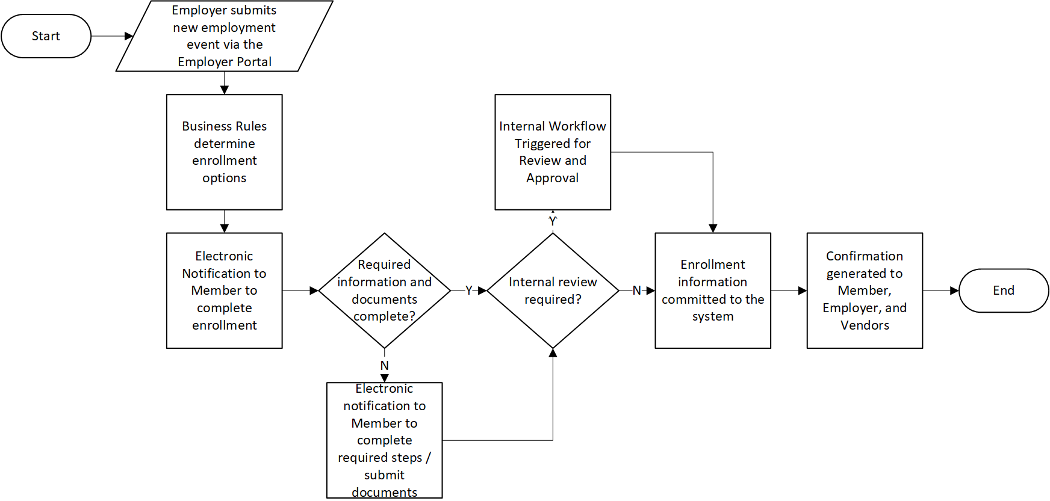

3.1.4.2 Employer Set Up and Maintenance

# (a) Future Vision

Employer Set Up and Maintenance functionality will support employers with all their transactions with PEBA including retirement operations, such as employer reporting, and insurance set up to support eligibility determinations and enrollment tools for employers. An employer will be maintained as a single entity with access to retirement and insurance functionality based on eligibility and participation. PEBA’s Employer Services will coordinate with potential new employers for the initial application process and provide all necessary information and documentation to the Legal department for review. Upon approval by the Legal department and completion of any necessary documentation, a workflow will be initiated within the system. The workflow will route set up tasks, payment information, and/or enrollment confirmations to the appropriate internal or external group(s). For additional details on payment processing, see Section 3.1.4.9 - Cash Receipts process flow.

Existing employers will have the capability to maintain their organizational and employer user contact information through the Employer Portal without having to submit requests in writing. Internally keyed employer organizational changes, such as a merger, can be changed and tracked with detailed audit history. All employer interactions, including correspondence, contact center calls, and case notes, will have a visible audit trail and history as to when employer changes were implemented.

Employers will have the ability to view participation in associated insurance and retirement plans (health, dental, vision, OPEB trust, SCRS, PORS, GARS, JSRS, State ORP, SCNG, SCDCP, etc.) including current and historical rates and dates and coverages.

# (b) Key System Functions

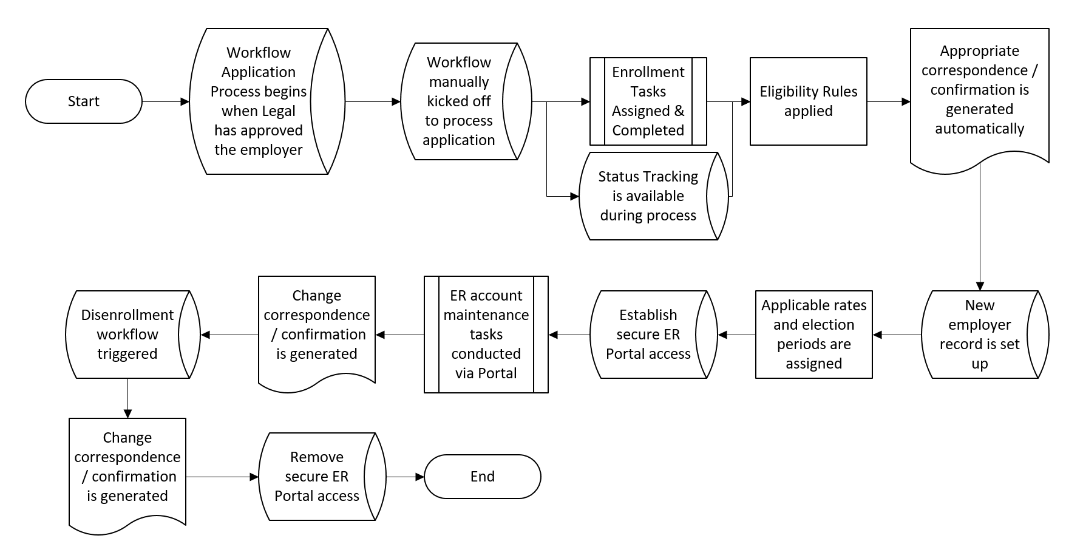

3.1.4.3 Employer Reporting

# (a) Future Vision

Employer Reporting functionality will provide employers the ability to initiate a reporting file through the Employer Portal by uploading a file or manually entering reporting data. Certain reporting entities, such as SCEIS, will complete the process through direct file transmittal outside of the Employer Portal. The employer payroll report will include new mandatory fields to collect an expanded data set and all employers will be required to submit a report, including employers that participate in insurance benefits only. Retirement service credit will be calculated using data provided in the employer reporting file; however, it will be applied based on when the compensation was earned rather than when it was paid to reduce the need for service adjustments at time of retirement.

In addition to employer and member contribution and earnings information, the reporting format will include fields to capture information such as member job data, service purchase installment deductions, and payroll withholdings information for insurance premiums. This expanded data set enables downstream system automation, provides real-time reconciliation for both retirement and insurance data, and allows employers to provide all applicable data to PEBA within one file. Employers can also submit enrollment data through the Employer Portal using a separate process. For additional details on member enrollment processing, see Section 3.1.4.1 - Common Enrollment process flow.

When an employer initiates a report, data validations and edits will be applied to reconcile expected values at both the reporting file and member level. Based on the results, the system will return error messages to the employer directly through the Employer Portal. These errors will be classified as high, medium, or low severity based on PEBA business rules, rule effective dates, calculation algorithms, and impact and severity. Based on the definition, an error message could reject the file, an individual record, or be informational only and not impact the ability to post the data. Employers will receive timely error notification to allow correction of the report via the Employer Portal prior to finalization of payment and posting to the member account. The system will have the capability to continue processing the payroll report once an error is identified at the member level to process all error free or low-level error transactions. Certain errors will initiate workflow that will be routed to the appropriate internal PEBA users for review and follow-up.

As part of the future process, employers will be required to move from quarterly reporting to more frequent reporting. This allows timely and accurate posting of employer data and payments to the member account, notifies employers of reconciliation errors more often, and reduces the number of requests to employers for payroll information to process a Member request, such as a retirement estimate. The Employer Portal will provide several tools to employers to support the reporting process including the ability to view the status of current or historical reports, set up and review automated payment information, receive and view electronic notifications and details on late reports or remittances, submit retroactive pay information, and access to run pre-defined reports on historical data. For additional details on the receipt and application of employer payments, see Section 3.1.4.9 - Cash Receipts process flow.

Authorized internal PEBA users will have full visibility into the status of employer reports with the ability to view report progress and query which reports have been received, which are late, which are delinquent, as well as what patterns in reporting exist. Certain error conditions or timing constraints will trigger workflow and route review requests to internal PEBA users for direct follow-up with the employer or review prior to authorizing the posting of the data to the member account. Audit trail reporting will be available to both internal PEBA users and employers to confirm acceptance and posting of the reporting files and transactions.

# (b) Key System Functions

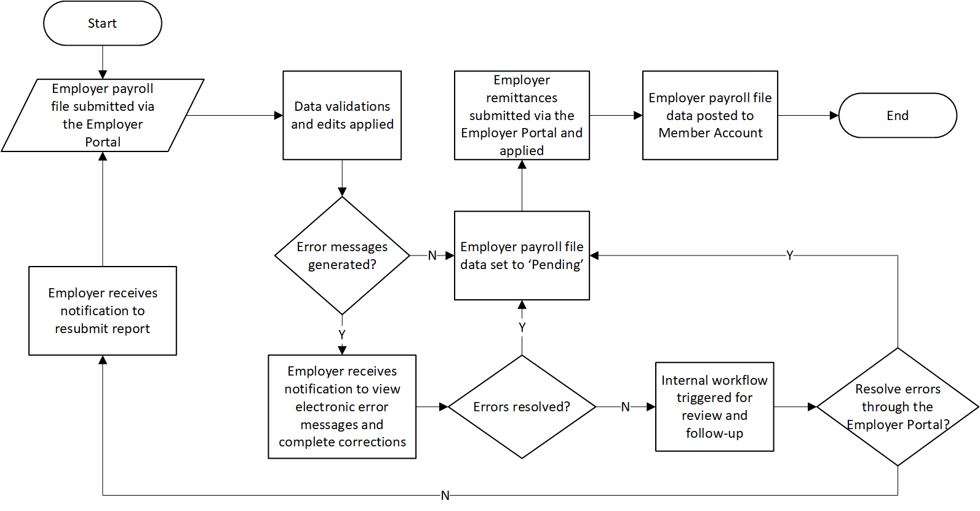

3.1.4.4 SCDCP and State ORP Data Exchange

(a) Future Vision

The South Carolina Deferred Compensation Program (SCDCP) and the State Optional Retirement Program (State ORP) data exchange with PEBA will provide Members and internal PEBA users with a consolidated view of PEBA benefits by combining PEBA core benefits and vendor-administered programs.

In addition to data exchange, the Member Portal will provide links to direct eligible Members to the websites for the applicable vendors to complete enrollment or updates to personal or beneficiary information. When a Member initiates a change to demographic information, the Member can choose to have PEBA share this information with vendors for other participating programs. Additionally, beneficiary changes will trigger messaging to remind the Member that the update must be made for each participating program to be effective for all benefits.

Key elements of the consolidated benefits view for SCDCP and State ORP are described in the following table. Additional considerations for the Member Portal will be discussed in the Insurance Third Party Administrator (TPA) Data Exchange and Member Self Service process areas.

| **Item** | **Description** | **Applicable Program(s)** |
| --- | --- | --- |
| **Links in the Member Portal** | Links to the SCDCP and State ORP vendor websites will be available directly on the enrollment pages in the Member Portal for members who are eligible.  Members will be able to click on the link to be directed to the applicable website to create a user profile and complete enrollment. This is covered as part of the **Common Enrollment Process**. | * SCDCP * State ORP |
| **Member Portal Comprehensive Benefit View**  *(SCDCP / State ORP -> PEBA)* | Participating Members will be able to view SCDCP and State ORP benefit information, such as account balances, through the Member Portal.  This data will not be stored in the PEBA system. When a user views this information in the Member Portal it will include the necessary disclaimers and direct the user to the applicable vendor website for additional detail. | * SCDCP * State ORP |
| **Outbound Enrollment Data**  *(PEBA -> SCDCP,*  *PEBA -> State ORP)* | Enrollment data will be transmitted to SCDCP with all eligible Members who have enrolled with PEBA since the last file was generated. This will allow SCDCP to follow up directly with this population.  Annual enrollment data for retirement will be transmitted to State ORP with changes to vendor selection or participation status (terminated State ORP participation).  These are covered as part of the **Common Enrollment Process**. | * SCDCP * State ORP |
| **Inbound Enrollment Data** *(SCDCP -> PEBA)* | The PEBA system will process inbound enrollment data from SCDCP with information on Members that have elected to enroll and capture this status. | * SCDCP |
| **Outbound Member Demographic and Status Changes**  *(PEBA -> SCDCP / State ORP)* | When a Member updates certain demographic information using the Member Portal, the Member can choose to have this information transmitted to other programs in which he/she participates. If the Member updates certain data, such as a beneficiary, messaging will provide a reminder to update that information for other programs as needed.  Other applicable changes will be transmitted within this process such as death notifications or member status changes, such as terminations. | * SCDCP * State ORP |
| **Inbound Member Information** *(SCDCP / State ORP -> PEBA)* | SCDCP and State ORP will transmit participant information to PEBA such as demographic changes, death notifications, and member status changes.  PEBA system validations will identify discrepancies in the vendor data and the PEBA data and generate notifications to the Member. This will allow the Member to update information in either system as needed. | * SCDCP * State ORP |
| **Outbound Service Purchase and Installment Account Information** | When a Member chooses to use SCDCP or State ORP funds for payment of a service purchase invoice or toward an installment account, the PEBA system will transmit required account and balance information to SCDCP or State ORP needed to initiate an electronic payment. | * SCDCP * State ORP |
| **Electronic Payments** | The system will provide the ability to receive electronic payments from SCDCP and State ORP for payment of service purchase invoices or toward installment accounts. The payments will be based on the account and balance information provided by PEBA.  In the case of an overpayment, the system will have the ability to return payments to the appropriate vendor electronically. | * SCDCP * State ORP |
| **Data to Support Audit Functions** | **Employer Contribution Data for State ORP:** The State ORP vendors will provide a file of detailed employer contribution and wage information to PEBA for audit purposes only. This information will not be stored in the PEBA system or posted to the member’s account.  **Member Data for Internal Processing*:** SCDCP and State ORP will provide a file and/or web inquiry to PEBA with data needed for internal processing and reporting such as distribution status, fund choice, contribution levels, account balances, beneficiary designations, and statistical data. This information will not be stored in the PEBA system. | * SCDCP * State ORP   *This is currently available by logging into vendor websites. Additional functionality or automation is a nice to have, but not required to obtain the data. |

(b) Key System Functions

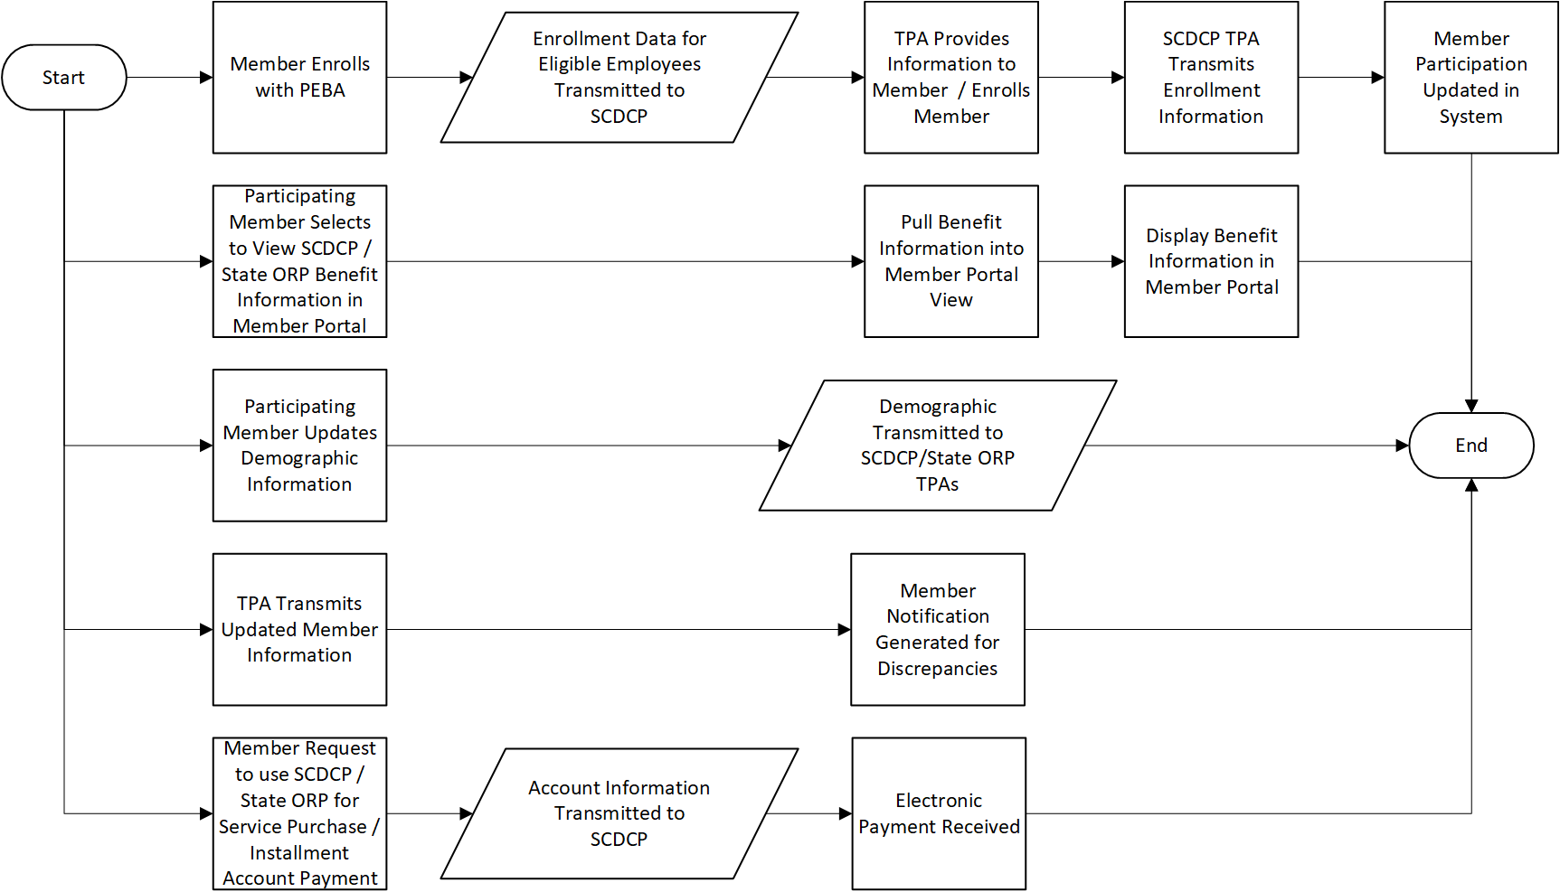

3.1.4.5 Insurance TPA Data Exchange

# (a) Future Vision

PEBA will expand the exchange of information with TPAs to provide a holistic view of insurance benefits and account information to members through the Member Portal.

The system will receive inbound insurance data from TPAs and display account information to the Member such as deductible progress, out-of-pocket maximum paid to date, and unused vision benefits. Status updates on applications for additional coverage or coverage outside of enrollment periods will also be displayed through the Member Portal. Notifications will be sent to Members with information on key account changes or approaching thresholds as well as changes to a status for a pending application.

The data will also support internal functions such as customer service by providing information to internal PEBA users that can be accessed to answer Member questions and direct them to the appropriate TPA for additional action as needed.

(b) Key System Functions

3.1.4.6 Customer Service

# (a) Future Vision

Customer service functions will be supported by a robust screen that is tightly integrated with all tools and applications, such as Customer Relationship Management (CRM) and Interactive Voice Response (IVR) functionality. Customer Service users will be provided the information and functionality needed to support employer and member related questions.

The screen will provide the information the user needs to authenticate a participant, as well as answer participant and employer questions in one consolidated area. The users will be able to view information such as document images, open and closed cases, pending and completed workflow, and Customer Relationship Management (CRM) data (phone calls, emails, chat information, etc.).

When a person calls, he or she will be prompted to answer questions over the phone to identify themselves or wait for a Customer Service user to answer the phone. If the person has authenticated themselves, the participant or employer account information will be displayed (popped) when the Customer Service user answers the call.

Information that is displayed on the Customer Service screen will be role based. Users will see information that is common across roles such as demographic information. Users that are receiving calls or visits related to insurance will see insurance related information, users taking calls or visits related to retirement will see retirement related information, and users taking calls related to employers will see employer related information. Certain cross-trained users will have access to both insurance and retirement information.

Customer Service users will be able to send documents electronically (upload forms, pre-filled forms, letters, etc.), create and receive chats with members or employers, create notes and cases, and generate workflow based on the needs of the member or employer.

Customer Service users will have access to frequently asked questions, as well as to wizards to walk them through the proper ways to handle requests.

Information that is sent from the Customer Service screen (emails, text, chat, etc.) and phone calls received will be stored and tracked in the Customer Relationship Management (CRM) system.

# (b) Key System Functions

# 

3.1.4.7 Service Purchase

# (a) Future Vision

Service Purchase requests will be initiated through multiple channels and will trigger workflow to support timely processing and communications. Requests will primarily be initiated from the Member and Employer Portals. In addition to the portals, workflow will also be created upon receipt of a scanned and indexed document or manually by an internal PEBA user.

If the internal PEBA user processing the request identifies that additional information is needed from the employer or Member, the system will send the request for information to the appropriate contacts and automatically send follow up requests at pre-defined intervals if the information is not received. The primary form of communication and response will be through the Member and Employer Portals. The employer or Member will receive an electronic notification and can submit the necessary information, including supporting documentation, through the portal.

When all the required information has been received, the system will calculate the cost to purchase the service. When the workflow is complete, an invoice will be created for the total cost and this information will be communicated to the Member so the appropriate payments can be initiated.

For additional details on payment processing, see Section 3.1.4.9 - Cash Receipts process flow.

# (b) Key System Functions

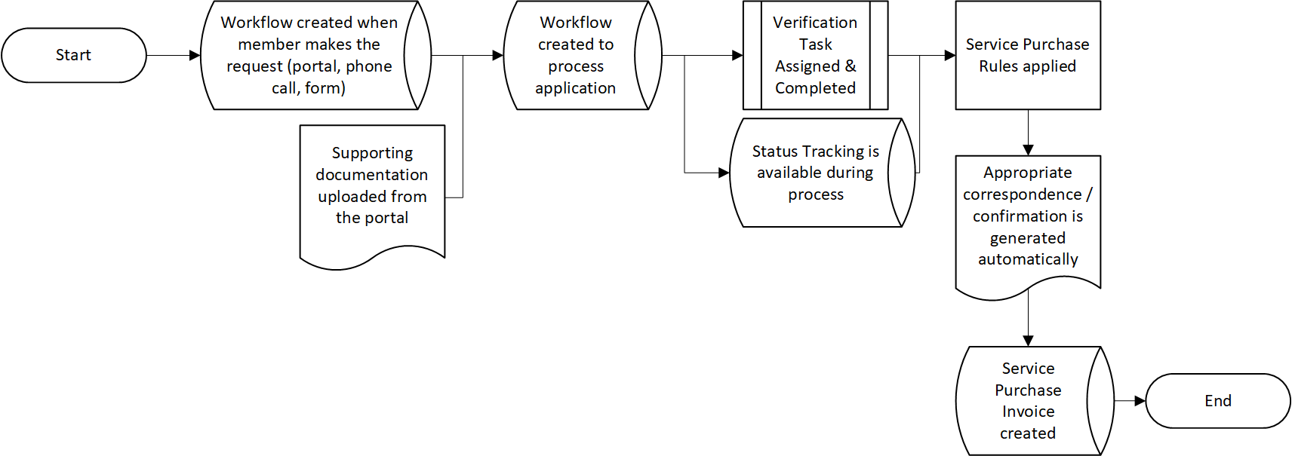

3.1.4.8 Service Accounting

# (a) Future Vision

The Service Accounting process is initiated after the Member receives an electronic notification from PEBA that a service purchase invoice has been created. Once the invoice is created, the Member can log in to the Member Portal and select a payment method for the cost of the service or elect to send in a physical check.

The Member will have the ability to select one or multiple payment options such as rollover, installment account, electronic check, or lump sum. The member can also select to have the payment made from their SCDCP or State ORP account. If needed, the Member will have the ability to upload supporting documentation. Credit card payments will not be an option for service purchase invoices.

If “installment account” is selected as the payment method, there will be communication to the employer to begin payroll deductions. The employer will be able to use the Employer Portal to submit the required deduction information electronically.

The Member can access the Member Portal to view the details of the invoice, such as the remaining balance and interest amount. If installment account was selected as the payment method, the status of the installment payments will be displayed, such as payment amount, payments received, and number of payments remaining.

As payments are received for the service purchase invoice, service credit is applied, and the Member is notified of the progress. The Member can elect to notify PEBA to stop payments on after-tax installment payments before the invoice is paid in full. If the Member requests to stop to the after-tax payments or if the invoice is paid in full or expires, the invoice status will be updated to “Closed” and the appropriate communications will be sent to the Member and employer.

# (b) Key System Functions

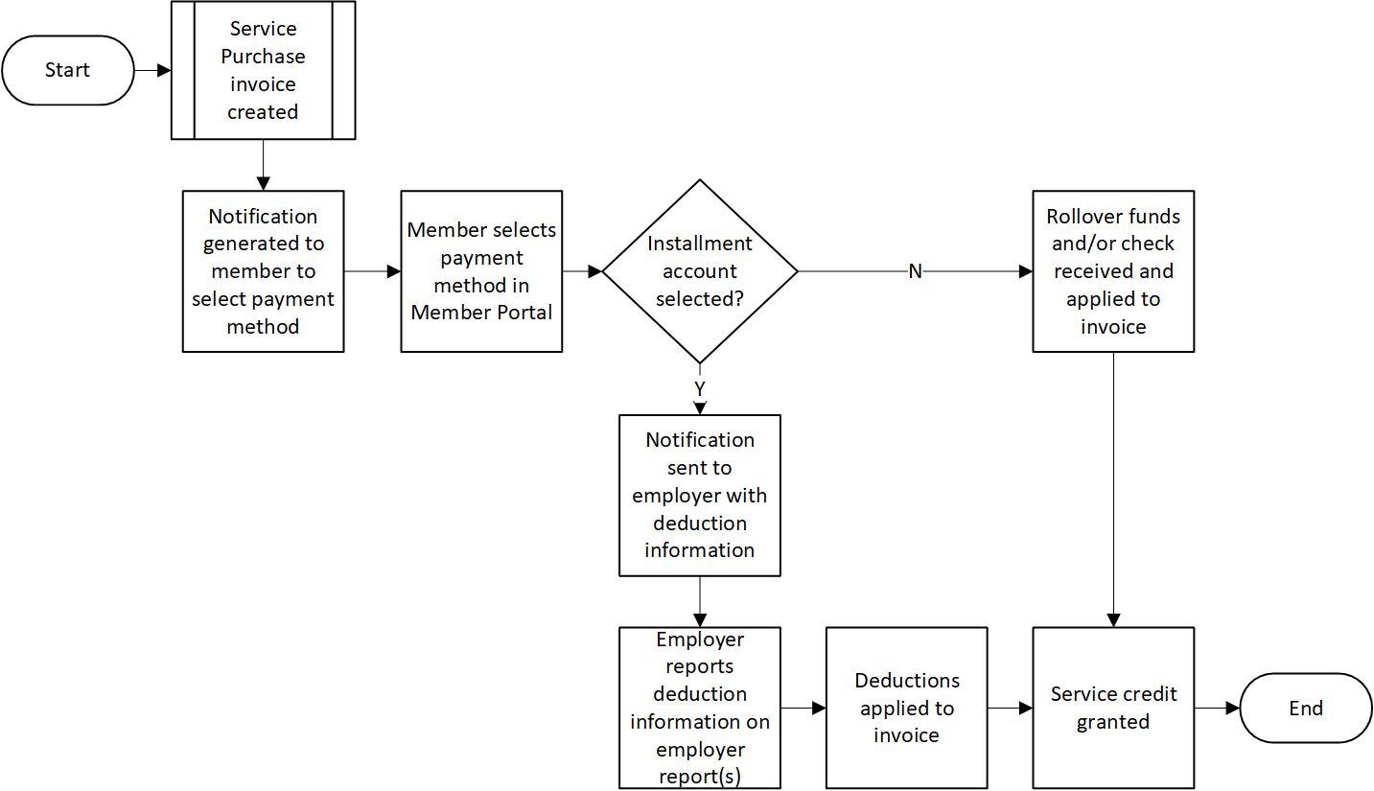

3.1.4.9 Cash Receipts

# (a) Future Vision

The cash receipts process will be initiated when cash for all departments comes in physically or electronically. As the deposits are created, workflow will be generated for the appropriate departments (insurance, retirement, service accounting, etc.) for processing, if the receipts are not allocated automatically.

Workflow will also be generated when there are conditions such as unmatched receipts, overpayments, or insufficient funds. The appropriate departments will be able to send electronic communication to the Member and/or employer and take appropriate action with the cash receipt and payment method.

The system will have the ability to apply payments from multiple sources including employer remittances for retirement contributions, active employee insurance premium payments, retiree payroll deductions, and payments initiated from the Member Portal. Internal PEBA users will have the ability to allocate full and partial payments and reverse/close an invoice and perform write-offs.

When updates are made to invoices (payments applied, write-offs, reversal, etc.), general ledger transactions will be generated, and communications will be sent to Members and/or employers based on PEBA defined business rules. Both Members and employers will have the ability to view the details of invoices from the portals.

# (b) Key System Functions

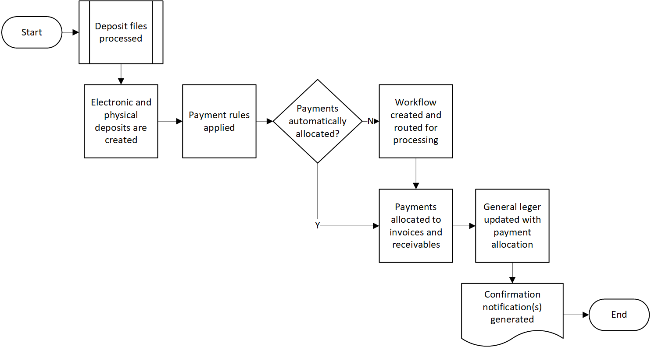

3.1.4.10 Refunds

# (a) Future Vision

The retirement refund process will be initiated when the Member electronically submits the application from the Member Portal or sends in a physical refund application. Members can access the Member Portal to track the status of the request and provide supporting documentation for timely payment. This process area is specific to distributions from the defined benefit plans (SCRS, PORS, GARS, and JSRS) and all retirement refunds must be a total distribution. Business rules applied to the request can return real-time messaging on eligibility for a refund and required documentation necessary to process the request. Based on the business rules and thresholds defined during system design, certain refund requests will be eligible for a single level of internal review prior to payment.

Calculation rules will determine the total payment owed for the refund request including any unapplied interest. The payment can be recalculated based on new information received prior to the final payment, including additional contributions remitted after the request is in process. Payment to an alternate payee based on an approved QDRO will also be included in the calculation prior to finalization of the payment to the Member or beneficiary. The system will capture the payment options chosen by the Member and process the refund appropriately such as a full or partial roll-over to a financial institution, direct payment by EFT, or issuing a check. The system will automatically generate electronic notifications to Members and correspondence to financial institutions with the necessary payment information as part of the workflow. Internal PEBA users will have access to reporting tools to track refund processing status and perform audits on pending and paid requests.

The system will support the Required Minimum Distribution (RMD) process by identifying all inactive Members that meet the RMD criteria, generating notifications, and calculating and issuing payments with limited user intervention. Withdrawn Members owed supplemental refund payments will also be identified at defined intervals and corresponding notifications will be generated in addition to automatically calculated and issued payments.

# (b) Key System Functions

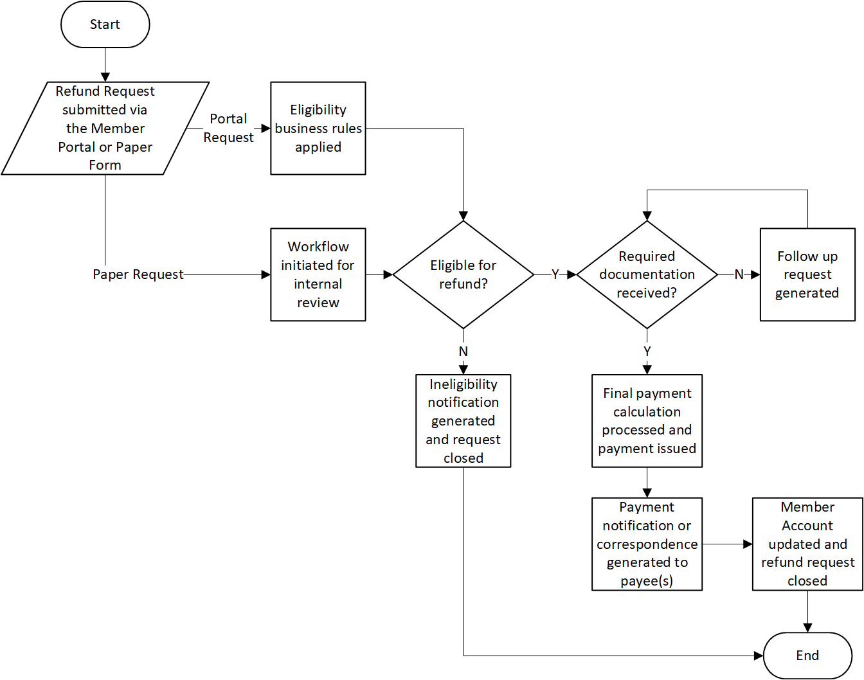

3.1.4.11 QDRO Processing

# (a) Future Vision

The Qualified Domestic Relations Order (QDRO) process will be created when PEBA receives notice of a pending order. Workflow will be created to flag the Member’s account, track the process, and capture all required information.

Within the workflow the user will be able to capture information such as the split or percent amount, alternate payee demographic information, date of marriage, date of separation, and date of divorce. If the Member is retired, the user will be able to see the calculation details for the Member and alternate payee’s benefits and have the ability to modify the details of the calculation. When the workflow is finalized, the new benefit amounts will be released to payroll. If the Member is not retired, the details captured within the workflow will be stored for future benefit calculations. When the Member creates an estimate, retires, requests a refund, or deceases, the details of the QDRO will be pulled into the calculation so that information presented will display the amount to be paid to the Member and the amount to be paid to the alternate payee.

For additional details on termination or enrollment of former spouses, see Section 3.1.4.1 - Common Enrollment process flow.

# (b) Key System Functions

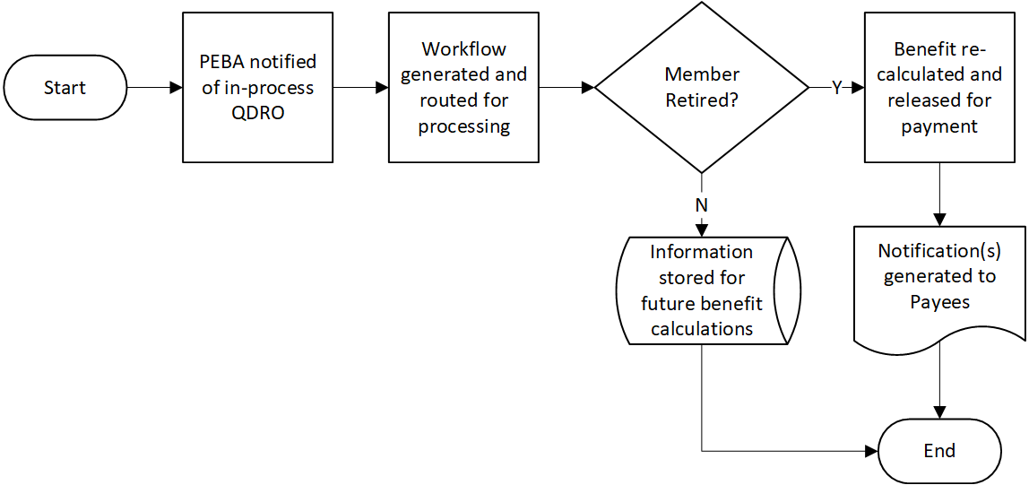

3.1.4.12 Benefit Estimate

# (a) Future Vision

Benefit estimate functionality will be available to calculate and provide estimates for service retirement, disability retirement, death benefits, QDRO, and QBC for all systems (SCRS, PORS, GARS, JSRS, and SCNG). Members and employers will have the capability to complete certain calculations, such as service retirement, and view estimates directly through the Member or Employer Portal. Other estimate requests will be routed to an internal PEBA user to complete and review before it is available on the portal. All estimates will be based on system data as well as certain user-entered fields that can be used to project a future benefit based on anticipated changes in factors such as compensation, total service credit, and unused leave.

When using the portal to complete an estimate, Members and employers can initiate the request, enter any user-projected data, and view the estimate in real-time. If a self service user requests an estimate that requires intervention by an internal PEBA user or the request is made through direct contact with PEBA, then the Member or employer will receive an electronic notification when the estimate is ready to log in and review in the portal. The estimate can be mailed as needed based on the Member or employer’s correspondence preference.

The benefit estimate functionality will include the ability to generate multiple estimates simultaneously to compare available benefits as well as how a change in a certain input, such as retirement date, impacts the total benefit. Beneficiary information on file will be used in the calculation with the option for the user generating the estimate to override. To provide a complete retirement picture, the estimate will automatically calculate insurance premium information and tax withholdings when applicable. A history of the generated estimates will be stored in the system as reference and can be accessed using the Member or Employer Portal or by an internal PEBA user. By providing this functionality through self service, Members and employers will have access to calculate or request a benefit estimate and understand the benefit options available to them.

(b) Key System Functions

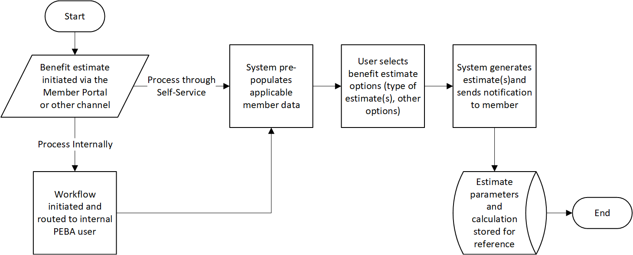

3.1.4.13 Retirement Processing

# (a) Future Vision

The retirement process includes determining eligibility for retirement benefits and retiree insurance coverage, enrolling a Member in retiree insurance and setting up the Member’s retirement benefit. Currently, the process of retiring a Member and enrolling them for insurance coverage are separate. Going forward, there will be a common retirement application for retirement and insurance.

The retirement process will be initiated when the Member electronically submits the application from the Member Portal or sends in a physical retirement application. From the Member Portal, the applicant can enter required information, such as insurance elections, retirement type, option, date of retirement, termination date, federal/state withholdings, payment information, beneficiaries and dependents, and upload any supporting documentation. The system will run validations prior to the Member being able to submit the application to check if the parameters are valid and if the Member is eligible for retirement.

Once the Member initiates the retirement process, a workflow will be created for an internal PEBA user to review. The user will be able to view the parameters entered by the Member, as well as review the supporting documentation that was uploaded with the application. Internal PEBA users will have the ability to electronically request required information from the Member and/or applicable employer. The Member and Employer Portal can be used to upload supporting documentation and/or enter information electronically.

When all the required information is provided and validated, the retirement calculation and any eligible insurance enrollment is finalized, and the benefit payments are released to payroll. If the Member enrolled for insurance coverage, the information will be sent to the applicable insurance carriers.

For additional details on the disability process, see Section 3.1.4.14 - Disability Processing process flow. For insurance related to retiree insurance eligibility, see Section 3.1.4.1 - Common Enrollment process flow.

# (b) Key System Functions

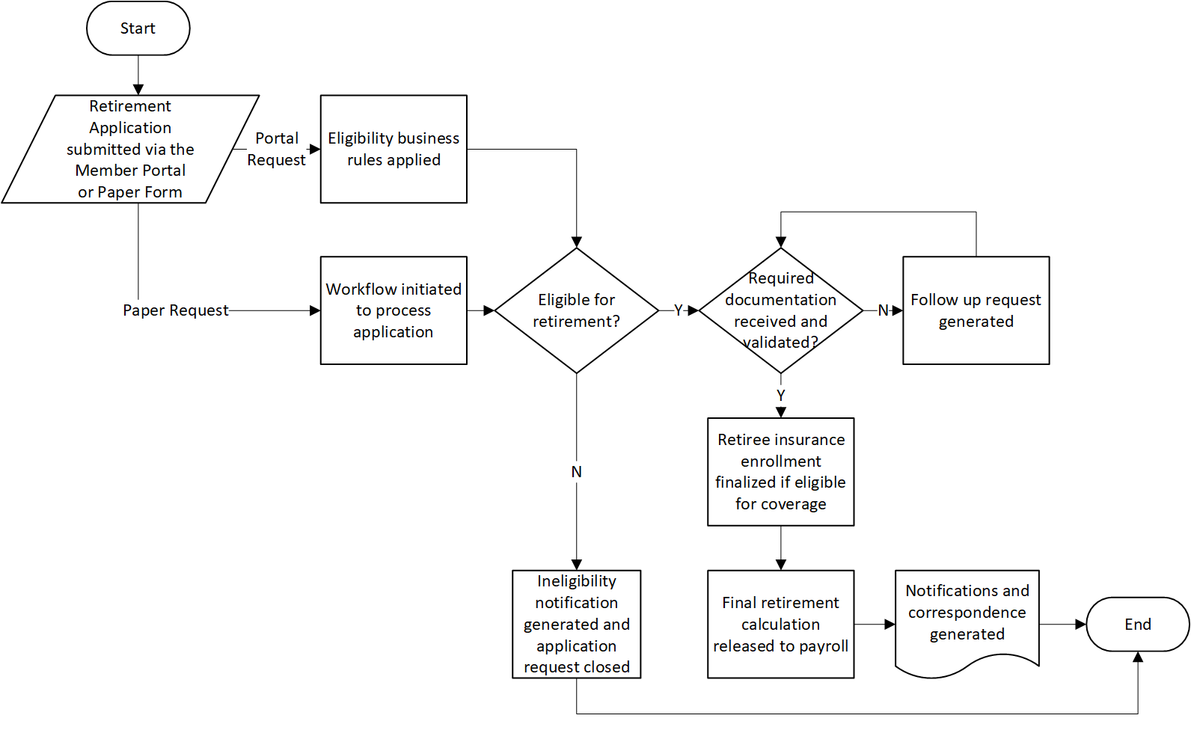

3.1.4.14 Disability Processing

# (a) Future Vision

Disability processing includes making a disability determination, handling the disability appeals process when applicable, and the continuing disability review process.

Disability processing will be initiated when the Member electronically submits the application from the Member Portal, sends in the physical application, or the employer electronically submits the application on behalf of the Member from the Employer Portal.

When the process is initiated from the Member Portal, the Member can apply for disability benefits (supplemental long-term disability, basic long-term disability, disability annuity, insurance), enter the required information, upload any supporting documentation, and electronically submit the application. The system will provide validations prior to the Member being able to submit the application to confirm that the data entered is valid and the Member meets insurance and retirement eligibility requirements.

When the Member selects disability annuity and initiates the process from the Member Portal, a workflow will be created for internal review. The user will be able to view the data entered by the Member, as well as review any supporting documentation that was uploaded with the application. The internal PEBA user will have the ability to electronically request required information from the Member and/or applicable employer. Certain requests will be automatically initiated with a notification to the workflow owner. The Member and employer will have the ability to upload supporting documentation and/or enter information electronically using the Member or Employer Portal.

Once the documentation is received, PEBA will have the ability to electronically and securely send required information to TPAs, such as the medical board or disability determination provider, when applicable. The status of the application will be tracked in the system as the TPAs make the disability determination, and a notification will be generated to the workflow owner when the decision is complete. If the application does not require TPA review, internal processing can proceed.

If the Member is approved for disability, the appropriate communications will be sent to the employer and/or Member and the retirement process will be initiated so the Member can be enrolled in retiree insurance and/or released to payroll. If the disability application is denied, a notification will be sent to the Member informing them of the opportunity to appeal. If the Member does not appeal the decision, the disability application will automatically close.

If the Member is approved with continuing disability review, a follow up case will be automatically triggered after a defined period to support the review process (ex. 3-year Continuing Disability Review, 1-year Social Security Administration). If denied during the review, the benefit will be suspended.

For additional details on retirement processing including rules related to retirement eligibility, see Section 3.1.4.13 - Retirement Processing process flow. For rules related to insurance eligibility, see Section 3.1.4.1 - Common Enrollment process flow.

<space left blank intentionally>

# (b) Key System Functions

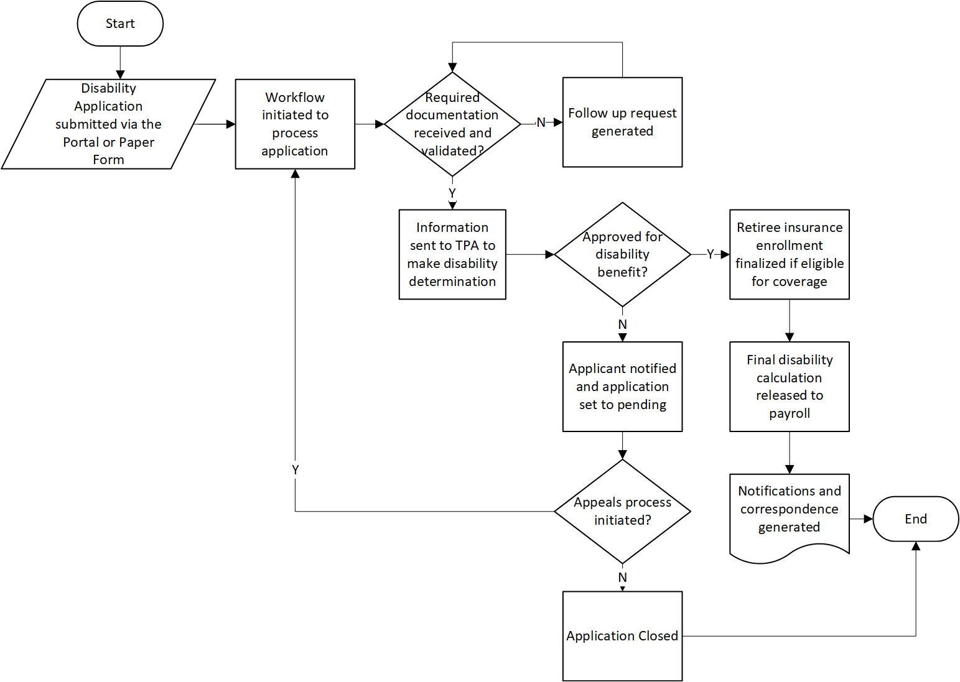

3.1.4.15 Retirement Payroll Processing

(a) Future Vision

The Retirement Payroll process includes running and reconciling the daily and monthly payrolls and managing the disbursement of benefits for all systems to payees. These payroll processes will be supported by system automation to run required payroll cycles, workflow to route requests for review and approval, and electronic notification and correspondence to payees. Included processes are:

* **Daily Payroll Processing.** Scheduled and ad-hoc payroll cycle processing for monthly annuity, incidental death benefit, refund, and daily annuity payments.
* **Daily Payroll Balancing.** Automated nightly process to compare payroll balances and generate notifications to the applicable PEBA user(s) for exceptions review.
* **Daily Tax Reporting and Remittance.** Automated generation of a tax record used to enter the federal and state tax withholding information for each system using the IRS and SCDOR portals and remit payment.
* **Cost of Living Adjustment (COLA).** Automated application of benefit adjustments based on statute. The COLA calculation will be configurable and include any applicable caps.
* **Qualified Excess Benefit Arrangement (QEBA).** The system will provide the ability to flag and set up QEBA payees based on information from predetermined IRS and actuarial calculations. Flagging payees can generate workflow for review and payment set up from the appropriate trust.
* **Payment Maintenance.** This process will include generating workflow to stop / recall, void, and reissue check and/or EFT payments.
* **Deduction Provider Payments.** Automated process to generate periodic payment of PEBA-approved deductions to the appropriate providers. This also includes maintenance of the deduction provider information.

Events that impact the retirement benefit are processed and applied as part of retirement payroll processing and include:

* **Earnings Limitations.** The system will automatically identify and track Members that are approaching a service or disability earnings limitation for a calendar year and generate workflow for review and contact. Earnings limits will be monitored through information from South Carolina Department of Employment and Workforce (SCDEW) and through employer reporting data. The system will allow for approved exceptions such as critical needs.
* **30-Day Break.** Based on a reported return to work date, workflow will be generated to review retirees that have not met the 30-day break requirement and determine if benefits should be suspended.
* **Change of Beneficiary and QBC.** Workflow will be generated when a retiree submits documentation for a qualifying life event for review, approval, and updates to information such as payment option, effective date, and benefit amount.
* **Revert-to-Max.** Workflow will be generated when a retiree submits documentation that qualifies the benefit payment to increase to the maximum option. Upon approval, the new benefit amount will be calculated and applied.
* **Receivables / Allocations.** Receivables will be generated when a payment due to PEBA is identified (e.g. overpayment of benefits). As the funds are collected they are applied to the receivable until it is paid in full.
* **Setoff Debt Process.** This process will include generating notifications and/or correspondence to impacted Members with delinquent receivables and generating a record to be used to enter data into the SCDOR portal.
* **Suspensions / Terminations/ Reinstatements.** Suspensions, terminations, and reinstatements will be processed and monitored automatically based on certain triggers, such as a change to a Member’s status or exceeding an earnings limit. These can also be manually processed for exception scenarios.
* **Medicaid.** Automated process to flag payees that should not receive COLA or identify where COLA should be reinstated based on Department of Health and Human Services (DHHS) data.
* **Pension Protection Act of 2006 (PPA) Deduction & Certification Maintenance.** Workflow will be generated to process payee requests for a PPA deduction and will include notifications to the employer to complete the certification through the Employer Portal.
* **PPA Insurance Provider Setup and Maintenance.** Workflow will be generated to set up new insurance providers/employers to participate in the PPA deduction program and update existing providers.

(b) Key System Functions

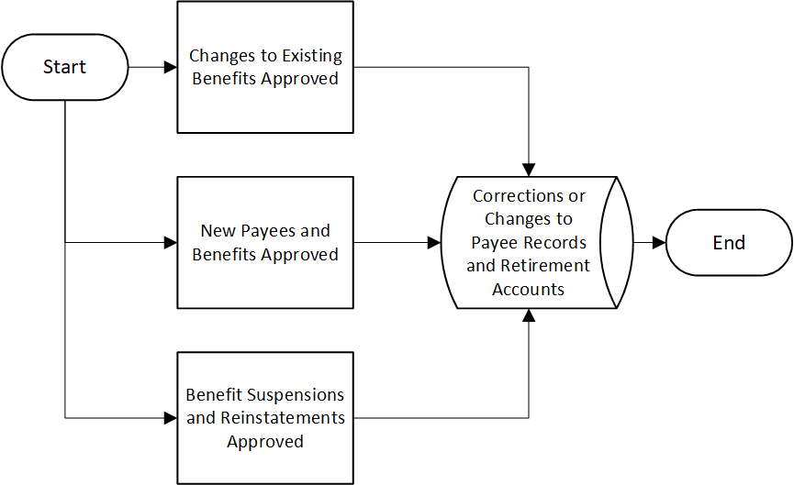(1) Payee and Benefit Adjustments:

(2) Payroll Processing:

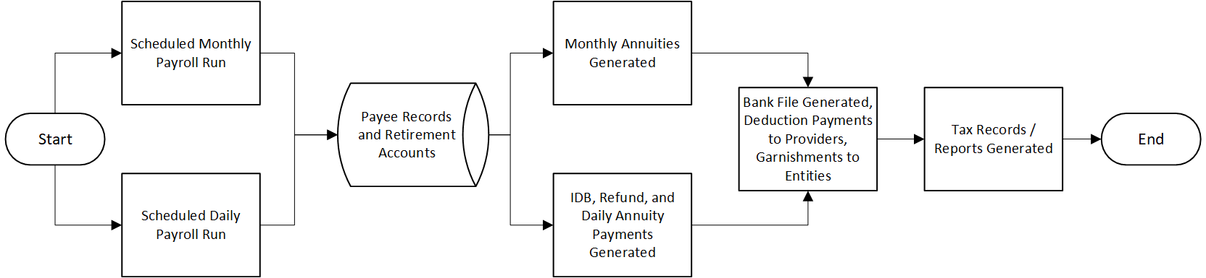

3.1.4.16 Death Notification and Processing

# (a) Future Vision

Death notification functionality will provide the ability to receive death information from multiple channels and trigger workflow to confirm date of death, terminate insurance coverage and initiate new coverage for survivors, and process retirement death benefit payments. Death notifications can be received directly from vendors or employers, the SSA, DHEC, CMS, DHHS, or direct contact with PEBA. The specific process steps within the workflow and benefits available will be based on the Member’s status (retiree/payee, active, inactive, working retiree) at time of death.

For payee deaths, the system will automatically suspend benefit payments when the date of death is entered, calculate any overpayments that require collection, and terminate all insurance coverage. The beneficiary and survivor information will be confirmed and notifications sent to the applicable contacts to gather required documentation. Survivors will be automatically enrolled in the insurance coverage they previously held or, in certain cases, a pending transaction will be sent to the employer for approval. Applicable death benefits will be calculated and paid.

Active or inactive deaths will follow a similar workflow by confirming and notifying beneficiaries and survivors and requesting information from the employer if needed to process the death benefits and insurance coverage appropriately. While different calculation rules may be applied to active or inactive death processing, the general workflow to confirm and process benefits will be similar.

There will be several system tools to support processing of all applicable benefits, such as beneficiary and survivor access to self service functionality to upload supporting documentation and check the status of the death claim. Electronic notifications and automated follow-up correspondence will be leveraged to collect all necessary information and process the benefits and coverages timely. When a death is reported, there will be automated eligibility determinations and enrollment in insurance benefits and system calculated death benefits. Employers will receive electronic notifications to provide required information to process PEBA-administered benefits or to send information directly to a TPA, such as in the case of a life insurance claim.

# (b) Key System Functions

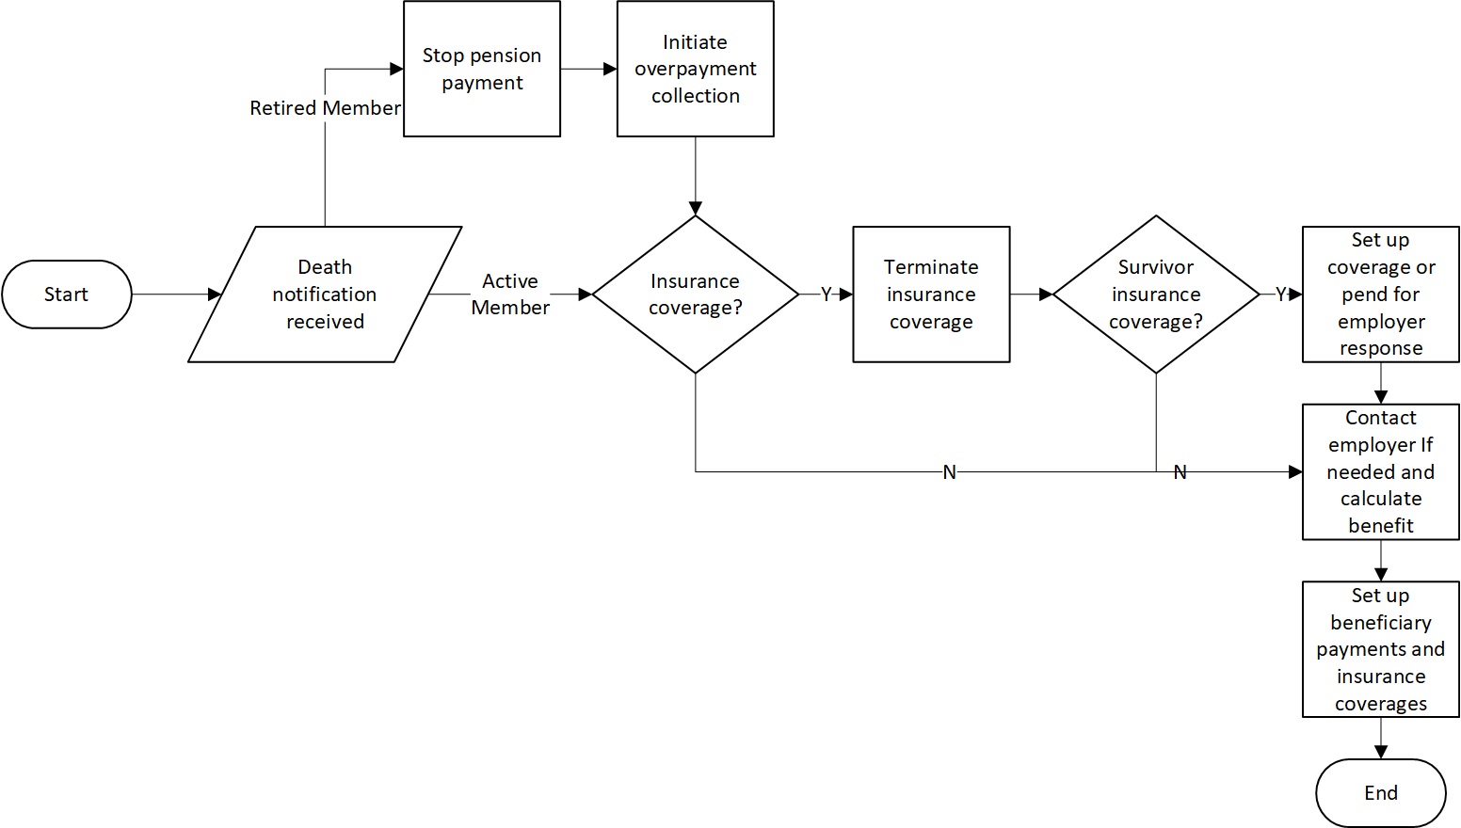

3.1.4.17 Member Self Service

# (a) Future Vision

Member Self Service functionality will provide a secure, informative, user friendly portal with the ability to view and update demographic data, initiate transactions, and enter information or upload documents to complete in-process requests. When a participant logs into the portal, they will see information and have access to certain functionality based on their account type and status (ex. active Member, retiree, beneficiary or alternate payee, QDRO recipient, etc.).

All participants will have the ability to initiate chat with internal customer service users, access documents, and view frequently asked questions and disclaimers. They will be able to make updates to their demographic and profile information and customize what they see based on their preferences. If the participant has an account with a TPA, such as the SCDCP, they will be able to view a summary of their account information with links to the TPA’s sites to make changes or view more details.

Non-retired Members will be able to view their employment information, contributions, service credit, and insurance benefits. They will be able to make updates to beneficiary designations, insurance coverage, and payment options for insurance premiums or open service purchase invoices. Additional functionality will include the ability to run estimates, schedule counseling and seminars, initiate a service purchase or refund, apply for retirement, initiate the disability retirement process, and update or apply for insurance coverage.

Retirees and other participants, such as alternate payees and survivor beneficiaries, will be able to view information such as account balance at time of retirement and any working retiree contributions, benefits paid to date, and insurance coverages. They will be able to update their state and federal tax information, check or direct deposit information, beneficiary designations, and insurance benefits when applicable.

# (b) Key System Functions

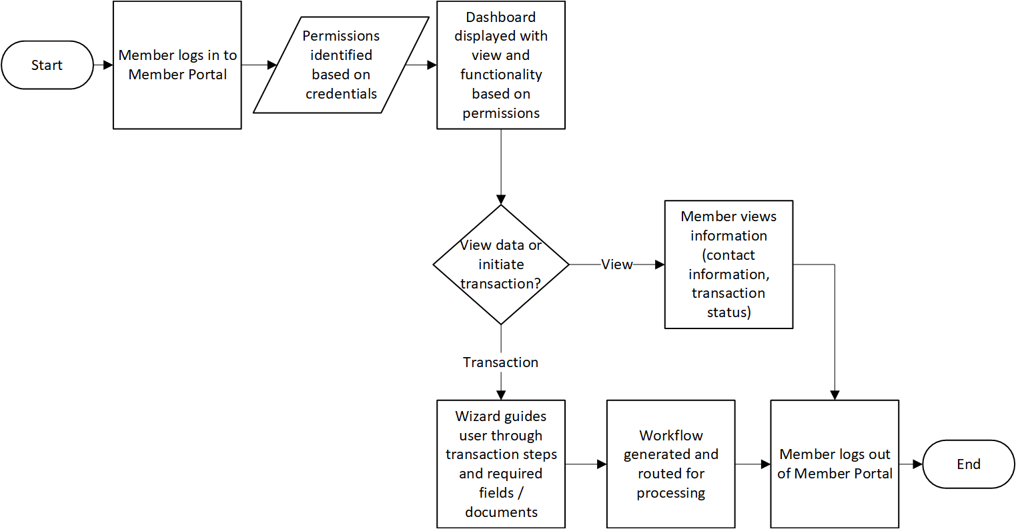

3.1.4.18 Employer Self Service

# (a) Future Vision

Employer Self Service functionality will provide a consolidated and secure communication channel between employers and PEBA to view information and complete transactions related to retirement and insurance participation. Employers will log in to the Employer Portal to view notifications and requests for information, view employer documents, and upload new documents to support requests. Real-time data validations and step-by-step prompts will guide employers through completing employer reports and other transactions. Employers will also have access to secure messaging and online help tools for questions specific to their organization.

Key functions that employers will complete through the Employer Portal include: employer reporting, enrollment for new hire transactions, updates to employee status or life events, initiating and managing payments, generating benefit estimates, registering for employer events, and providing supporting documentation for pending requests. When an employer initiates a transaction or provides supporting documentation for an in-process request, workflow will be generated and routed to the appropriate PEBA department for review and processing. Employers can view the status of a pending request and will be notified upon completion. Additional member data and reporting functionality will be available to allow employers to run reports on their employee data and view employer communications.

Employers can maintain their users with permissions and access based on employer participation (retirement, insurance, both). When a user logs in to the Employer Portal, he/she will see functionality and dashboard views specific to their credentials. Electronic notifications will be routed toward specific users based on the type of request. There will be an option to send information or requests to contacts at the employer that are not users of the system based on their communication preference. Reminders for items such as pending employer reports or outstanding document requests will be sent to employers at certain intervals to prevent late reporting and expedite outstanding Member requests.

# (b) Key System Functions

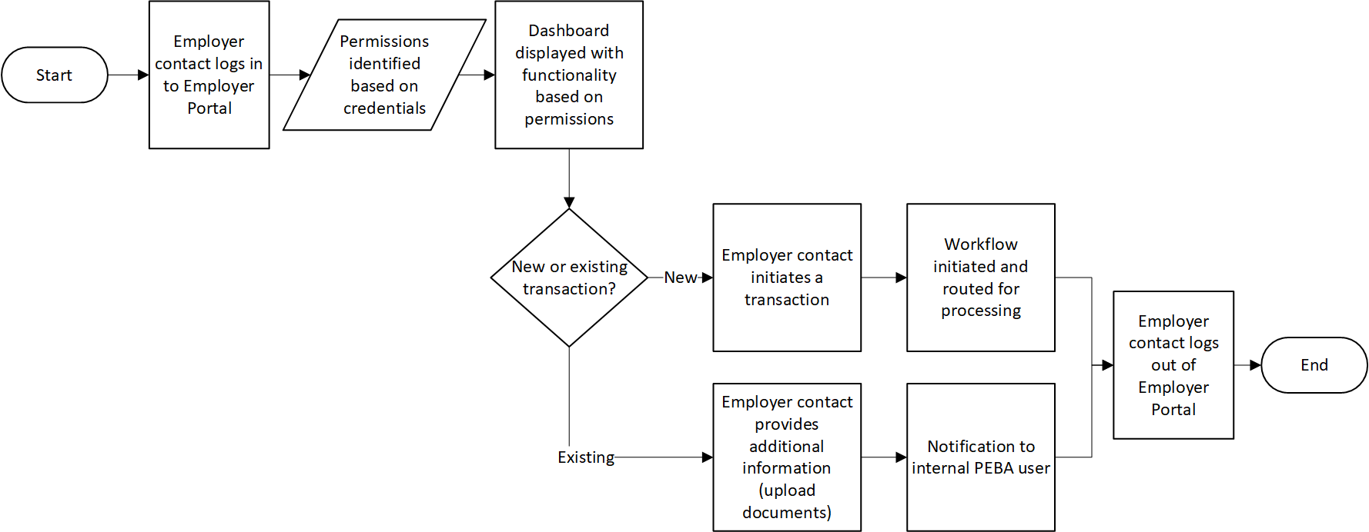

3.1.4.19 Member Account Maintenance

# (a) Future Vision

Member accounts are updated from various processes within the system. For example, the retirement process will update information on the Member’s account related to retirement (retirement option, retirement date, taxes, and bank information) and employer reporting will update information on the Member’s account related to employment (service transactions, contributions, etc.).

Internal PEBA users should be able to view, add, and maintain details of member accounts, including but not limited to, personal information, beneficiary designations, insurance dependents, insurance coverage and history, service, contributions, employment information, invoice details, tax withholdings, bank information, retirement details, and payroll. Certain member account data can be updated by the participant directly through the Member Portal.

Multiple system processes will provide data that will update the member account. This functionality is detailed in the individual process areas.

# (b) Key System Functions

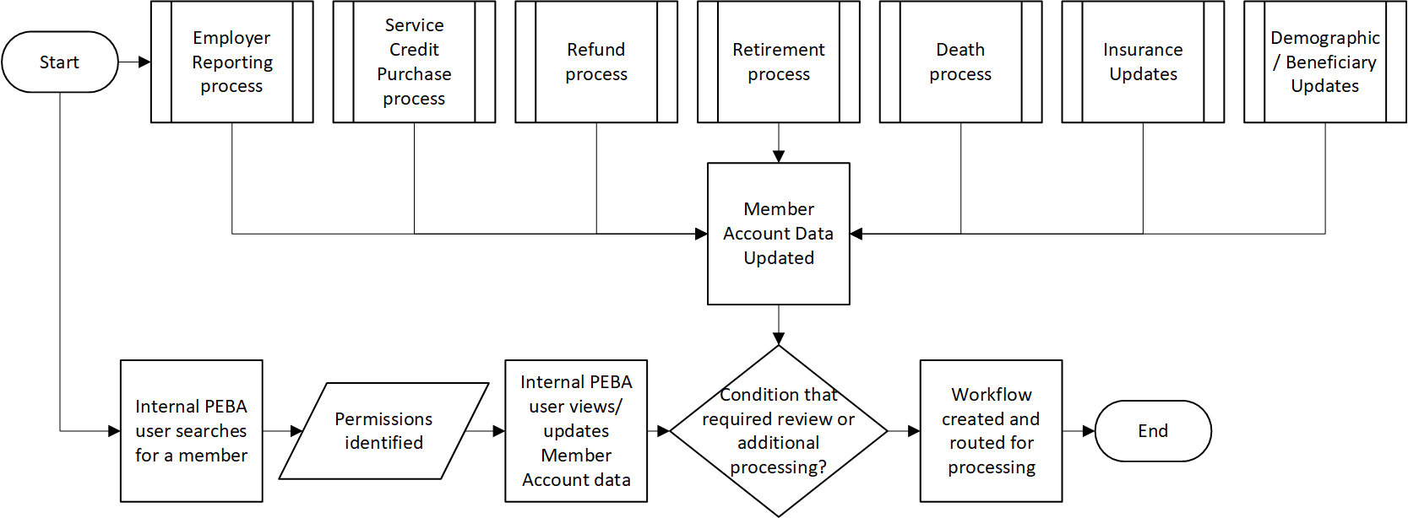

3.1.4.20 Periodic Processes

(a) Future Vision

The system will have the ability for PEBA staff to schedule a process (date, time, frequency, etc.) in the future or run a process on demand. If the process fails, a notification will be generated and routed to the appropriate internal PEBA user(s) with the details on why the process failed. When the process completes, a notification will be sent to the appropriate internal PEBA user(s) with details on the process (process name, number of members processed, etc.). Processes that require communication to the member (1099s, W2s, PPA letter, etc.) will be available via the Member Portal or mailed per the member’s communication preference.

Note: The benefit administration system will have the ability to generate reports of data that will be used to prepare various schedules that are included in financial reports that are compiled and published outside of the system such as the Comprehensive Annual Financial Report (CAFR) and Popular Annual Financial Report (PAFR).

The following will be covered as part of Periodic Processes:

* Annual IRS Reporting
* 1094: ACA Health Care Coverage Transmittal
* 1095B/C: ACA Health Care Coverage Member Form
* 1099R
* W2
* PPA Statement of Premium Deductions
* Required Minimum Distribution (RMD)
* Annual Contributions Interest Posting Process
* Generation of Actuarial Files
* Generation of Non-Discrimination Testing File
* Financials and Other Reporting
  + Annual Insurance Benefits and OPEB Trusts’ Financial Reports
  + CAFR and PAFR
  + GASB (ex. 44, 48, 68, 71, 74, 75, 82, etc.)
  + CEM Benchmarking
  + Transfer of Stale Date Checks to the Office of the State Treasurer
* Processing of Annual National Guard Service / Enrollment Files
* Processing of Inbound Insurance Financial Files
  + OPEB IBNR Transfer
  + Semi-Annual Receipt of Vendor Administration Fees
  + Receipt of MoneyPlus Forfeitures

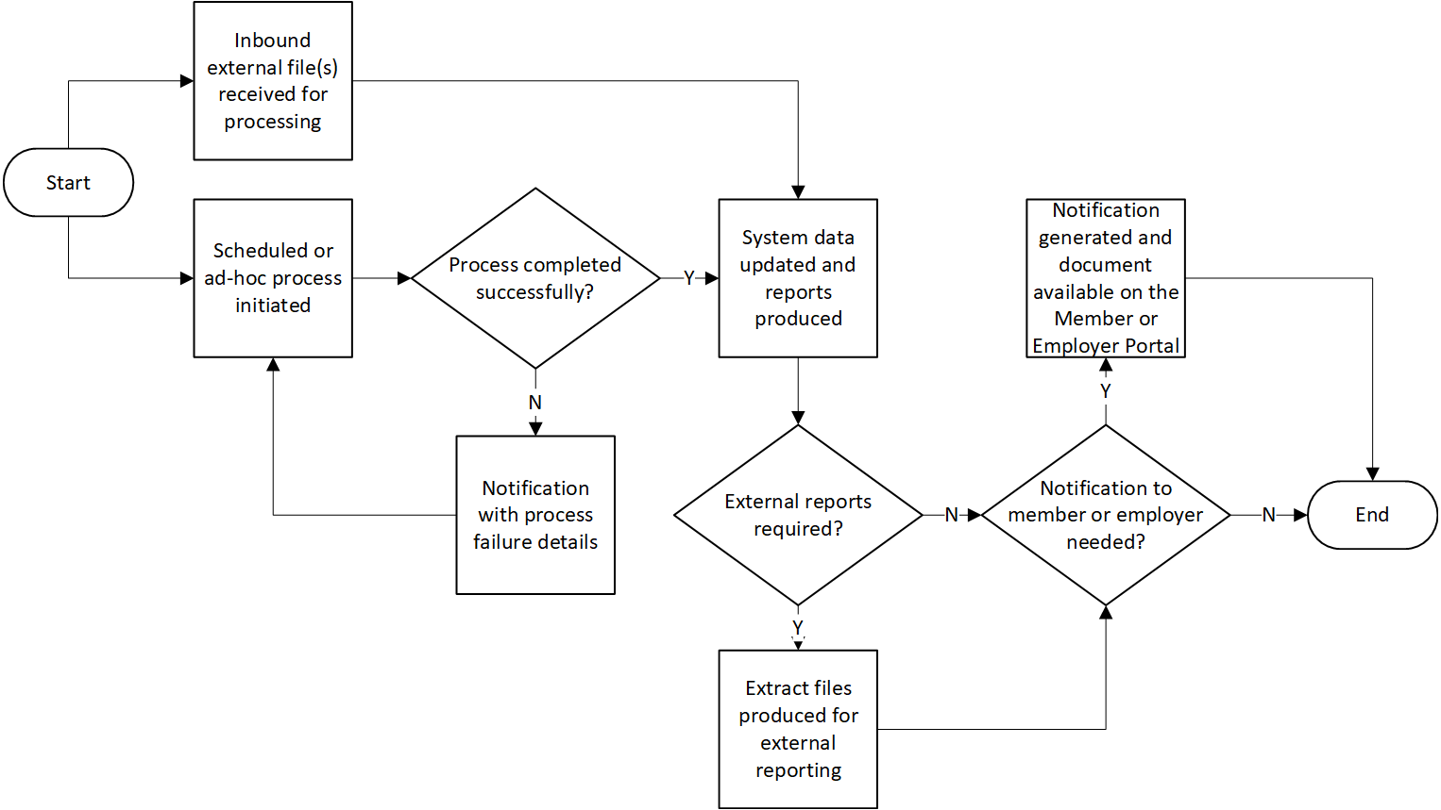(b) Key System Functions

3.1.4.21 Premium Management

(a) Future Vision

It is PEBA’s goal to implement a BAS solution that will provide fully integrated premium billing and receipts management. The following is a list of operational objectives that must be met:

* Run trial batch for Insurance Billing that will pick up all current Subscribers as well as changes in enrollment (additions, changes, and terminations of coverage) that have been entered since the last billing batch was run.
* Reconcile the trial batch run to validate the Insurance Bills against current enrollment rosters and premium amounts.
* Apply and carry forward credits and debits outstanding from prior periods, including retroactive premiums and past-due amounts.
* Post approved trial batch and generate Insurance Bills at the employer and individual Subscriber levels.
* Generate and distribute Insurance Bills according to the preferences designated by the payer. For example, electronic file, paper, etc.
* Generate banking files for debiting or crediting EFTs that reconcile to Insurance Billing detail files.
* Generate General Ledger integration files that will create Journal Entries for Accounts Receivables (or Payables in the case of a credit due) according to the transaction Chart of Accounts (subledgers).
* Consolidate and process summary payables generated through the retirement payroll process. This includes payment to third-party vendors (Fully Insured program) and the transference of money to designated state or PEBA subsidy funds.
* Integrate with the SCEIS SAP system to reconcile Subscriber enrollment.
* Incorporate OPEB Trust activity in internal accounting system.

The system functionality necessary to meet the objectives noted above is summarized as follows:

* A single-system user interface for the management of all aspects of benefits administration, including premium management.
* Premium billing based on individual Member assignment to benefit programs and plans, or based on calculations defined by business rules configured in the system.
* Accounts receivable and payable transactions visible in individual person records and summarized at the employer level.
* Effective Date driven billing, capable of automatically applying retroactive credits and debits.
* Eligibility rules configured for participation in benefits programs that will ensure accurate billing.
* Batch-based billing processes that will be run according to any schedule defined by PEBA.
* Integrated benefit premium deductions applied to retiree and associated dependents payments as part of the monthly retirement payroll process.
* Ability to define an unlimited number of new benefit programs, including eligibility rules, rates, and calculations. Existing programs may be closed to new enrollment, while allowing existing Subscribers to continue coverage (grandfathered), or may be closed while existing Subscribers are assigned to other programs.
* Ability to designate payer to be billed at the benefit program level for employers and/or at the individual Subscriber level.
* Generation and distribution of premium bills in multiple ways, including invoices to individual payers and summary billings to employers. Distribution methods may include direct mail, web portal, and secure file transfer.
* Posting of payments at the employer level, and at the individual person level when and where the data makes that possible. Payments may come through check, wire transfer (EFT “pulls”), credit card, and funds transfers within the SCEIS SAP system.
* Batch and extraction of general ledger transactions, summarized to the defined chart of accounts configured for all person-level transactions posted in the benefits administration system.
* Definition of workflow and associated communications in support of accounts receivable and payable.
* Validation and Reconciliation of all premium transactions, including:
  + active employee premium billing to current enrollment at the individual person and the employer level;
  + automated reconciliation of imported or entered payment data against receivables at the individual person level and at the summary employer level; and
  + reconciliation of retirement payroll premium deduction transactions to current enrollment.
* Generation of all necessary reports, detailed and summary to ensure that reconciling items will be identified.
* A complete and unified view of all financial transactions (credits and debits) at the employer level, including:
  + Retirement Contributions – Member;
  + Retirement Contributions – Employer;
  + Premium Billed;
  + Premium Paid;
  + Past Due;
  + Fees; and
  + Penalties.

<space left blank intentionally>

(b) Key System Functions

(1) Premium Management for Active Employees and their associated Subscribers

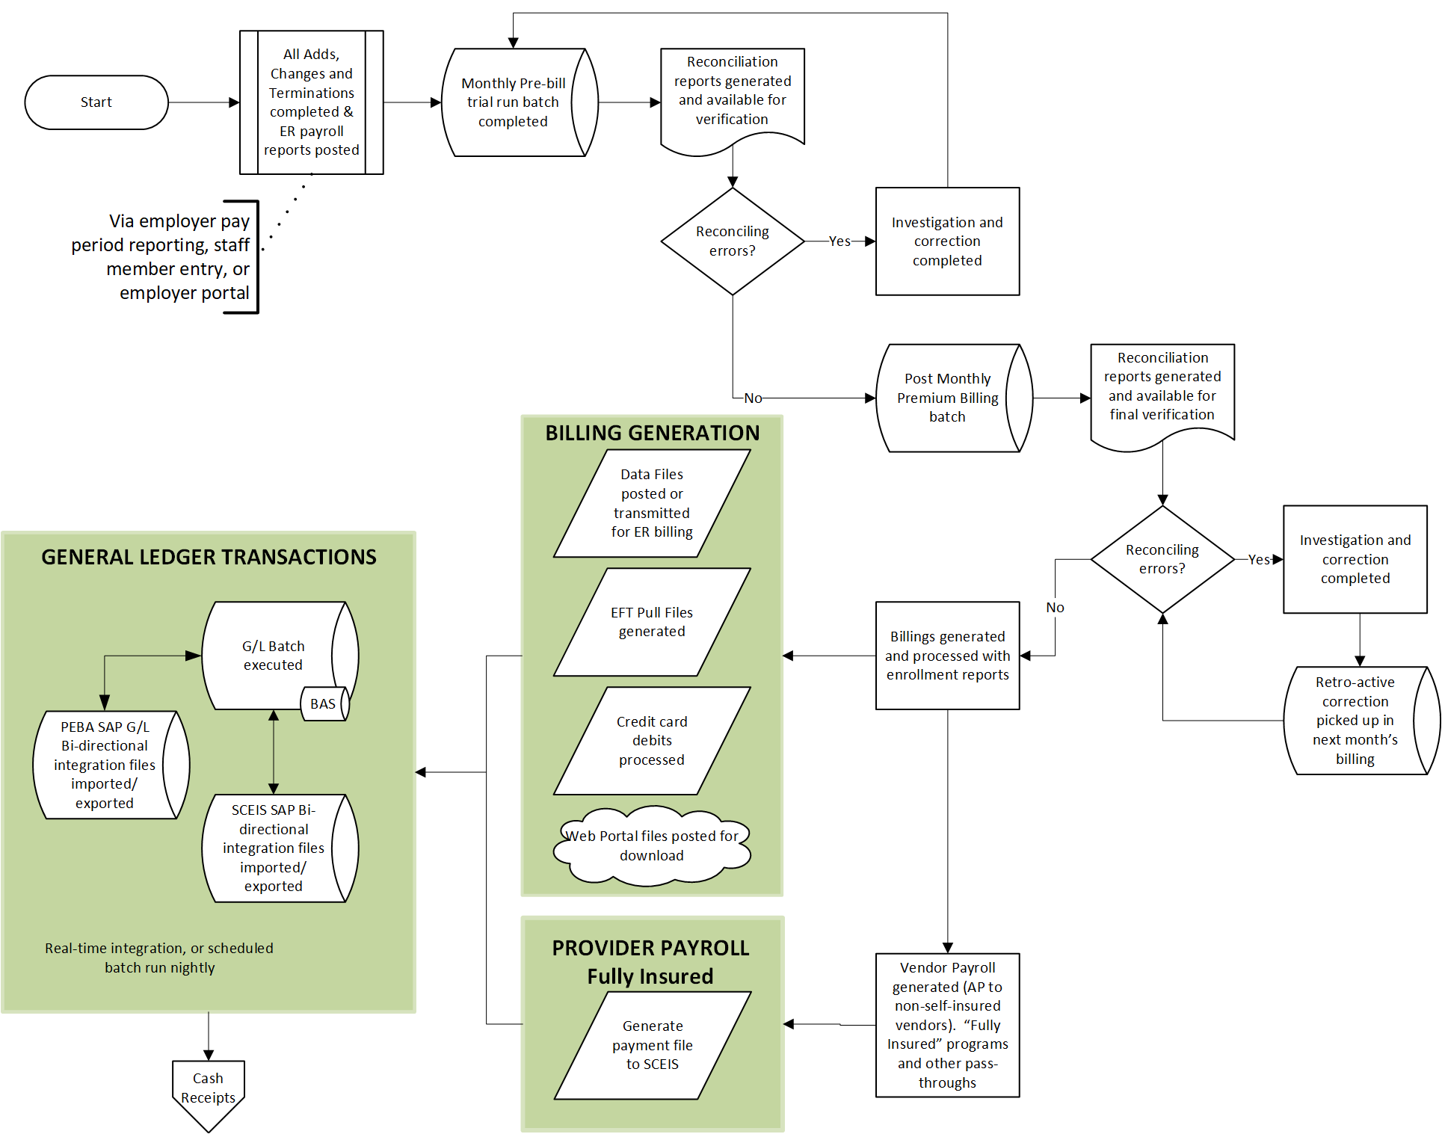

<space left blank intentionally>

(2) Premium Management for Retirees and their associated Subscribers

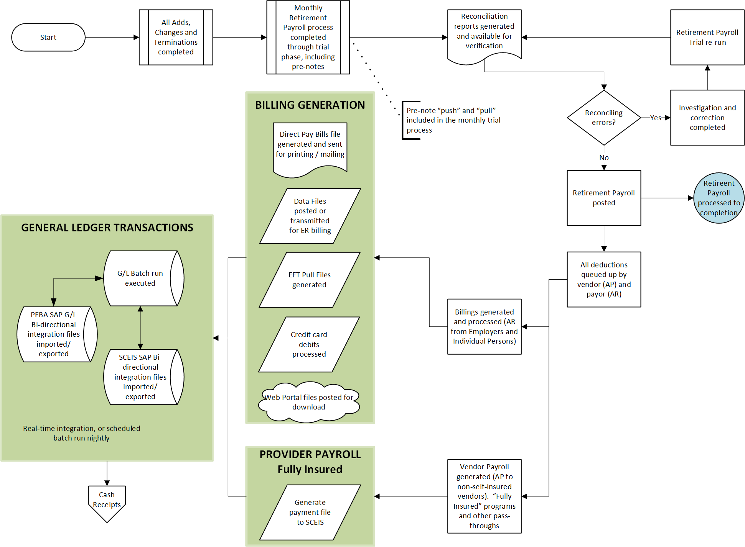

<space left blank intentionally>

(3) Premium Cash Management: Employer Batch Example



(4) Premium Cash Management: Individual Direct Pay Example



* + 1. **Key Business Rules**

Exhibit 1 Business Rules contains detailed descriptions of each of the major business process key business rules at PEBA. The descriptions will help to provide a fuller context to the Contractor, as compared to just listing requirements. Each major process is identified by a number. There is nothing to be implied from the process identification numbers other than simple identification. Please do not alter the process ID numbers.

* 1. **GOVERNMENT CLOUD SERVICES**

PEBA is interested in an off-site government cloud services hosting option for the new BAS.

The Contractor is not merely delivering a software solution. The Contractor must deliver a solution capable of meeting the dynamic, year-over-year needs of PEBA. As the System includes the service provided by the hardware and software infrastructure required for its hosting, operation, and maintenance, the Contractor will, therefore, select and enter, or has entered, into a written agreement with a vendor (the “Government Cloud Services Provider”), who will provide the System infrastructure, delivered as a service, in such a manner as to allow PEBA to benefit from the pricing of such services and to promote functionality of the System.

The Government Cloud Services Provider will be a distinct entity from the Contractor. The Contractor will enter or has entered into an order under its agreement with the Government Cloud Services Provider (the “Government Cloud Services Order”), in accord with the terms set forth below in this section. The term of the Government Cloud Services will be coextensive with the term of this Contract.

* + 1. **General Terms.** The Government Cloud Services Order will provide the following elements of the System’s infrastructure solution:

1. **Cost-Effective Delivery.** The Contractor will ensure that the Government Cloud Services will provide for sustainable and cost-effective operation of the System. The Contractor will, therefore, compensate the Government Cloud Services Provider and will, upon request by PEBA, if charges for the Government Cloud Services is utilization-based, promptly make available copies of reports regarding the billing and usage of the Government Cloud Services in support of the System.
2. **Flexibility.** The Contractor will require that the Government Cloud Services Order accommodate transaction rates and storage demands that accommodate anticipated and mutually agreed PEBA usage in the Warranty Period and/or during Maintenance and Support services delivery.
3. **[[Assumption.** The Contractor will require that the Government Cloud Services Subcontract provide that, in the event the Contractor’s services are terminated pursuant to Section(s) 6.11.3 and 6.11.4 below, prior to the expiration of the term set forth in this Contract, PEBA will have the right to assume all of the Contractor’s rights in the Government Cloud Services Subcontract.]]
4. **Change Management.** The Contractor will require that the Government Cloud Services Order provide that changes will be managed pursuant to Sections 6.3.8 and 6.3.9 below, provided that Contractor may temporarily suspend PEBA’s access to the Government Cloud Services or hosted environment if it reasonably determines that (i) PEBA or any PEBA End User is not in compliance with the Government Cloud Services Provider’s Acceptable Use Policy, or (ii) access to the Government Cloud Services or hosted environment poses a security risk to the Services, any third party, including the Government Cloud Services Provider, or Contractor’s or the Government Cloud Services Providers systems, infrastructure, or networks, and provided further that:
   * 1. Changes To the Government Cloud Services. Government Cloud Services Provider may change or discontinue any of the Government Cloud Services or change or remove functionality of any or all of the Government Cloud Services from time to time. Government Cloud Services Provider will provide prior notice to Contractor if Government Cloud Services Provider decides to discontinue a Government Cloud Service or functionality of a Government Cloud Service that it makes generally available to its customers, except that Government Cloud Services Provider will not be obligated to provide such notice if the discontinuation is necessary to address an emergency or threat to the security or integrity of Government Cloud Services Provider, respond to claims, litigation, or loss of license rights related to third-party intellectual property rights, or comply with the law or requests of a government entity.
     2. Changes To APIs. Government Cloud Services Provider may change or discontinue any APIs for the Government Cloud Services from time to time. For any change or discontinuation of an API that is not also a discontinuation of a Government Cloud Service or a functionality of a Government Cloud Service, Government Cloud Services Provider will continue supporting the previous version of such API for 12 months after the change or discontinuation (except if doing so (a) would pose a security or intellectual property issue, (b) is technically infeasible, or (c) is needed to comply with the law or requests of governmental entities).
5. **[[Maintenance.** The Contractor will require that the Government Cloud Services Subcontract include a calendar of scheduled maintenance, which will be continuously available to PEBA, with all scheduled activities occurring within the Maintenance and Support periods set forth herein. The Contractor will require that the Government Cloud Services Subcontract provide for the underlying cloud infrastructure, including network, servers, operating systems and storage maintenance, upgrades, and enhancements over time (“Infrastructure Maintenance”), including through the system development and testing, Warranty Period, and any optional Maintenance and Support periods PEBA elects. The Contractor will further require that the Government Cloud Services Subcontract provide that major upgrades to the System’s Software and Equipment must be scheduled after advanced prior notice that allows PEBA an opportunity to assess the impact and make any needed changes to accommodate the new infrastructure.]]
6. **Service Level Agreement.** The Contractor will have a Service Level Agreement (SLA) with the Government Cloud Services Provider.
   * 1. **Data Ownership.** PEBA shall have and maintain in effect at all times, during the term of this Contract, all licenses and rights necessary in, and in connection with, Client Items (defined below) to enable, and does hereby authorize, the receipt, hosting, storing, transmitting, processing, destroying, and the use and disclosure of Client Items by Contractor and its authorized subcontractors and service providers as contemplated in this Contract, or as required by applicable law. The Contractor will ensure the Government Cloud Services Provider will not access PEBA user accounts or Client Items, except (1) in the course of data center operations, (2) in response to service or technical issues, (3) as required by the express terms of this contract (including as necessary to maintain or provide the Government Cloud Services), (4) as necessary to comply with the law or a binding order of a governmental body or (5) at PEBA’s written request. “Client Items” means any hosted applications and any PEBA-provisioned machine images, data, text, audio, video, images or other content that PEBA or a third party or Contractor on behalf of PEBA, installs or uploads onto the hosted environments as part of the Services, or that PEBA or PEBA End User (a) runs on any hosted application hosted on the hosted environments, (b) uploads to any hosted application hosted on the hosted environments, or (c) causes to interface with the hosted environments.
     2. **Import and Export of Data:** PEBA will have the ability to import or export data in piecemeal or in entirety at its discretion without interference from the Government Cloud Services Provider. This includes the ability for PEBA to import or export data to/from other service providers.
     3. **Data Location.** The Contractor will require, as a condition of entering into the Government Cloud Services Order, that all data, including data stored in all databases, environments, and data backups, will be stored on-shore within the United States of America and that the data will be accessed only by personnel located within the United States of America. System access will be limited to PEBA-assigned access and only those Contractors’ staff required performing services under this Contract. The Contractor will use the data only as necessary to perform services hereunder and not share or sell the data in any way. PEBA acknowledges that Contractor is not a reseller or sub-licensor of the Government Cloud Services, and further agrees that the only access PEBA shall have to the Government Cloud Services and any Client Items hosted thereon shall be through accessing the hosted environment, as PEBA End Users, without any administrative access or management rights to the Government Cloud Services.
     4. **Data Protection.** Protection of personal privacy and data will be an integral part of the business activities of the Government Cloud Services Provider to ensure there is no inappropriate or unauthorized use of PEBA information at any time. To this end, the Contractor will require the Government Cloud Services Provider will safeguard the confidentiality, integrity, and availability of PEBA information within its control and comply with the following conditions:
7. The Government Cloud Services Provider will implement and maintain appropriate administrative, technical, and organizational security measures designed to safeguard against unauthorized access, disclosure, or theft of all PEBA data within its control. Such security measures will be in accordance with the ISO 27001 standards or such other alternative standards as are substantially equivalent to ISO 27001.
8. All data transferred by PEBA for processing, storage or hosting by the Government Cloud Services in the performance of this contract and any computational results that Contractor or PEBA derive from the foregoing through its use of the Government Cloud Services will become and remain the property of PEBA.
9. Confidential Data, Restricted Data, and Personal Data will be encrypted at rest and in transit with controlled access.
10. At no time will any data or processes, which either belong to or are intended for the exclusive use of PEBA or its officers, agents, or employees, be copied, disclosed, or retained by the Government Cloud Services Provider or any party related to the Government Cloud Services Provider for subsequent use in any transaction that does not include PEBA.
11. The Government Cloud Services Provider will be Federal Risk and Authorization Management Program (FedRAMP) certified at the Moderate level. PEBA reserves the right to inspect the Government Cloud Services Provider’s FedRAMP Readiness Assessment Report and other such FedRAMP certification supporting documentation.
12. The Government Cloud Services Provider must provide Contractor, annually a SOC-2, Type 2 audit report that addresses all five trust principles of security, availability, processing integrity, confidentiality, and privacy, audited by an independent public accounting firm under Statement on Standards for Attestation Engagements No. 18 (“SSAE 18 Report”) or such other industry standard reports or certifications that cover comparable standards or controls as defined by Government Cloud Services Provider for each facility from which Government Cloud Services are provided.
13. The Government Cloud Services Provider will support HIPAA compliance and enter into a Business Associate Agreement with Contractor, as required by HIPAA.
14. The Government Cloud Services Provider will maintain and implement procedures to logically separate PEBA data from the Government Cloud Services Provider’s data and the data belonging to the Government Cloud Services Provider’s other customers.
15. [[The Government Cloud Services Subcontractor will not store PEBA Data on any portable computing device including, but not limited to, personal data assistant (PDA), cell phone, smartphone, laptop (each a “Portable Computing Device”), unless PEBA Data stored on such Portable Computing Device is encrypted.
16. The Government Cloud Services Subcontractor will not store Client Items on any removable media, such as compact disc, flash drive, tape (each a “Removable Media”), unless Client Items stored on such Removable Media is encrypted.
17. Encryption of Data at Rest: The Government Cloud Services Subcontractor will ensure hard drive encryption consistent with validated cryptography standards as referenced in FIPS 140-2, Security Requirements for Cryptographic Modules for all Confidential Data, Restricted Data, and Personal Data, unless the Government Cloud Services Subcontractor presents a justifiable position approved by PEBA that data must be stored on a Government Cloud Service Subcontractor portable device in order to accomplish work as defined in the scope of work.]]

PEBA acknowledges and agrees that, except for the above security requirements, any other security or infrastructure security requirements specified in the Contract shall apply only with respect to Contractor systems and infrastructure used to provide the Services, excluding the Government Cloud Services infrastructure.

* + 1. **Incident Response.** The Government Cloud Services Provider may need to communicate with outside parties regarding a Security Incident, which may include contacting law enforcement, fielding media inquiries, and seeking external expertise as mutually agreed upon, defined by law, or contained in the contract. Notification of Security Incidents will be provided to Contractor within twenty-four (24) hours of confirmation(unless prohibited by court order or other legal requirement) as part of the Government Cloud Services Provider communication and mitigation processes.
    2. **Termination and Suspension of Service.** The Contractor will require that the Government Cloud Services Order provide that:

1. In the event of an early termination of the contract, the Government Cloud Services Provider will allow for PEBA to retrieve its digital content unless prohibited by law or the order of a governmental or regulatory body or it could subject Government Cloud Services Provider or its Affiliates to liability and provide for the subsequent secure disposal of PEBA digital content.
2. During any period of suspension, the Government Cloud Services Provider will not take any action to intentionally erase any PEBA digital content.
3. In the event of early termination of any services or agreement in entirety, the Government Cloud Services Provider will not take any action to intentionally erase any PEBA data until thirty (30) days after such termination. After the transition, the Government Cloud Services Provider will have no obligation to maintain or provide any PEBA data and will thereafter, unless legally prohibited, delete all Client Items in its systems or otherwise in its possession or under its control. During the transition period, the Government Cloud Services Provider will impose fees for the Government Cloud Services.
4. [[After termination of the contract and the prescribed retention period, the Government Cloud Services Subcontractor will securely dispose of all digital content in all of its forms, such as disk, CD/ DVD, backup tape, and paper. PEBA’s digital content will be permanently deleted and will not be recoverable, according to NIST-approved methods. Certificates of destruction will be provided to PEBA.]]
   * 1. **Access to Security Logs and Reports.** The Contractor will require that the Government Cloud Services Order provide that:
5. [[The Government Cloud Services Subcontractor will provide access to system logs which include usage statistics, user access data, user access IP address, user access history, and security information.]]
6. [[PEBA will be allowed to scan for vulnerabilities against systems in which PEBA has the primary responsibility for system and data confidentiality, integrity, and availability.]]
7. [[The Government Cloud Services Subcontractor will allow PEBA, or its representative, to conduct forensic investigations for both criminal and non-criminal purposes. The Government Cloud Services Subcontractor will ensure that there is no interference with the investigation and will ensure the integrity of the data is maintained throughout the investigation.]]
8. Upon Contractor’s request, the Government Cloud Services Provider will promptly provide assistance and information in order to respond to or otherwise address any inquiry, access request, complaint, enforcement notice, claim, or similar action raised by a regulator in relation to PEBA’s use of the Government Cloud Services.
   * 1. **[[Contract Audit:** The Contractor will require that the Government Cloud Services Subcontract provide that the Government Cloud Services Subcontractor will allow PEBA to audit conformance to the contract terms. PEBA may perform this audit or contract with a third party at its discretion and at PEBA’s expense.]]
     2. **Change Control and Advance Notice:** The Contractor will require that the Government Cloud Services Order provide that the Government Cloud Services Provider will give advance notice to Contractor of any changes (e.g., major upgrades, minor upgrades, system changes) that may impact service availability and performance in accordance with 3.2.1(d). above.
   1. **FUNCTIONAL REQUIREMENTS**

The Contractor will provide, at a minimum, the following material and essential requirements subject to any modifications that may be issued in an Amendment by PEBA to the Request for Proposal resulting from the question and answer phase. Attachment 8 Functional Requirements contains a detailed listing of all functional requirements by major process. Each major process is identified by a number. There is nothing to be implied from the process identification numbers other than simple identification. The individual requirements listed are numbered as an extension to the process number. Please do not alter the functional requirement ID numbers.

* 1. **REPORTS, FORMS, LETTERS, E-COMMUNICATIONS, AND INTERFACES**

PEBA intends to be an active partner and co-implementer of the proposed BAS solution, in particular in the areas of reports, forms, letters, e-communications, and interfaces.

* + 1. Attachment 8 Functional Requirements and Attachment 9 Technical Requirements contain specific named functionality and technical requirements that the proposed system must meet.
    2. PEBA has assumed for planning purposes, but does not warrant or guarantee, the following quality and complexity of reports, forms, letters, e-communications, interfaces, and workflows:

|  |  |
| --- | --- |
| **Item** | **Quantity and Complexity** |
| Reports & Queries | 250 High Complexity  500 Medium Complexity |
| Forms, Letters & E-Communications | 75 High Complexity  150 Medium Complexity |
| Interfaces | 45 High Complexity  90 Medium Complexity |
| Workflows | 10 High Complexity  20 Medium Complexity |

* + 1. All necessary data back bridges, back feeds, and interim interfaces between the PEBA legacy systems and the new BAS during the Phase deployment of the new system will be the responsibility of the Contractor. Compensation to Contractor for the services required in this contract will be based upon the Contractor’s estimate and best judgment of required level of effort for the successful completion of the work based upon the information provided by PEBA. Deviations or variations from the Contractor’s expected level of effort or an erroneous estimate of hours and personnel required to complete the work will not serve as a basis for an increase in Contractor’s fees or compensation as Contractor expressly assumes this risk.
    2. PEBA intends to co-implement low to medium complexity reports, forms, letters, e-communications, and interfaces as part of the training of PEBA technical IT and ORD staff in Section 3.15.2.3(b).
  1. **TECHNICAL REQUIREMENTS**

The Contractor will provide, at a minimum, the following material and essential requirements, subject to any modifications that may be issued in an Amendment by PEBA to the Request for Proposal resulting from the question and answer phase. Attachment 9 Technical Requirements contains a detailed listing of all technical requirements by category. Each category is identified by a number. There is nothing to be implied from the category identification numbers other than simple identification. The individual requirements listed are numbered as an extension to the category number. Please do not alter the technical requirement ID numbers.

Please note throughout the exhibit any use of HTML refers to HTML5. Technologies such as JSP and ASP that are processed on a webserver and sent to the user may be generically referred to as HTML in this exhibit.

* 1. **REQUIREMENTS TRACEABILITY MATRIX (RTM)**
     1. The Requirements Traceability Matrix (RTM) traces each functional and technical requirement to, among other things, the design components, project schedules, and test cases to enable PEBA to verify that they are being met.
     2. Attachment 8 Functional Requirements and Attachment 9 Technical Requirements will form the foundation for the RTM. During the first 120 days after the start of the Project, the Contractor will perform a detailed requirements validation to confirm a complete and thorough understanding of each requirement. The Contractor will submit an updated RTM that assigns each requirement to its appropriate implementation Phase and sub-system, function, or delivery group to provide tracking to scheduled Project delivery. PEBA anticipates that the RTM content may be tailored to conform with the Contractor’s development methodology so long as it achieves PEBA’s tracking objectives; this means knowing when each requirement is being addressed in the schedule and having the ability to schedule verification that the requirement has been met as part of testing.
     3. Prior to the start of each of the Contractor’s Integration and System Test, the Contractor will submit confirmation of the requirements included in the scope of the test event. Confirmation must include the “as delivered” categorization of how the requirement was met (Configuration, Minor Customization, Major Customization, or Other; see Section 3.1). Any changes made during system test must be delivered at the end of each test phase.

* + 1. As part of User Acceptance Testing, PEBA will verify that the requirement meets PEBA’s quality standards. The RTM will be a primary tool for tracking that the requirements of the system have been delivered, verified, and accepted.
  1. **STAFFING/KEY PERSONNEL AND ACCOUNT MANAGEMENT** 
     1. **Contractor Personnel.**
        1. The Contractor will maintain Contractor Personnel levels and expertise sufficient to complete the required services and meet the requirements specified in this Contract.

1. PEBA reserves the right to accept or reject any personnel resource the Contractor proposes in support of the contract for any or no reason at PEBA’s discretion.
2. PEBA will give written notice to Contractor of the requirement of replacement. Contractor will not be liable for the Replacement Fee for Key Personnel that are required to be removed by PEBA. If such replacement is for performance issues not cured within a reasonable period of time, such replacement will not constitute an Event of Force Majeure as defined in Section 6.5 or a PEBA-caused delay under Section 6.4.3 hereof.
   * + 1. The Contractor will provide Contractor Personnel:
3. Who have fluent English language skills, both spoken and written.
4. Who have technical expertise sufficient to implement the System.
   * 1. **Key Personnel.**
        1. The Contractor will provide Key Personnel:
5. Who have at least five (5) years professional work experience in the specific area of expertise for which they are being proposed.
6. Who have experience in implementing pension or health and welfare systems for public benefit systems and with environments and projects similar to that described in this RFP.
7. Who are authorized to work in the United States for the portion of the Project to which they are assigned.
   * + 1. The Contractor will provide the Key Personnel designated in its proposal.
8. The Contractor will provide PEBA with prompt notice of the termination or transfer of any Key Personnel, the reason(s) for the termination or transfer, and an action plan for replacing the terminated or transferred employee.
9. Prior to providing a replacement for any Key Personnel that leaves the Project for any reason, Contractor will obtain PEBA’s written approval of the replacement, which may be withheld in PEBA’s reasonable discretion. Contractor will provide PEBA with the option to interview such replacement and provide PEBA with all reasonably requested information regarding such replacement to allow for PEBA to determine if it approves of the replacement. Such replacement (other than for a Permitted Reason (defined below)) and/or PEBA’s reasonable disapproval of a replacement will not constitute an Event of Force Majeure as defined in Section 6.5 or constitute a PEBA-caused delay under Section 6.4.3 hereof.
10. Contractor will: (i) ensure that any replacement candidate proposed by Contractor has qualifications of substantial similarity to the qualifications of the individual being replaced and use reasonable efforts that such replacement will not delay the Project; and (ii) use reasonable efforts to ensure that such replacement has served on the Project in another role and had not been previously removed due to PEBA’s request. Notwithstanding the foregoing, such replacement of the Key Personnel will not be permitted to serve in more than one Project role. Accordingly, if the replacement is being removed from another role for the Project, the Contractor will have to not only replace the Key Personnel but also the role the replacement is vacating.
11. Replacement Fee.Contractor acknowledges the loss to the Project of Key Personnel, due to unauthorized reassignment or for any other than a Permitted Reason, may result in harm to PEBA and the damages resulting from that harm will be difficult to estimate. As a consequence thereof, Contractor agrees it will not make any change in Key Personnel without the prior written approval of PEBA unless such Key Personnel leaves the Project for a Permitted Reason (defined below). Contractor further agrees that if it makes a change in Key Personnel in violation of the preceding sentence, Contractor will pay PEBA a fee of fifty thousand dollars ($50,000.00) (the “Replacement Fee”). The Replacement Fee will be paid to PEBA no later than five (5) Business Days, or as soon as practicable, after the last day that the Key Personnel in question works on the Project. PEBA reserves the right to deduct the Replacement Fee from whatever payments may be due the Contractor or if not such payments are due, to separately invoice the Contractor for the Replacement Fee. As used herein, a “Permitted Reason” will mean: the Key Personnel becomes unavailable due to serious illness, legally mandated leave, death, or disability; the Key Personnel is terminated by Contractor for cause (provided, however, that Contractor may not terminate a Key Personnel for the purpose of reassigning the Key Personnel to another project); or the Key Personnel voluntarily leaves the employ of Contractor. Should a Key Personnel leave the employ of Contractor and return at any time prior to the completion of the Project, Contractor will notify PEBA of such employee’s return and PEBA will have the right, at PEBA’s sole discretion, to require that such employee be reassigned to the Project.
    * + 1. The Contractor will ensure Key Personnel, with the exception of the Account Executive, will be present at PEBA Premises no less than eighty percent (80%) of the Business Days for the duration of the portion of the Project for which they are responsible, unless otherwise approved by PEBA
      1. **Account Management.**
12. The Contractor will promptly and without delay remove or reassign any Contractor Personnel, Key Personnel, or Subcontractor personnel assigned to this contract who are found unacceptable by PEBA. The Contractor will use commercially reasonable efforts to replace the employee within thirty (30) calendar days by another employee with acceptable experience and skills, subject to PEBA’s prior written approval. Such approval will not be unreasonably withheld or delayed.
13. The Contractor will make Key Personnel and any other requested Contractor Personnel reasonably available for all meetings relevant to their role. In addition to the regular status reports and meetings, Contractor agrees that it will provide all other information reasonably requested by PEBA in a timely manner and attend all other reasonably requested meetings by PEBA’s Personnel.
    * 1. The Contractor will work with the PEBA Project Manager and PEBA Project Director in coordinating all project management related efforts that involve PEBA resources and staff. The Project Manager and the Project Director will be responsible for the following:
         1. The identification, coordination, and acquisition of PEBA resources, as needed.
         2. Serving as the single points of contact for all contract related communications, deliverable Acceptance, payment approvals, and initial dispute management.
    1. **PROJECT WORK PLAN**
       1. **Project Work Plan**. The Contractor will update their proposed Project Work Plan (Attachment 10) and will review it weekly with the PEBA Project Manager and PEBA Project Director. The Project Work Plan will be kept current throughout the Project to reflect PEBA-approved changes and current information.

The Project Work Plan will include the following to demonstrate that Project delivery is fully resourced, realistic, and achievable throughout the duration of the Contract:

* **Critical Path**. A critical path with parallel and dependent Project tasks.
* **Baseline**. A baseline of the project schedule with variances.
* **Work Breakdown**. A work breakdown structure of the major phases of the Project, accounting for all tasks, Deliverables, and Milestones will be provided.
* **Timetables**. The Project Work Plan will include adequate time for PEBA to review, provide feedback, and approve all Deliverables, revisions, or corrections. A timetable will be developed for each task, Deliverable, and Milestone, including: estimated start and completion dates; actual start and completion dates; estimated and actual task hours; and completion percentage for all in-process tasks. The dates arrived at within the Project Work Plan must be mutually agreed upon between PEBA and the Contractor within ninety (90) days of the Project Start Date, with PEBA having final authority for approval.
* **Resource Loading**. A description, by phase, of the number of Contractor personnel (including Subcontractor personnel, if applicable) will be provided. The Contractor will ensure that the schedules of the Contractor personnel have been designed to guarantee timely completion of Deliverables. A summary of total Contractor and PEBA hours by phase is required.
  + 1. The Contractor will create the Project Work Plan using the latest version of Microsoft Project and save a copy of it in the Project Documentation Repository described in Section 3.15.1.2. After the update of the Project Work Plan, the Contractor will save a copy of the Plan to PDF format and include it in the Project Documentation Repository so that PEBA can assess schedule risk independently.
  1. **PROJECT RESOURCE PLAN**

The Contractor will update their proposed Project Resources Plan (Attachment 11) that identifies the organizational structure, roles, and phases of all participating PEBA staff as they will be assigned throughout the Project, consistent with the Contractor’s proposal. The PEBA Project Manager will coordinate the assignment of PEBA resources and will provide the Contractor with the names of individuals assigned to the project roles.

The Project Resource Plan will be kept current throughout the Project to reflect any changes in staffing and organization as soon as they occur.

* 1. **QUALITY MANAGEMENT**
     1. **Quality Management Plan.** During the first 90 days after the start of the Project, the Contractor will submit a Quality Management Plan. The Contractor will update this plan and continue to do so throughout the duration of the Contract. The Quality Management Plan will cover the following topics:
* **Purpose and Scope of the Quality Management Plan.** The Contractor will define the purpose and scope of the plan.
* **Project Quality Objectives and Metrics.** The Contractor will describe the Project quality objectives and metrics needed to assess progress toward those objectives. Quality assurance activities will be fully described as to method, schedule, and responsibility. Detailed procedures may be included or referenced from a separate document.
* Each identified metric will be fully defined in terms of:

Purpose and expected use.

Definition of data elements used in the metric.

Collection, calculation, reporting method, schedule, and responsibility.

Standards to be used in the Project (these may be references to external documents).

Management-level, Milestone, or payment point review activities.

* **Quality Management Record Keeping.** The Contractor will provide up-to-date records on its quality-related activities during the Project and make them available to PEBA upon request. These records will include documents such as inspection reports, test plans, test results, and metrics required by the Quality Management Plan. Records will be uniquely identifiable with the subject activity or deliverable (including version), include tracking data such as date created, and be organized to facilitate researching specific process or deliverable issues.
* The Quality Management Plan will include programming and technical document standards to ensure, among other things, efficient, appropriately commented, structured source code that is easy to follow and maintain. PEBA may schedule periodic source code review(s) with the Contractor for any or all Application source code. Source code that PEBA determines does not meet programming, performance, or documentation standards will be corrected by the Contractor, within a timeframe mutually agreed upon by PEBA and Contractor.
* The Quality Management Plan will include the software development standards used for any modules provided by the Contractor for the Project. The Contractor will ensure that any development work performed for this Project adheres to those standards.
  + 1. **Quality Control.** The Contractor will perform quality control on its work. It will inspect or test all Deliverables, both documents and software, before submitting them for PEBA review. Quality assurance will ensure that documents are complete, accurate, and detailed sufficiently for their intended use. The Contractor will ensure that all components of the Project function in accordance with the design specifications.
    2. **Quality Reviews.** The Contractor will perform quality reviews of Project Deliverables and submit results of each review to PEBA. This submission will consist of storing the results of the review, as well as the Deliverable itself, in the Project Documentation Repository.
  1. **PROJECT RISK MANAGEMENT**

The Contractor will update their proposed Project Risk and Mitigation Plan (Attachment 12) that identifies any potential Project risks that could impact its ability to meet Milestone dates in the Project Work Plan. This plan will include a risk matrix with mitigation plans that documents procedures for handling potential and actual problems, including general plans for dealing with the slippage of critical dates. The Contractor will update the Project Risk and Mitigation Plan and keep it current throughout the Project.

* 1. **RELEASE AND CONFIGURATION MANAGEMENT**
     1. **Release Management Plan.** The Contractor will create a Release Management Plan to outline procedures for release and deployment of system components. The plan will include details on how the Contractor will track activities, artifacts, and environments related to releases. The Contractor will include in this plan all mechanisms, systems, procedures, and documentation that will enable the Contractor or PEBA to reproduce any release at any time, including but not limited to, the object code, the operating system, and Application environments, and any supporting artifacts, files, or other resources necessary for the proper operation of the released system or component. The Plan will also contain any proposed mechanisms, steps, and procedures for ensuring proper rollback of any release. The proposed solution must support automated date/time stamping and labeling of various releases. The Contractor will keep this plan current with any changes in subsequent phases.
     2. **Configuration Management Plan.** The Contractor will create a Configuration Management Plan to outline procedures for version control for all Deliverables and artifacts, including configurations, documentation, environments, executables, execution plans (including rollback) and System source code. The Contractor will update this plan in subsequent Phases, as more information is available.
     3. Version releases of all Contract Deliverables will be tracked, as determined by PEBA. The configuration management process will assure that the status of all existing Deliverables is known, that only approved versions are released for production use, that prior released versions can be recreated, and that changes are made to released Deliverables only when authorized by PEBA. The final release of each Deliverable will reside in a library under PEBA control.
     4. The Contractor will use an automated configuration management tool that is PEBA approved.
  2. **PROBLEM RESOLUTION**
     1. The Contractor will create a Problem Resolution Plan. The Contractor will use an automated tracking tool approved by PEBA to track all reported problems and issues, including the current status and approvals, and for tracking other open Project issues that are not classified as software Defects.
* The **Problem Resolution Plan** will demonstrate how the Contractor will meet the following performance standards:
* **Problem Reporting and Tracking**. The Contractor will track problems from the time reported or discovered to closure using a tracking tool approved by PEBA and will report their statuses upon request.
* **Problem Resolution.** The Contractor will evaluate each reported problem, estimate the time needed to resolve the problem, identify potential impacts on the System and the Project, and report immediately to PEBA. If PEBA is impacted by the problem, it will assign a relative priority to the problem. The Contractor will then resolve the problem according to its assigned priority. Resolutions will be verified and approved in writing by PEBA to be considered closed.
  1. **SOFTWARE TESTING**

PEBA anticipates that the content and terminology for testing will be tailored to adapt to the Contractor’s development methodology so long as it achieves PEBA’s testing objectives; this means a comprehensive verification that all functional and technical requirements are met and demonstrated to PEBA.

For each Phase, the Contractor will be responsible for all test planning, preparation, and execution until the start of User Acceptance Testing. The Contractor will identify and prepare test plans, test variants, test scenarios, test cases, test scripts, test data, and expected results for the Functional Test, Integration and System Test, and Capacity and Performance Test.

PEBA will be responsible for test planning, preparation, and execution of User Acceptance Testing with the support of the Contractor. During User Acceptance Testing, Contractor will fix all reported Defects in a timely manner to prevent delays to the project. Prior to the start of User Acceptance Testing, the Contractor will be responsible for training all staff that will be included in User Acceptance Testing. The Contractor will provide dedicated support for User Acceptance Testing, including application and technical assistance.

* + 1. **Test Management Plan**

1. Within the first ninety (90) days from the Project Start Date, the Contractor will submit a Test Management Plan that describes testing for the entire Project. This Test Management Plan will, at a minimum, provide PEBA the opportunity to participate in the testing and to require that the results of the tests meet thresholds set by PEBA before the testing will be considered complete.
2. The Test Management Plan will describe the verification tasks that will be performed in each Test Phase. The Test Management Plan will describe the objectives and PEBA-approved entry and exit criteria for each Test Phase. The plan will include required resources (personnel, hardware, and software), required data, and data sources.
3. The Test Management Plan will describe regression testing to ensure that previously deployed changes will continue to work properly after new changes are deployed.
4. The Contractor will keep the Test Management Plan current with any changes, approved in writing by PEBA, throughout the Project.
   * 1. **Test Tools**
5. The Contractor will use an automated software testing tool proposed by the Contractor and approved in writing by PEBA. This tool will be easily integrated and allow for traceability throughout the execution of all program logic to the requirements.
6. The Contractor will use and instruct PEBA in the use of a PEBA-approved automated test tracking tool that tracks and facilitates management of Defects found during testing, resolution of these Defects, and progress towards test completion.
7. The Test Management Plan will indicate how the Contractor will use testing tools.
   * 1. **Integration and System Test Plan**
        1. The Contractor will create an Integration and System Test Plan, including test conditions and test data. This test plan will clearly set forth how the system test is designed to fully test system functions and features. The plan will identify the inputs to the test, the steps in the testing process, and the expected results. The plan will provide detailed descriptions of the test environment, functional testing, regression testing, and other test methods, workflow, and training. The Contractor will be responsible for all aspects of the Integration and System Testing. PEBA staff will actively provide input and feedback during the plan’s development and during test execution.
        2. The Contractor will keep this plan current with any changes, approved in writing by PEBA.
        3. Before the Integration and System Test Plan can be considered approved, PEBA must approve that the test plan is properly designed to fully test the functions and features of the System, and that the expected results accurately reflect what would be expected from a successful test of the System. The Contractor will address, subject to the approval of PEBA, how converted legacy data and data generated by the new design will be used in Integration and System Testing.
        4. The Contractor will fully test all software that is proposed to ensure that it meets the Project requirements and to demonstrate the functionality and performance characteristics before the start of User Acceptance Testing. The system tests will actively use all the functions, test all interfaces, process all types of input, and produce all reports, correspondence, and notices. The Contractor will include additional types of cases and transactions in the test, as specified by PEBA. PEBA will be responsible for the coordination of interface testing with third parties.
        5. Integration Testing will be performed by the Contractor on each sequence of related or dependent modules and on converted data from existing legacy systems. Any sequence of modules which will be run concurrently or consecutively (module called subroutines or additional modules) to produce an output or a result will require integration testing. Full sets of test data and test plans will be produced by the Contractor which will completely test any conditions within the sequence.
        6. All test cases will be traced in the Requirements Traceability Matrix to specific requirements and specifications, and each requirement and specification will be mapped to one or more identified test cases.
        7. At the request of PEBA, the Contractor must be prepared to replicate any or all Integration and System Tests. The Contractor must be prepared to provide PEBA with the test scenarios and data the Contractor used during its own Integration and Systems tests. In addition, the results of the Integration and System Tests will be available for inspection by PEBA at any time in the Project Documentation Repository.
        8. In preparation for Integration and System Testing, at a minimum, the Contractor will:

* Create the appropriate test environment(s);
* Install the System in the test environment;
* Install and configure any automated testing tools/packages; and
* Ensure that sufficient test data is located in the test environment.
  + 1. **Capacity and Performance Test Plan**
       1. The Contractor will create a Capacity and Performance Test Plan. The Contractor will conduct a Capacity and Performance Test that addresses the needs and performance measurements identified in the Capacity and Performance Test Plan. Capacity and Performance Testing will be performed at a system level by the Contractor and in cooperation with the PEBA Project team.
       2. The Capacity and Performance Test will include a stringent stress test that includes a simulation of workload and volume testing, which will be used to test and monitor the limits of the System in a simulated production environment. The Capacity and Performance Test will be performed at peak times with peak volumes. The Capacity and Performance Test results will determine whether the System conforms to acceptable response and hardware load conditions. The Contractor will be required to perform Capacity and Performance Testing multiple times until test results meeting or exceeding the requirements are obtained. The Capacity and Performance Test results will confirm that the software and the hardware configuration meet PEBA’s requirements.
       3. All Capacity and Performance Tests will be performed using converted data in the Government Cloud Services Subcontractor Pre-Production environment. PEBA will approve the volume and breadth of converted data used in each Performance Test.
       4. Capacity and Performance Test will be performed in multiple cycles. A preliminary performance test will be executed During the Integration and System Test. The final Capacity and Performance Test will be completed as part of the final User Acceptance Testing before the decision to Go Live.
    2. **User Acceptance Test Plan**
       1. PEBA will create a User Acceptance Test Plan with support from the Contractor. The User Acceptance Test Plan will include a description of the Contractor’s role in supporting PEBA in User Acceptance Testing.
       2. PEBA will develop detailed test case scenarios for User Acceptance Testing to provide PEBA testers with clear, user-friendly instructions and expected test results. PEBA will use these test cases as it deems necessary as part of User Acceptance Testing.
       3. The User Acceptance Test Plan will include multiple daily business cycles, as well as testing all periodic (e.g. weekly, monthly, quarterly, annually, and on-demand) processes. PEBA will test all interfaces to external systems in conjunction with PEBA’s IT staff and support from the Contractor.
       4. The User Acceptance Test Plan will include realistic time frames for completion of the testing by PEBA staff.
       5. The Contractor will correct problems, in accordance with their Severity Type, discovered during User Acceptance Testing, including any problems found during regression testing.
    3. **Software Test Results Document**
       1. The Contractor will track and upload to the Project Documentation Repository the results of testing all test case scenarios, including the percent of requirements tested, number passed and failed, and status of retests for previous failed tests.
       2. The Contractor will deliver a Software Test Results Document for each test cycle executed by the Contractor. The Software Test Results Document will include all information necessary for PEBA to validate that the test has been successfully executed in accordance with the approved Test Management Plan.
       3. PEBA will conduct a review of the test results. Such reviews may include attempts to replicate test results reported by the Contractor, or performance of additional tests to verify functionality claims made by the Contractor. PEBA’s approval of the testing process is required. The Contractor will conduct a review of the testing process and the test results to enhance PEBA’s understanding and to facilitate the approval process. The Contractor will provide written feedback.
    4. **PEBA Approval**.
       1. Contractor will keep track of all errors and problems during testing and implement and maintain a management strategy and methodology for resolving errors and problems in a timely manner.
       2. All Software Deliverables, Phases, and the System must be tested and accepted by PEBA. After testing, PEBA will identify and categorize any Defects with the Deliverable, Phase, or System for Severity and Priority, as provided in the charts below. For clarity, the Severity and Priority descriptions provided below will only apply to Defect resolution prior to the applicable Go-Live, after which the definitions in Section 3.17.4 shall apply.

|  |  |  |
| --- | --- | --- |
| Severity Code | Severity Type | Severity Description |
| S1 | Critical | Anything that completely prevents or blocks the use of the product, component, or feature. Failure causes loss of function or data and there is not a mutually agreed upon workaround. |
| S2 | Major | Anything that is not meeting its requirements or specifications and behaves differently than expected. Impacts one or more components or features, has a significant outage or failure precluding its successful operation, or impacts PEBA’s environment. The System may operate, but its operation is restricted. |
| S3 | Moderate | Any feature that is not meeting its requirements or specifications and behaves differently than expected but the impact is negligible to some extent or it doesn’t have a major impact on the system. Failure causes a loss of function or data, but there is a mutually agreed upon workaround. |
| S4 | Low | Any cosmetic Defects including spelling mistakes, alignment issues, or font casing that has a negligible impact on system function. |

|  |  |  |
| --- | --- | --- |
| Priority Code | Priority Type | Priority Description |
| P1 | Critical (Immediate) | Progress is stopped. Issue needs to be resolved as soon as reasonable possible. |
| P2 | High | Once the critical incidents are resolved, these are the next highest priority. Must be resolved to complete the test cycle or release. |
| P3 | Medium | Once the high incidents are resolved, these are the next highest priority. Must be resolved to complete the test cycle or release. |
| P4 | Low | Low priority indicates that there is an issue, but it doesn’t have to be fixed to match the “exit” criteria. |

1. The Contractor will perform all necessary work required to remedy the Defects identified. The Contractor may not invoice PEBA for such necessary additional work, nor will the work be subject to or the grounds for a Change Order.
2. Contractor will be finished when it completes all testing required for the applicable Phase as set forth in the Project Work Plan and Test Management Plan. Upon completion of testing, Contractor will issue a written certification signed by the Contractor Project Manager and the lead of its testing group certifying in writing that all Contractor Testing requirements were completed and that User Acceptance Testing can begin (the “Certificate of Contractor Testing Completion”). Contractor will supply the Certificate of Contractor Testing to PEBA with the applicable testing materials demonstrating the results of the Contractor Testing.
3. PEBA will either accept or reject Software Deliverables in accordance with Section 6.3.10. PEBA and Contractor may agree that PEBA will accept a Deliverable that has outstanding Defects remaining to be resolved, and in such case Contractor will continue to be obligated to resolve such outstanding Defects..
4. When User Acceptance Testing is complete and the Software Deliverable is ready to be implemented PEBA will issue a final Certificate of Acceptance to the Contractor to initiate the production data conversion and implementation for Go Live.
5. The specific criteria for acceptability will be determined in each relevant test plan, however, generally Deliverables will be rejected if PEBA determines the Severity of the Defects are Critical or Major, or the Priority of the issues are Critical or High.

<space left blank intentionally>

* 1. **DOCUMENTATION, TRAINING AND KNOWLEDGE TRANSFER**
     1. **Documentation**

3.15.1.1 General

All Document Deliverables will be developed in a highly collaborative process with PEBA to provide high quality products that meet PEBA’s stated needs. For all Document Deliverables, PEBA will review and approve or reject the Document Deliverable in accordance with Section 6.3.10, below.

3.15.1.2 Project Documentation Repository

The Contractor will propose and establish a Project Documentation Repository, subject to PEBA’s approval, as a common repository for Project documentation and to facilitate communication to Project participants as to Project status, activities, Work Products, Milestones, accomplishments, etc. The Contractor will store all versions of Project Deliverables and other Project documentation in this documentation repository in accordance with procedures established by PEBA. The versions of the Deliverables stored in the Project Documentation Repository will include at least the Deliverables approved or accepted by PEBA. An “as accepted” version of such Deliverables will be added to the Project Documentation Repository no later than twenty-four (24) hours after the Deliverables are accepted. The Contractor may not remove, modify, or rename any information in the Project Documentation Repository without prior written consent from PEBA.

3.15.1.3 IT Operations Manual

The Contractor will develop an IT Operations Manual, which features clear organization of content, easy to understand language, useful graphic presentations, and a thorough index and glossary. The IT Operations Manual will provide PEBA staff the knowledge to efficiently operate and update the System independent of Contractor assistance. The IT Operations Manual will address the view of the System required by technical users. It will provide an understanding of the Application, database design and file structures, relationships between programs, security, troubleshooting, special constraints, procedures for data recovery, and other operational guidelines.

The IT Operations Manual will cover all aspects of the technical operation of the System for PEBA with PEBA-specific configurability, logic, and business rules and will include, but not be limited to the following topics:

* Application and database design and architecture;
* Application structure and module/sub-module/program/subroutine relationships;
* Application start-up/shut-down procedures;
* Application backup, recovery, and restart procedures;
* data dictionary structure and maintenance procedures;
* database logical and physical organization, and maintenance procedures;
* Application security features;
* audit and testing procedures;
* system data input, error checking, error correction, and data validation procedures;
* user help procedures and features;
* system troubleshooting and system tuning procedures and features;
* system administration functions, such as code management and copy file management;
* on-line and batch processing procedures;
* unique processing procedures;
* system interface processing;
* menu structures, chaining, and system command mode operations;
* job scheduling using automated tool;
* job cycles (daily, weekly, monthly, quarterly, annual, and special);
* report generation procedures; and
* printing requirements.

The IT Operations Manual will include overviews of the Application, System structure, required administrative tasks, major processing, required interfaces, and required maintenance schedules. The IT Operations Manual will also describe the overall process schedule, processing cycles, job streams, and job submission logs including dependencies, files accessed, critical sequencing, timing criteria, and operating instructions for each process and process step consistent with the chosen environment. The IT Operations Manual will also include, by processing cycle, a list of jobs that are mandatory to be run as scheduled and an explanation of what to expect (impact) if a job is not run. The IT Operations Manual will also include a list of jobs that can be deferred and the instructions for running them at a later date and a list of jobs that can be run using concatenated files from multiple days. The IT Operations Manual will include descriptions of special date files, parameter files, and other control files, including their purpose, procedures for creating them, specific jobs and programs that use them and procedures for their recovery in the event a cycle will be restarted or rerun. The Contractor will develop the backup operating instructions and on-line, batch, and database recovery procedures for the Project. The Contractor will provide help-desk procedures including problem identification, initial diagnosis along with checklists, and problem resolution/referral procedures for the Project.

The Contractor will develop the IT Operations Manual in a format to be approved by PEBA. The IT Operations Manual will be provided by the Contractor in paper and electronic format.

The IT Operations Manual will be revised with any changes resulting from PEBA’s Acceptance testing and initial user training sessions.

3.15.1.4 Business User Manual

The Contractor will develop a Business User Manual that features clear organization of content, easy to understand language, useful graphic presentations, and a thorough index and glossary. The Business User Manual will be used by the PEBA Acceptance Test team to mirror the production environment and verify manual content.

The Business User Manual will address all aspects of system functions and operations, including, but not limited to:

* complete instructions for the users, explaining the use of each system function;
* system usage scenarios, based on real world examples drawn from the day-to-day workloads of typical users, that fully describe and explain the salient features and operation of the System;
* how input data is stored and related between system records;
* how to generate/suppress standard and ad hoc reports;
* normal report distribution;
* prioritization processing and system-determined priorities;
* system log-on, log-off, and security features;
* error messages, including a definition if the message is not self-explanatory, and error correction procedures;
* help features and usage;
* problem reporting procedures;
* entering data and data validation;
* mandatory data fields and default data values;
* data correction and user help features;
* menu and system function navigation;
* screen layouts and contents; and
* search and inquiry features.

The Business User Manual will be able to serve as a reference guide and a teaching aid.

In conjunction with the Business User Manual, a Quick Reference Business User Document will be produced by the Contractor that will be an immediate aid to the user and quickly describe operations. The Contractor will develop the Business User Manual and the Quick Reference Business User Document in a format to be approved by PEBA.

The Business User Manual and Quick Reference Business User Document will be revised with any changes resulting from PEBA’s Acceptance testing and initial user training sessions.

3.15.1.5 Business Procedure Manual

The Contractor will develop a Business Procedure Manual in a format to be determined by PEBA. The Contractor will develop a Business Procedure Manual which features clear organization of content, easy to understand language, useful graphic presentations, and a thorough index and glossary.

The Business Procedure Manual will document instructions for manual operations and tasks that are performed in direct conjunction with the automated system. It will address each task performed in a step by step procedure that identifies the action (task to be performed) and the individual with responsibility to complete the action.

The Business Procedure Manual will be revised with any changes resulting from PEBA’s Acceptance testing and initial user training sessions.

3.15.1.6 Backup and Recovery Plan

The Contractor will create a Backup and Recovery Plan that supports multiple environments, failover environments, and Disaster Recovery. In order to prevent loss of data, the Contractor will develop and implement backup and recovery procedures, including procedures for the periodic copying of data to other media at least daily and the process for restoring data, beginning the restore within one (1) hour, to its original or prior form. The Contractor will perform tests to validate the backup and recovery procedures. The Contractor will include provision in the Plan for off-site storage of Project Application and data. The Contractor will participate in the disaster recovery tests requested by PEBA during the Implementation and Post-Implementation Support Warranty Phases of this Project. The Contractor will keep this plan current with any changes, approved in writing by PEBA, throughout the Project.

3.15.1.7 Capacity Analysis and Evaluation Plan

The Contractor will create a Capacity Analysis and Evaluation Plan. The Project Work Plan will incorporate the defined activities for the Capacity Analysis and Evaluation Plan and allocate time and resources to them. The Contractor will keep this plan current with any changes in each subsequent Phase.

The purpose of the Capacity Analysis and Evaluation Plan is to identify users and interfaces of the System and to assist PEBA technical, operations, and telecommunications personnel in projecting the capacity requirements needed (disk space, memory, etc.) and communication requirements (bandwidth, lines, etc.) to support the System. The Contractor will document the approach for the selection and utilization of computers and services (Applications, communications, databases, gateways, firewalling, etc.) that provide a modular, scalable solution that meets PEBA’s minimum performance objectives as defined in Section 3.18. The Contractor will provide the planning coordination for the network to achieve the minimum performance standards indicated below and will perform all System modifications required to ensure System performance meets the required performance standards.

3.15.1.8 Security Plan

The Contractor will prepare and deliver a comprehensive written Security Plan describing how the System’s Application security features and the Government Cloud Services will satisfy the security requirements found in Section 3.2 and Attachment 9 Technical Requirements. The Plan will include all recommended levels of security, limitations of capabilities, and any required rules, and will incorporate any reasonable and lawful requests or requirements of PEBA. The format and content of security tables will be included, as well as the recommended starting phase for establishing security profiles. Further, and without limitation, the Security Plan will demonstrate how Contractor will:

1. Protect all information and information systems in a manner designed to ensure:

* Integrity, which means guarding against improper information modification or destruction and includes ensuring information non-repudiation and authenticity;
* Confidentiality, which means preserving authorized restrictions on access and disclosure, including means for protecting personal privacy and proprietary information; and
* Availability, which means ensuring timely and reliable access to and use of information.

1. Secure the System, and the information contained therein that connects to PEBA’s network, or any network operated by the Contractor, regardless of location, on behalf of PEBA.
2. Adopt and implement, at a minimum, the policies, procedures, controls, and standards of PEBAs’ Information Security Policies as contained in Exhibit 2 – PEBA Standards and Information Security Policies in a manner designed to ensure the integrity, confidentiality, and availability of information and information systems for which the Contractor is responsible under this contract or to which it may otherwise have access under this contract.

The Contractor will comply with federal security laws that include, but are not limited to, the Federal Information Security Management Act of 2002 (Title III of the E-Government Act of 2002, Public Law 107-347) (“FISMA”), and the following Federal and HHS policies and procedures, in each case to the extent applicable to Contractor in its performance of the services hereunder:

* Office of Management and Budget (OMB) Circular A-130, Management of Federal Information Resources, Appendix III, Security of Federal Automation Information Resources.
* National Institutes of Standards and Technology (NIST) Special Publication (SP) 800-18, Guide for Developing Security Plans for Information Systems, in form and content, and with any pertinent contract Statement of Work/Performance Work Statement (SOW/PWS) requirements.
* The Plan will identify and document appropriate IT security controls consistent with the sensitivity of the information and the requirements of Federal Information Processing Standard (FIPS) 200, Recommend Security Controls for Federal Information Systems.
* The Contractor will review and update the Plan in accordance with NIST SP 800-53 REV 4, Assessing Security and Privacy Controls in Federal Information Systems and Organizations and FIPS 200, on an annual basis.
* The plan will identify and document appropriate security controls consistent with the U.S Department of Health and Human Services Office of Civil Rights HIPAA, HITECH Act, and Omnibus Rules.

The Contractor will document how system security and access restraints comply with applicable federal and South Carolina State laws, regulations, standards, and policies pertaining to the management and protection of information resources including, without limitation, such laws, regulations, standards, and policies pertaining to the protection of data assets that constitute personal information of individuals. The Contractor will maintain an updated version of this document.

The Contractor will document system security and access constraints, requirements, and procedures, as defined in the Security Plan. The Contractor will develop security design specifications and will detail how role-based security features will be implemented in the Project, including what products will be used. Proposed levels of security, limitations of capabilities, and required protocols will be provided. The format and content of role-based security tables will be included, as well as the recommended starting point for establishing security profiles.

* + 1. **Training**

3.15.2.1 General

All Training Deliverables will be developed in a highly collaborative process with PEBA to provide high quality products that meet PEBA’s stated needs. The Contractor will prepare a Training Plan for training PEBA personnel. All training will be role-based, modular and scalable in design. The Contractor will conduct train-the-trainer training for PEBA, while PEBA will be responsible for training its remaining staff, TPA staff, and others who may use the System to perform daily and periodic job functions. Contractor will promptly correct any deficiencies noted by PEBA in the Training Plan and Contractor will be solely responsible for any delays in the Project caused by such corrections and will not invoice PEBA for work done to correct the deficiencies to PEBA’s satisfaction. Upon Acceptance, PEBA will issue a Certificate of Acceptance.

1. **Modular and Scalable Classes.** The Contractor will develop training that is modular and scalable designed to meet the specific needs of each individual who requires training for the Project and the method of training that will provide the most benefit for each business user.
2. **Training Methods.** The Contractor will utilize multiple methods of training, including, but not limited to, web training, classroom training, and computer-based training (CBT).
3. **Training Content.** The Contractor will present “the big picture” in each training class to address how that specific training component fits into the larger picture and contributes to a result. The Contractor’s training content will include system workflow and usage training for all types of System users. The Contractor will emphasize the importance of following standard practices for data entry and other system usage to ensure quality and completeness of data and to achieve maximum system benefits for all users.
4. **Training Curricula and Materials.** The Contractor will create role-based training curricula that are customized for each unique training class. All training materials and curricula will be owned by PEBA. The Contractor is not responsible for making copies of training curricula; this task will be performed by PEBA. However, the Contractor will ensure that all training curricula, plans, and other training materials are current prior to training.
5. **Training Schedule.** The Contractor will schedule training sessions in accordance with the System implementation schedule and the Project Work Plan. The Contractor will prepare a “just-in-time” training schedule for all training classes. PEBA is responsible for identifying training locations and providing training facilities for training conducted by the Contractor for its business users.
6. **Training Preparation.**  The Contractor will ensure that all procedures, training environment hardware and software configurations, classroom setup requirements, etc. reflect the most current information for PEBA training.

3.15.2.2 Train-the-Trainer

The Contractor will provide train-the-trainer training to prepare PEBA trainers to perform training for PEBA staff, Employer staff, TPA staff, and others who may use the System to perform daily and periodic job functions. PEBA trainers will train all other PEBA staff, Employer staff, TPA staff, and other business users. Training will be structured around the new business user roles that are defined during the Design Phase.

The business user training curricula and materials will cover, at a minimum, the following topics:

* System Overview including: system benefits; data inputs, data outputs, and reports produced; major business functions; and User Manual contents and usage.
* System Usage including: entering data and data validation; data correction and user help features; menu and System function navigation; problem recovery; report contents, report generation; search and inquiry features; and record update procedures.
* System Operation including: seeking technical help (Application and equipment assistance); all course instructors’ and students’ classroom materials (e.g. manuals, handouts, etc.).

3.15.2.3 Technical Team Training

1. The Contractor will train PEBA’s technical IT team to perform configuration, set up, development, maintenance, and support activities.
2. **Training Assessment by Technical User Role.** PEBA will identify technical IT and ORD staff that the Contractor is responsible for training. The Contractor will assess the training needs of the PEBA’s business analysts, systems analysts, DBAs, developers, and operations specialists. The Contractor will provide a matrix of specific skills/roles that will require technical training and knowledge transfer on the new System.
3. **Technical Training Content.** The Contractor will train and provide knowledge transfer to PEBA’s technical IT and ORD staff in the PEBA-approved detailed product development methodology for the Project and in the use of automated tools that are used to support that methodology for the initial implementation and future maintenance and support of the System. The Contractor will mentor PEBA’s technical IT and ORD staff by allowing members of PEBA’s staff to work in conjunction with Contractor staff to transfer knowledge and build skills that are necessary to promote a successful turnover of future configuration, set up, development, maintenance, and support to PEBA’s technical IT and ORD staff.
4. The Contractor will develop curricula and materials for training technical IT and ORD staff. The Technical IT Staff Training Curricula and Materials will support the role-based training and be developed in accordance with the approved Training Plan. The Technical IT Staff Training Curricula and Materials will be kept current to reflect all changes.

3.15.2.4 Business User Staff Training

The Contractor will develop curricula and materials for training business users. The Business User Staff Training Curricula and Materials will support the role-based training and be developed in accordance with the approved Training Plan. The Business User Staff Training Curricula and Materials will be kept current to reflect all changes.

3.15.2.5 User Acceptance Testing Team Training

The Contractor will train PEBA’s User Acceptance Testing Team in User Acceptance Testing to thoroughly evaluate the accuracy, completeness, and understandability of all training materials and curricula. The Contractor will have a structured approach to tracking and managing the changes to training curricula resulting from User Acceptance Testing. The Contractor will require each individual who participates in PEBA’s User Acceptance Testing training session to complete a training assessment form. These forms will be submitted to PEBA for review.

3.15.2.6 Training Validation

In order to validate that training is effective, the Contractor will:

* make available training to be completed prior to implementation for all effected staff;
* adjust training methods and materials to correct ineffective training; and
* revise all training materials for correction of deficiencies or resulting from system changes during the testing, training, and implementation phases.
  + 1. **Knowledge Transfer**

3.15.3.1 General

To implement the Turnover Plan, the Training Plan, and the knowledge transfer required in this Contract, the Contractor will collaboratively and continuously transfer its knowledge to PEBA, so that PEBA receives full knowledge of the System at all times, including but not limited to, full knowledge of: software; software and System architectures; requirements management discipline; software development methods and standards; practices; configuration; operations; issue identification and resolution; and project management.

3.15.3.2 Turnover Plan

The Contractor will create a Turnover Plan and will submit the Plan for approval by PEBA. The Contractor will keep this plan current with any changes in subsequent Phases.

1. **Content of Turnover Plan.**  The Contractor will outline its plan for turnover of the System by Phase from Contractor support to the support by PEBA and, as applicable, the Government Cloud Services Subcontractor. The Turnover Plan will include the state of readiness required for System turnover, should it be required for transference or migration by PEBA, and will outline the conditional criteria required to turn over responsibilities for the operation and support of the System from the Contractor staff to PEBA and/or the Government Cloud Services Subcontractor staff and the essential knowledge transfer to PEBA and/or the Government Cloud Services Subcontractor.

The Contractor will develop detailed specifications for describing PEBA’s staff responsibilities for System operations, support, and maintenance. The Turnover Plan will describe all tasks to be performed by PEBA, the Government Cloud Services Subcontractor, and the Contractor to ensure a smooth transfer of services. For the purposes of training only and without limiting or revoking any of the Contractor’s warranties or other duties under this Contract, PEBA’s technical IT and ORD staff will assist the Contractor with some of the daily maintenance and support activities during the Warranty Period This activity will serve as a method of teaching PEBA’s staff to perform the necessary job functions to allow PEBA to assume full responsibility for the maintenance and support of the System at the end of the Warranty Period.

1. **Measurements for Successful System Turnover**. At a minimum, the Contractor’s success with system turnover will be measured by the ability of PEBA to perform the numbered tasks set forth below. The determination of whether PEBA is able to perform such numbered tasks will be made in the discretion of PEBA. It is within the scope of this Contract for the Contractor to provide training for PEBA to be able to perform each of the numbered tasks set forth below.

(1) Demonstrate an understanding of the Project business processes and rules with the ability to explain concepts to others.

(2) Support the on-line environment by resolving any interruptions in a timely manner.

(3) Successfully schedule, execute, and support the batch cycles (daily, weekly, monthly, quarterly, annual, and special) and understand the business implications of batch jobs and production issues.

(4) Respond to all production issues in a timely manner, providing accurate and meaningful responses and workarounds.

(5) Respond to all inquiries and requests in a timely manner, providing accurate and meaningful responses and workarounds.

(6) Demonstrate an understanding of the Project technical architecture and capability to resolve technical issues that are architecturally related.

(7) Apply data model changes, upgrading as needed.

(8) Assess the impact future changes would have on the System by: performing thorough analysis, consulting with stakeholders and end users, and communicating impact of proposed changes; estimating effort required to design, develop, test, document, implement, and support requested changes; developing detailed designs, assessing program logic and performance; developing and modifying program logic that meets business requirements and adheres to development standards; developing comprehensive test plans; conducting comprehensive functional, system, and User Acceptance Tests to confirm business requirements; and successfully planning, implementing, and verifying all System changes.

(9) Assess the performance of the System and the impact of future modifications and recommend and implement changes to correct performance issues.

(10) Successfully execute all other responsibilities, tasks, and functions as documented in the IT Operations Manual and Business Operations Manual.

3.15.3.3

The Contractor will initiate the Turnover Plan. The Contractor will provide mentoring and training necessary to enable PEBA staff to operate, support, and maintain the System. The Contractor will confirm whether PEBA’s staff has skills to maintain and support the System.

3.15.3.4 Turnover Readiness

Notwithstanding the completion of the training described in Section 3.15.3.2, PEBA may elect that Contractor continue to perform the Maintenance and Support Services, in which case Contractor will continue to do so for the remaining term of the Maintenance and Support Services at the charges set forth herein. Alternatively, PEBA will direct the Contractor in writing to commence System turnover to PEBA.

3.15.3.5

Once System turnover is approved, the Contractor will provide to PEBA the current and complete versions of all System documentation in a form and content consistent with all applicable PEBA-approved standards.

3.15.3.6

The Contractor will prepare the turnover results report documenting completion and results of the turnover plan, as well as current System status information regarding outstanding problems and any recommendations for System enhancements.

* 1. **IMPLEMENTATION PLAN**

The Contractor will prepare an Implementation Plan. The Implementation Plan will describe the strategy for installing the System on the Government Cloud Services infrastructure by defining the site preparation, hardware installation (if applicable), software installation, processes, and schedules.

1. **Approach to Implementation**. The Contractor will describe its overall approach to implementation in the Plan. The Implementation Plan should reduce risk, minimize “bridging,” minimize the need to keep legacy databases synchronized with new Project databases, and minimize the time required to implement. The Contractor will develop a strategy for providing the necessary staff to ensure that the optimal level of implementation support is available.
2. **Required Content of Implementation Plan**. The Implementation Plan must describe, at a minimum, the following:

* a list of objective criteria from which PEBA will determine the sequence of implementation;
* the schedule of installation activities, relating to system issues, data conversion, training, and testing of third-party software (if applicable);
* implementation preparation tasks in detail, readiness to convert the required data, security preparation, staff training, personnel assignments, and level of resources required for each area;
* the steps necessary to migrate and promote the System from environment to environment;
* the objectives and approach for components requiring installation with particular emphasis on utilization of the WAN, Intranet, Extranet, and Internet;
* recommendations concerning third-party software needs, and PEBA approval and timing of purchase by PEBA (if applicable);
* site preparation, addressing site-specific requirements and plans;
* confirmation of the training schedule;
* confirmation of the System’s test objectives and schedule;
* confirmation of the software completion schedule;
* confirmation of the data conversion and system conversion schedule;
* identification of production locations;
* production job flow and job dependencies;
* manual support procedures;
* updated documentation;
* backup and recovery procedures; and
* contingency approach.
  1. **MAINTENANCE AND SUPPORT**
     1. **Maintenance and Support during System Implementation**

1. From date of Phase 1 Go Live until the final Phase Go Live, the Contractor will provide the following Maintenance and Support Services to PEBA, and the Maintenance and Support Services fees will apply.
2. The Contractor will provide system maintenance and technical support for all products/services provided, including ongoing, unlimited, 24/7/365 telephone technical support problem determination and resolution, with response times as specified in Section 3.18.
3. System maintenance and support includes, but is not limited to patching, updating, upgrading, system and data backup and recovery, security monitoring, performance monitoring, incident identification and resolution, problem resolution, and system documentation.
4. The Contractor will provide to PEBA all generally available improvements and additions to the functionality, as well as new functions, of the Licensed Program.
5. The Contractor will maintain the System in conformity with all descriptions and specifications herein or as otherwise provided by the Contractor or the applicable Third Party Software, including specifications for the maintenance of all versions of the System that PEBA has been licensed to use.
6. The Contractor will implement upgrades to the System components, including, as needed Government Cloud Services components, within mutually agreed timeframes.
7. The Contractor will provide software documentation (other than documentation for any Third Party Software in the System separately licensed by PEBA, which PEBA would obtain directly from the applicable third party) that is kept up-to-date with any upgrade or revision to the System. Such updated software documentation must be provided to PEBA at the time of installation of any upgrade or revision to the System, unless otherwise agreed to PEBA.
8. The Contractor will perform regression testing on upgrades prior to installing/implementing the upgrades into production. In performing the regression testing on a new version/upgrade of the software, the Contractor must certify in writing to PEBA that all the previous System capabilities still perform in accordance with the Contract requirements.
9. The Contractor will detect and correct System errors, according to the specifications described in this RFP and in the Contractor’s documentation of the System and the implementation of all program changes, System configuration, new releases/updates, upgrades, enhancements, new versions, and implementation of additional programs provided under this Contract discovered by PEBA or otherwise made known to the Contractor.
10. The Contractor will respond to PEBA inquiries regarding the use and functionality of the System as issues are encountered.
11. The Contractor will provide all services necessary to assist PEBA in maintaining the system operational uptime and recovery from system failures.
12. The Contractor will proactively monitor the System and not rely solely on PEBA to notify the Contractor of System problems.
    * 1. **Maintenance and Support after Final Phase Go Live Warranty Period**
13. From date of the final Phase Go Live until the end of the term of Maintenance and Support Service, as set forth in Section 6.2.3 of the Contract, this contract, the Contractor will provide the following Maintenance and Support Services to PEBA, and the Maintenance and Support Services fees will apply.
14. The Contractor will provide system maintenance and technical support for all products/services provided, including ongoing, unlimited, 24/7/365 telephone technical support problem determination and resolution, with response times as specified in Section 3.18. System maintenance and support includes making software patches and updates available, and supporting incident and problem resolution.
15. The Contractor will make available to PEBA all generally available improvements and additions to the functionality, as well as new functions, of the Licensed Program.
16. The Contractor will provide software documentation (other than proprietary documentation for any Third Party Software) that is kept up-to-date with any upgrade or revision to the System. Such updated software documentation must be provided to PEBA at the time of installation of any upgrade or revision to the System, unless otherwise agreed to by PEBA.
17. The Contractor will perform regression testing on upgrades prior to installing/implementing the upgrades into production. In performing the regression testing on a new version/upgrade of the software, the Contractor must certify in writing to PEBA that all the previous System capabilities still perform in accordance with the Contract requirements.
18. The Contractor will respond to PEBA inquiries regarding the use and functionality of the System as issues are encountered.
19. The Contractor will provide all services necessary to assist PEBA in maintaining the system operational uptime and recovery from system failures.
    * 1. **Support Levels.**
20. Level 1 – Help Desk.

The Contractor will provide Level 1 Help Desk. The list of authorized PEBA personnel to call the Contractor’s help desk will be provided to the Contractor. The Contractor will provide help desk/technical support personnel who will be knowledgeable and technically trained to answer/resolve system technical support problems.

When PEBA staff calls the help desk/technical support, the Contractor’s technical support staff will not place the PEBA caller on hold for more than five (5) minutes.

If investigation and research is required by staff and the problem cannot be resolved or question answered immediately, then the help desk/technical support staff will call back within two (2) hours to report progress on the problem’s resolution. Help desk staff will continue, on a daily basis or other basis agreed upon between PEBA and the Contractor, to keep PEBA staff informed on progress of the problem’s resolution.

The Contractor will keep a log of all maintenance/technical support calls made to the help desk/technical support personnel and document the complaints and problems reported to the help desk system by PEBA. The log will be made available electronically to PEBA monthly, as well as at any other time upon request by PEBA in a format to be approved by PEBA. The log must at a minimum contain the following information:

* Date and Time of call;
* Name of Caller;
* Caller’s Organization Name;
* Caller’s telephone number and email address;
* Description of Reported Problem/Complaint;
* Indication of whether the problem/compliant was resolved at time of call;
* Description of any follow-up investigation/resolution plans;
* Assigned Case number if resolution not provided during call; and
* Date of and Description of Final Resolution.

If the Level l support analyst cannot resolve the problem, the help desk ticket will be escalated to Level 2 or Level 3 support.

1. Level 2 – Hosting/Infrastructure Support.

This level of support serves as the escalation point for incidents and issues that cannot be resolved by Level 1 support. Contractor also will provide monitoring and technical support in regard to the Government Cloud Services 24 hours per day, 365 days per year.

1. Level 3 – Root-Cause Analysis / Corrective Maintenance.

This level of support serves as the escalation point for incidents and issues that cannot be resolved by Level 1 or Level 2 support. Level 3 support resources will be responsible for the following tasks, as needed:

* **Root-cause analysis** – Analysis of the root causes of problems. Problems will be reviewed to determine their root causes, measures will be taken to correct the source of the problems. Root cause and resolution will be recorded within the Help Desk Application and provided to PEBA upon request.
* **Defect/Bug fixes** – Defined as the repair of system errors or unexpected results within the system that render it unusable for the purpose it was designed.
  + 1. **Severity Codes.** PEBA reserves the right to determine and assign the initial levels of severity for the issue/support problems. PEBA and Contractor will triage the issue/support problems to agree on the levels of severity. The severity of the issue/support problem will determine the problem resolution response time as follows:
* **Severity Level 1 (Critical)** will be defined as urgent situations, such as when PEBA’s System is down or PEBA is unable to use the System. Failure causes loss of function or data and there is not a mutually agreed upon workaround. The Contractor’s technical support staff will accept the call for assistance at the time PEBA places the initial call; however, if such staff is not immediately available, the Contractor will return the call within fifteen (15) minutes. The Contractor will work to resolve Severity Level 1 problems as quickly as possible. The target to resolve the Severity Level 1 or implement a workaround therefore is not to exceed two (2) hours unless mutually agreed between the Contractor and PEBA.
* **Severity Level 2 (Major)** will be defined as when one or more critical System component(s) has a significant outage or failure precluding its/their successful operation or possibly endangering PEBA’s environment. The System may operate but is severely restricted. Failure causes a loss of function or data, but there is a mutually agreed upon workaround. The Contractor’s technical support staff will accept PEBA’s call for assistance at the time PEBA places the initial call; however, if such staff is not immediately available, the Contractor will return PEBA’s call within thirty (30) minutes. The Contractor will work to resolve Severity Level 2 problems as quickly as possible. The target to resolve the Severity Level 2 or implement a workaround therefore is not to exceed four (4) hours, unless mutually agreed between the Contractor and PEBA.
* **Severity Level 3 (Moderate)** will be defined as a minor problem that exists with the System, but the majority of the functions are still usable and some circumvention may be required to provide service. Failure causes a partial loss of function, but users can accomplish tasks with a mutually agreed upon workaround. The Contractor’s technical support staff will accept PEBA’s call for assistance at the time PEBA places the initial call; however, if such staff is not immediately available, the Contractor will return PEBA’s call within sixty (60) minutes. The Contractor will work to resolve Severity Level 3 problems as quickly as possible. The target to resolve the problem is not to exceed forty-eight (48) hours, unless mutually agreed between the Contractor and PEBA.
* **Severity Level 4 (Low)** will be defined as cosmetic and minor errors; all the user tasks can still be accomplished. Example: Grammar errors, color changes, misspelled words, layout, etc. The Contractor’s technical support staff will accept PEBA’s call for assistance at the time PEBA places the initial call; however, if such staff is not immediately available, the Contractor will return PEBA’s call within 2 hours. The Contractor will work to resolve Severity Level 4 problems as mutually agreed between the Contractor and PEBA.
  + 1. **Problem Resolution Response Time**. PEBA defines the problem resolution response time as the total elapsed time from when the Contractor’s qualified service technician has been contacted by PEBA and the system error/nonconformity severity level has been determined until the time when the issue or problem has been fixed, tested, and assigned to PEBA to be verified as being resolved in accordance with the aforementioned severity level provisions.
    2. The Contractor may elect to have telephone or on-site Maintenance and Support Services performed by subcontracted personnel; however, the Contractor will be responsible for coordinating the effort so that the use of any third-party support is transparent to PEBA and so that PEBA will not have to deal directly with the Subcontractor. PEBA reserves the right to approve Subcontractors for System Maintenance and Support services, and the Contractor must obtain such approval from PEBA in writing prior to the Contractor’s election to use a Subcontractor.
    3. **Maintenance of Operations and Services during System Maintenance Work**. The correction of errors, Defects, deficiencies, or deviations in Work Products/services will not detract from or interfere with the System’s operations or PEBA’s related business operations.
  1. **SERVICE LEVELS AND PERFORMANCE CREDITS**

The following Service Levels shall apply during the Maintenance and Support Services.

|  |  |
| --- | --- |
| **Uptime** | |
| Percentage uptime guarantee. See Exception Periods. | 99.99% |
| Intervals measured | Every 15 minutes during guaranteed periods. |
| Time periods used for measuring uptime | Monthly, starting each first of month at 12:01am Eastern Time |
| **System Response Time** | |
| Maximum response time (for query & update functions), goal percentage | 98 percent within 2 seconds |
| Intervals measured | Every 60 minutes during guaranteed periods. |
| Time periods used for measuring system response time | Monthly, starting each first of month at 12:01am Eastern Time |
| **Support Response Time** | |
| Maximum support response time | Severity 1: 2 hours  Severity 2: 4 hours  Severity 3: 48 hours |
| Percentage Help Desk call responded to in accordance with the Severity Level | 90% |
| **Recovery Time Objective** | |
| Maximum system recovery time | 24 hours |
| **Recovery Point Objective** | |
| Maximum time period of lost transactions, data changes, or work-in-process | 8 hours |
| **Performance Credits** | |
| Performance credit calculation for failure to meet the Recovery Point Objective Service Level | 5% of the applicable monthly Maintenance and Support Service Charge for each consecutive block of 12 hours of failure to meet Recovery Point Objective Service Level |
| Performance credit calculation for failure to meet the Uptime Service Level | 5% of the applicable monthly Maintenance and Support Service Charge for each Service Outage of the complete System that lasts longer than 45-minutes. |

* + 1. **Exception Periods**. Availability for the System, including Government Cloud Services for production access by PEBA and end users will be twenty-four (24) hours per day, (7) days per week excluding: (i) periods of scheduled maintenance (not to be performed during PEBA’s Business Hours and not to exceed four (4) hours per week), provided that the Contractor provides at least twenty-four (24) hours advance notice of such maintenance; (ii) Service Outages caused by or arising from gross negligent acts or intentional misconduct of PEBA; and (iii) Service Outages caused by or arising from an Event of Force Majeure. PEBA and Contractor will agree on the records, whether internal or through an outside third-party vendor, that will be used to determine and calculate any Service Outage. A “Service Outage,” as used herein, will mean a period-of-time in which the System is not available to PEBA or end users.
    2. The system response time measurement will be the amount of time from the Application receiving a request until the user receives the result, i.e., internal Application response time between receipt of a request and the requested page being downloaded and the page ready for use by the user. The response time measurement will not include the time required to transmit the user’s request to the System.
    3. **PEBA Requests to Conduct Independent Capacity Simulation Models**. PEBA may conduct independent capacity simulation models and, if PEBA so elects, the Contractor will provide all necessary support for that process by supplying information and tools sufficient to support system Benchmark Testing and Capacity Evaluations as described in the following paragraphs.
    4. **Benchmark Tests.** To determine the growth and reliability of the System, the Contractor will design and perform benchmark tests. The benchmark will be designed to produce information that supports projections of system performance characteristics and capacity projections of the System under full operations for the contract life following implementation. The benchmark will address stress testing across all levels of technology employed by the System. A capacity simulation and benchmark report documenting the projections will be submitted to PEBA for review and approval.
    5. **Capacity Evaluation Reporting.** The Contractor will prepare interim and final Capacity Evaluation Reports that document, in detail, the results of the tests and recommendations for resolving any problems, as outlined in the Capacity Analysis and Evaluation Plan. The Contractor will provide detailed documentation demonstrating how the required response time will be achieved by the Application. A basis for all calculations and assumptions are to be shown. At a minimum, the documentation will show line speeds, devices supported per circuit and per location, routing, average and peak traffic load, and average and worst case response times. The Contractor will provide to PEBA all information about the impact of Application solutions, including, but not limited to, additional memory.
    6. **Performance Credits.** Performance credits assessed under this Section 3.18 will be PEBA’s sole and exclusive remedy, and the sole and exclusive obligation of Contractor, in relation to a failure to meet the applicable Service Level. In no event will Contractor’s total aggregate liability for all Performance credits assessed under this Section 3.18 in a given month exceed ten percent (10%) of that month’s charges for the Maintenance and Support Services. Contractor shall be excused of any failure to meet a Service Level, and shall not owe any Liquidated Damages, if Contractor is not the sole causes of failure. For illustrative purposes only, examples of when Contractor will be excused pursuant to the foregoing sentence include failures to meet Service Levels caused in whole or in part by: (i) the act or omission of or delays caused by the PEBA, its subcontractors, suppliers, contractors, vendors (other than Contractor) or third parties, (ii) problems with hardware, software, systems, connectivity, equipment, environment, networks, systems, databases, or other items or materials that are not the responsibility of Contractor, or Contractor’s contractors; (iii) circumstances or matters that are excluded from Contractor’s responsibility under the contract; or (iv) circumstances that are outside of the reasonable control of Contractor (such as the occurrence of a force majeure).
  1. **GENERAL REQUIREMENTS**

The Contractor will:

* + 1. Adhere to those PEBA standards, policies, and procedures set forth in Exhibit 2 while on-site at PEBA and in all work performed with and for PEBA, to the extent applicable to Contractor in its performance of the services. Submit any request for an exception in writing, and PEBA must approve it in writing. Please see the document entitled “PEBA Standards and Information Security Policies” which may be found as Exhibit 2 PEBA Standards and Information Security Policies.
    2. Complete a security due diligence process as reasonably requested by PEBA or a PEBA designated third party. This process comprises a written questionnaire and could require an on-site visit from PEBA or a PEBA designated third party for purposes of discussing with Contractor questions regarding Contractor’s responses to the questionnaire. In addition, PEBA may follow up on such discussions.
    3. Have a criminal background check completed on Contractor’s assigned staff prior to accessing systems or Applications that contain PEBA data. The background check will be nationwide and, at a minimum, include federal, state, and county records where the Contractor’s staff member has resided for the past seven years. PEBA maintains the right to request any of Contractor’s assigned staff who is involved with PEBA data or systems be removed from the further interaction with PEBA’s data or systems based on the results of the criminal background check.
    4. Contractor will provide security and privacy training, including training on HIPAA, for all staff members who have access to systems or Applications that contain PEBA data at least once annually.
    5. Conduct periodic and special vulnerability scans of any network or site maintained by Contractor that houses sensitive PEBA data and install software/hardware patches and upgrades in a manner designed to protect all automated information assets against, at a minimum, vulnerabilities identified on the SANS Top-20 Internet Security Attack Targets list, as updated. (<http://www.sans.org/top20/?ref=3706#w1>).
    6. Contractor shall promptly take reasonable steps to remediate any vulnerabilities of exposing sensitive PEBA data identified by .the scans described in Section 3.19.5, above. The Contractor will ensure that all Subcontractors, where applicable, comply with the above requirements.
    7. If the proposal includes hardware, software, and services from a third party, the Contractor may procure all or certain of such proposed products and services in accordance with Section 6.3.1(c), below.
  1. **PROOF OF CONCEPT**

The two highest scored responsive and responsible Offerors (see Part 5, Award Criteria) may be awarded twelve-week contracts to conduct a Proof of Concept.

* + 1. **Proof of Concept Format.**

1. The functionality to be provided in the Proof of Concept will be a subset of the business and technical requirements as stated in this RFP and as selected by PEBA. The specific functionality will be defined in a Proof of Concept Scope document that gets attached to the resulting contract.
2. The Proof of Concept will include all steps proposed by the Contractors that will be used to gather requirements, design working software as a solution to specific functionality, conduct testing of the software, and deliver the final software to PEBA.
3. PEBA intends to conduct the Proof of Concept in tandem with the selected Contractors.
4. Each selected Contractor will be allowed a maximum of six (6) weeks of on-site interaction with PEBA during a maximum twelve-week contract period. The selected Contractors will alternate their weeks of on-site interaction (one week on-site, then one week off-site) for the duration of the Proof of Concept.
5. Each Contractor is expected to deliver a fully-functional solution, based on the agreed scope for the Proof of Concept, using the approach, tools, and methodologies that are proposed for its full solution.
6. Each Contractor is expected to interact and conduct the Proof of Concept with PEBA as if performing the services of the full RFP.
7. Each Contractor will be paid a fixed lump sum of $100,000.00 upon completion of the Proof of Concept.
   * 1. **Proof of Concept Deliverables**

Each Contractor will provide, at a minimum, the following deliverables (tailored to fit the scope of the Proof of Concept):

1. Proof of Concept Project Work Plan;
2. Proof of Concept Requirements Traceability Matrix;
3. Proof of Concept Problem Resolution Plan;
4. Proof of Concept Software Test Results Document;
5. Proof of Concept Functional Test Plan;
6. Periodic Proof of Concept Status Reports; and
7. A fully functional solution as defined by the Proof of Concept Statement of Work.
   * 1. The Proof of Concept will be subject to all provisions of this Solicitation unless otherwise agreed to in writing by PEBA.
     2. The Proof of Concept must be hosted at the same Government Cloud Services Subcontractor that is proposed for the full solution.
     3. The Key Personnel used on the Proof of Concept must be the same Key Personnel that are proposed for the full solution.
     4. All software, tools, methodologies, and approaches used in the Proof of Concept will be the same as those proposed for the full solution.