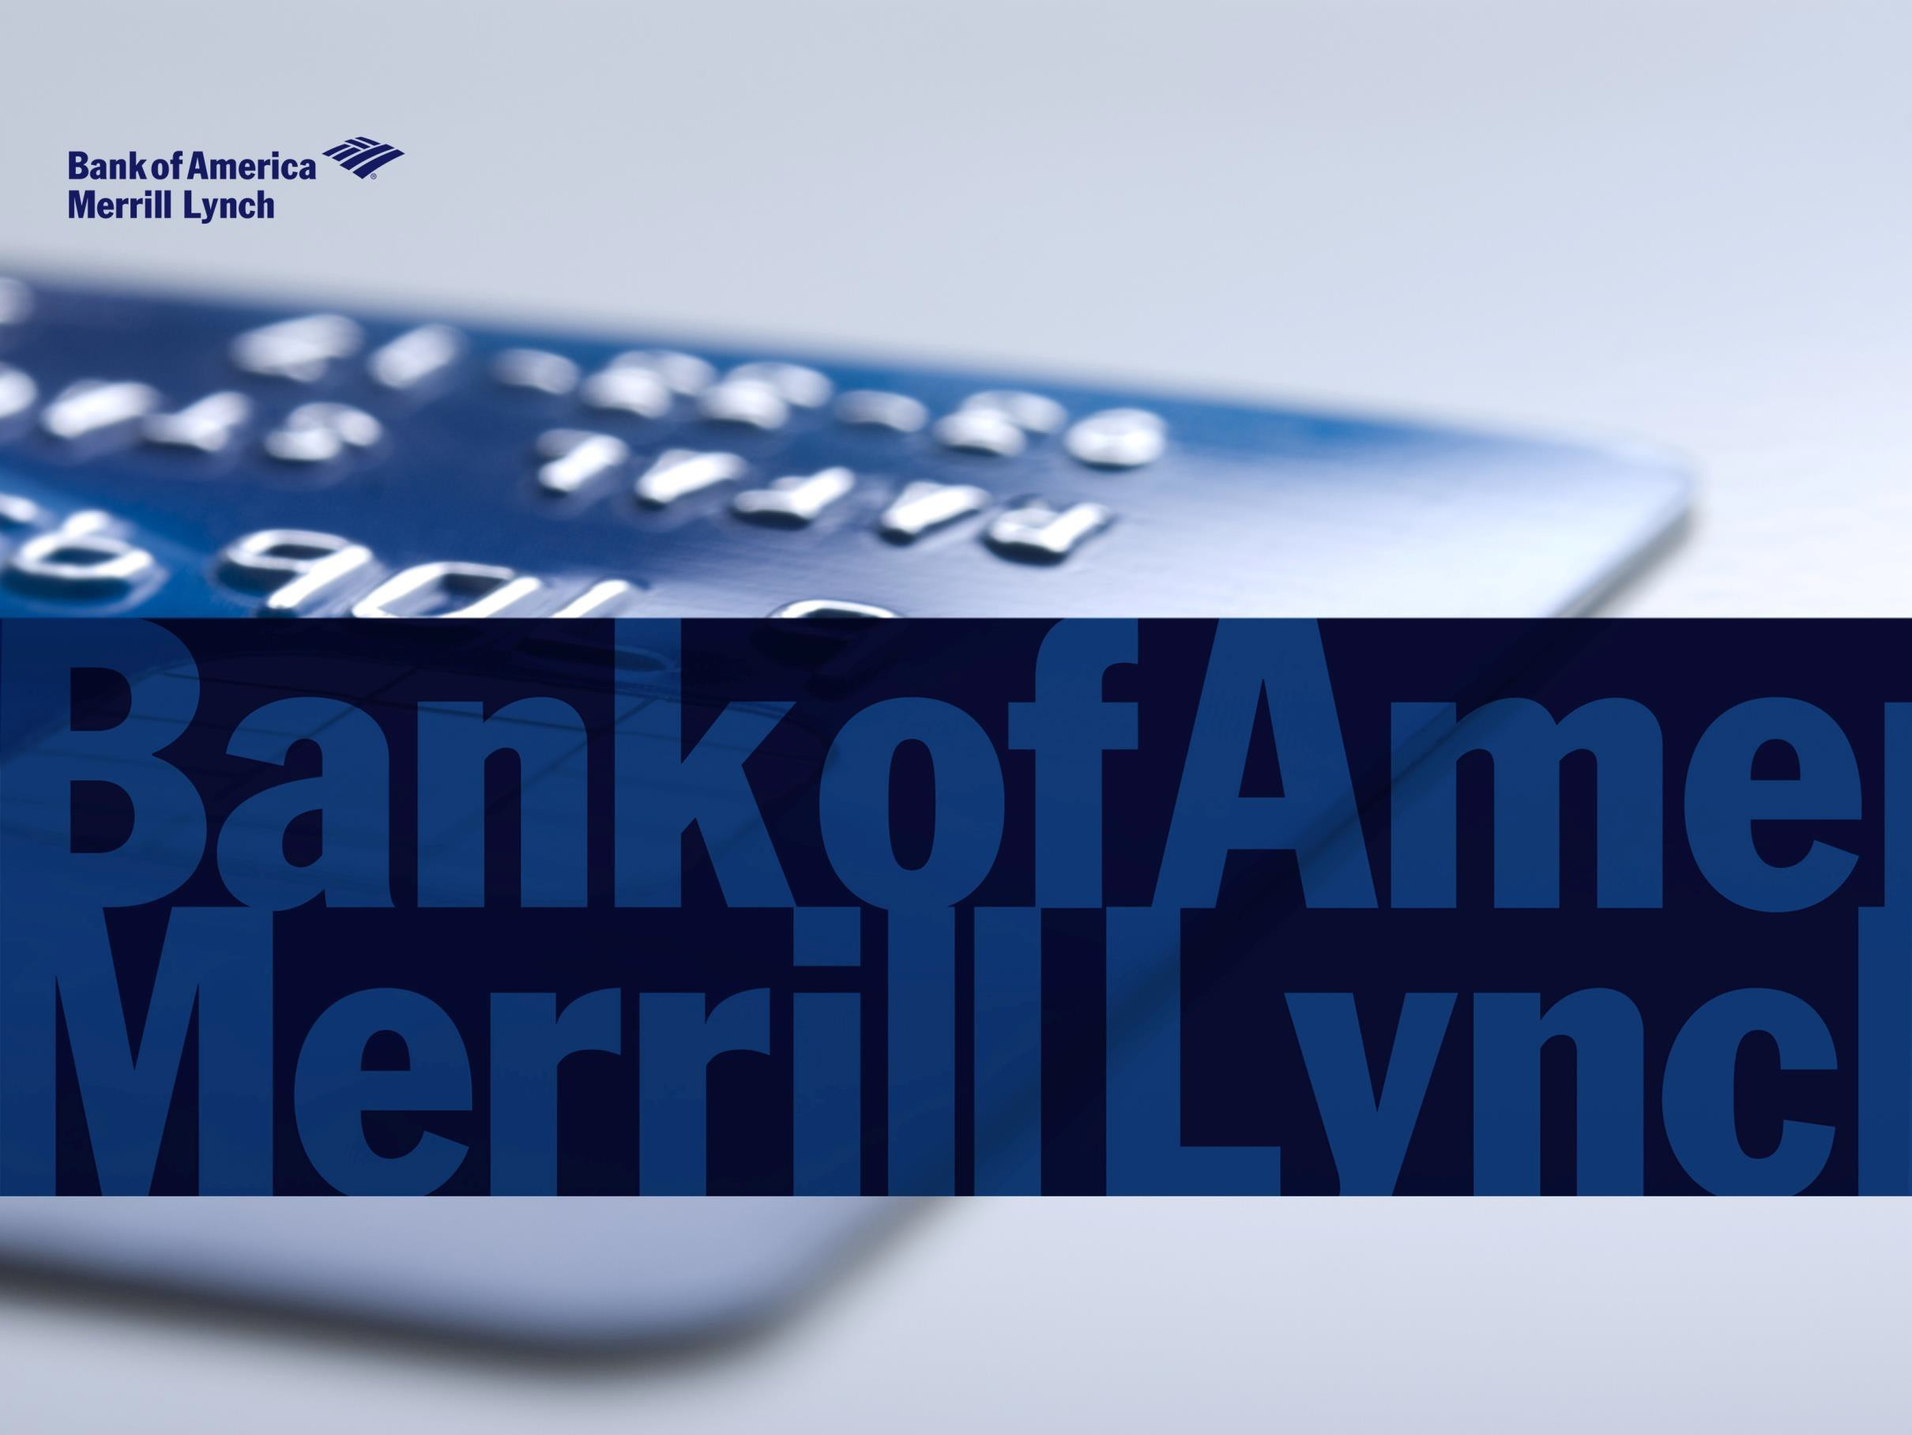
Purchasing Card Program: | MMO Purchasing Card Coordinator:
Solicitation: 5400020074 Contractor: Bank of America Contract: 4400026963  Contract Period: 10/01/2021 to 09/30/2028  Contract Terms and Conditions | Portia Davis  PDavis@mmo.sc.gov (803) 737-5473  SC Purchasing Card Policy and Procedures

Servicing Overview
Card & Comprehensive Payables

Program Administrator Quick Reference Guide
Company level support
PAs contact CLS for assistance with any inquiries or maintenance requests that cannot be completed via a self-service tool.

Card Account Specialist is the first point of
contact.
Global Card Access Online PIN check Account Activity Alerts
www.bofaml.com/globalcardaccess
Card Account Specialist (CAS): Dorothy Williams Phone: 888.715.1000 Ext. 22122
Fraud & Disputes
Release fraud blocks or notify of international travel:
1-866-500-8262 (domestic) and
+1-757-441-4124 (international-able to call collect)
Fraud claim status:
1-800-714-5923
Disputes – 866-601-9490 (non-fraud)

Fax: 804.264.0046

Email: dedicated_card_east@bankofamerica.com

Team Servicing: 8:00 AM –4:30PM EST

Phone: 1.800 822.5985, Option 2
Card Activation
Phone: 888.571.1000
Collect Calls: 509.353.6656
Hours: 24 hours/day, 7 days/week
Cardholder Support
After Hours Support
U.S. Toll Free 888.449.2273
Collect 509.353.6656 Outside the U.S.

Card Account Manager: Joseph Leonard
Phone: 980.388.2319
Email: joseph.leonard@bofa.com
Technical help desk
PAs contact THD for assistance with technical related questions or for functionality issues with account management & reporting tool.
North America | Monday - Friday  8 a.m. to 4:30 p.m. Eastern  888-715-1000 Option 2,4  carddigitalservices@bofa.com

Works Training | cardclientreadiness@baml.com http://training.works.com/bankofamerica/

BofAML card issued locations

PROGRAM ADMINISTRATOR QUICK TIPS – Who to call for assistance
Use your self-service application to… | Call/Email Company Level Support to…. | Call/Email Technical Help Desk to… | Call Fraud to….
- Request new cards  - Request replacement cards  - Cancel or deactivate cards  - Reset user passwords  - Change card controls (credit limit, other limits, MCC groups, cash, etc.)  - Research real time declines  - Update cardholder information  - Change account code defaults  - Create and configure reports  - Export data to a financial system  - Request overnight delivery of a card  - Access online statements (if applicable)  Examples of self service tools are Works, GRAM, or Payment Center  3 | - Change the statement address on a corporate billing account  - Change the Merchant Category  - Codes in a custom MCC group  - Create a new custom MCC group (also need to notify Tech Help Desk)  - Research missing or misapplied payments  - Research about decline reasons  - Change standard delivery method  – regular mail, bulk ship, etc.  - Report a lost/stolen  - Request overnight delivery to an alternate address  - Obtain 3 digit security/CVV code  - Update fleet information, if applicable  Cardholders should utilize Cardholder Support at the phone number listed on the back of their card | - Obtain technical support for issues with bank provided applications such as GRAM or Works  - Request periodic large uploads of user, card, or general ledger information  - Add a new custom MCC group to Account Manager (after creation by Company Level Support)  Cardholders should not contact the Technical Help Desk directly - They should contact the Program Administrator and/or Cardholder Support  For how-to questions regarding application functionality, Program Administrators should refer to the how-to guides available online or the Client  Education team | - Review watches on individual accounts  - Report potential fraud or unauthorized transactions  - Initiate claim or dispute process  - Obtain status of claim or dispute  Cardholders and Program Administrators can utilize the Fraud team for 24/7 support

Successful program management starts here
By employing our dedicated resources in implementation and servicing, along with our proactive relationship teams, we will deliver fully aligned resources and industry expertise every step of the way.

implementation +
servicing
+ relationship

- Single global card program owner to build, implement
- Regional resources to provide local strategic support
- Builds reporting platform and hierarchies to support reporting, data integration
- Provides training to program administrators
- Effective resource coordination from a single source
- Service sites around the globe
- Cardholder/company-level support
- Local card, language support in local time zone
- Specialists assist with operational questions
- Company-level servicing provides in-region support; key point of contact for the program administrator; and assists with card program management
- Global & regional account managers share:
  - Best practices
  - Overall growth strategies and program optimization
- Works with client to identify and help improve processes
- Works in a strategic capacity to help clients achieve their program goals and objectives
- Provides consultative feedback during implementation process

Project/implementation managers
Account Specialists Technical Help Desk Cardholder support
Treasury Sales Officer Product Solution Specialist Card Account Manager

OUTSTANDING CUSTOMER SERVICE
#1
7 YEARS IN A ROW, J.D. Power, 2016

FRAUD PREVENTION
10 YEARS IN A ROW, Javelin Strategy and Research, 2015
100% in-house service representatives
Dedicated only to corporate card clients

Company-

- Key points of contact for client program administrators (Card Account Specialist)
- Dedicated resources based in region
- Supports all aspects of card program management
level support

Servicing solutions
Technical help desk

Cardholder servicing
- Cardholder support based in region
- Cardholder support offered in local languages
- Support available 24/7
- Automated card activation
- Multi language VRU/IVR for simple queries

- Technical assistance for program administrators
- In region and local language support
- Available for all card products

Card account specialist Technical Help Desk

- Acts as operational service contact for card program administrators
- The program administrator typically contacts their account specialist (phone or email) regarding various queries including credit limit changes, statement questions, card issuance, cardholder complaints, receipt of payment, disputes and lost or stolen cards.
- The account specialist is also your escalation point for any concerns working with partner banks, technical support or any other support groups at the bank.
- The Technical Help Desk provides technical support for program administrators assisting with technical problems that a client may encounter relating to their card program.
- Program Administrators can contact the Technical Help Desk directly through a specific phone option, or via email.
- These options will be staffed with our most experienced and knowledgeable associates and is designed to bring greater first call resolution to clients.
- The technical support team is ready to respond to requests:
  - How to use online tools (Works, Global Card Access)
  - Issues with file transmissions/deliveries
  - Maintenance of system defaults
  - Resetting of passwords

Include the following information for Company Level Support
- Company Name
- Company Number
- Full account number or last 4 digits
- Embossed Line 1
- If a shipping request, shipping address, method and attention to field
- All requests must have PA signature in email body
- Specific requests do require signed company letterhead to be submitted to complete maintenance
Include the following information for Technical Help Desk
- Company Name
- Company Number
- Application in question (Works/Other)
- User ID
- Details of the card / user / group / profile / report / transaction in question
- Content or screen shot of any error message
- Contact Phone Number

“Bank of America Merrill Lynch” is the marketing name for the global banking and global markets businesses of Bank of America Corporation. Lending, derivatives, and other commercial banking activities are performed globally by banking affiliates of Bank of America Corporation, including Bank of America, N.A., Member FDIC. Securities, strategic advisory, and other investment banking activities are performed globally by investment banking affiliates of Bank of America Corporation (“Investment Banking Affiliates”), including, in the United States, Merrill Lynch, Pierce, Fenner & Smith Incorporated and Merrill Lynch Professional Clearing Corp., both of which are registered broker-dealers and Members of SIPC, and, in other jurisdictions, by locally registered entities. Merrill Lynch, Pierce, Fenner & Smith Incorporated and Merrill Lynch Professional Clearing Corp. are registered as futures commission merchants with the CFTC and are members of the NFA. Investment products offered by Investment Banking Affiliates: Are Not FDIC Insured • May Lose Value • Are Not Bank Guaranteed.
©2017 Bank of America Corporation.
This document is intended for information purposes only and does not constitute a binding commitment to enter into any type of transaction or business relationship as a consequence of any information contained herein.
These materials have been prepared by one or more subsidiaries of Bank of America Corporation solely for the client or potential client to whom such materials are directly addressed and delivered (the “Company”) in connection with an actual or potential business relationship and may not be used or relied upon for any purpose other than as specifically contemplated by a written agreement with us. We assume no obligation to update or otherwise revise these materials, which speak as of the date of this presentation (or another date, if so noted) and are subject to change without notice. Under no circumstances may a copy of this presentation be shown, copied, transmitted or otherwise given to any person other than your authorized representatives. Products and services that may be referenced in the accompanying materials may be provided through one or more affiliates of Bank of America, N.A.
We are required to obtain, verify and record certain information that identifies our clients, which information includes the name and address of the client and other information that will allow us to identify the client in accordance with the USA Patriot Act (Title III of Pub. L. 107-56, as amended (signed into law October 26, 2001)) and such other laws, rules and regulations.
We do not provide legal, compliance, tax or accounting advice.
For more information, including terms and conditions that apply to the service(s), please contact your Bank of America Merrill Lynch representative.
Investment Banking Affiliates are not banks. The securities and financial instruments sold, offered or recommended by Investment Banking Affiliates, including without limitation money market mutual funds, are not bank deposits, are not guaranteed by, and are not otherwise obligations of, any bank, thrift or other subsidiary of Bank of America Corporation (unless explicitly stated otherwise), and are not insured by the Federal Deposit Insurance Corporation (“FDIC”) or any other governmental agency (unless explicitly stated otherwise).
This document is intended for information purposes only and does not constitute investment advice or a recommendation or an offer or solicitation, and is not the basis for any contract to purchase or sell any security or other instrument, or for Investment Banking Affiliates or banking affiliates to enter into or arrange any type of transaction as a consequent of any information contained herein.
With respect to investments in money market mutual funds, you should carefully consider a fund’s investment objectives, risks, charges, and expenses before investing. Although money market mutual funds seek to preserve the value of your investment at $1.00 per share, it is possible to lose money by investing in money market mutual funds. The value of investments and the income derived from them may go down as well as up and you may not get back your original investment. The level of yield may be subject to fluctuation and is not guaranteed. Changes in rates of exchange between currencies may cause the value of investments to decrease or increase.
We have adopted policies and guidelines designed to preserve the independence of our research analysts. These policies prohibit employees from offering research coverage, a favorable research rating or a specific price target or offering to change a research rating or price target as consideration for or an inducement to obtain business or other compensation.

Copyright 2017 Bank of America Corporation. Bank of America N.A., Member FDIC, Equal Housing Lender.

