STATE OF SOUTH CAROLINA
State Budget and Control Board
OFFICE OF GENERAL SERVICES
JIM HODGES, CHAIRMAN  GOVERNOR  GRADY L. PATTERSON, JR.  STATE TREASURER  JAMES A. LANDER  COMPTROLLER GENERAL |  | HUGH K. LEATHERMAN, SR.  CHAIRMAN, SENATE FINANCE COMMITTEE  ROBERT W. HARRELL, JR.  CHAIRMAN, WAYS AND MEANS COMMITTEE  FRANK FUSCO  EXECUTIVE DIRECTOR
GEORGE N. DORN, JR.
DIRECTOR

MATERIALS MANAGEMENT OFFICE
1201 MAIN STREET, SUITE 600
COLUMBIA, SOUTH CAROLINA 29201
(803) 737-0600
Fax (803) 737-0639

R. VOIGHT SHEALY
MATERIALS MANAGEMENT OFFICER

August 31, 2001

Mr. George N. Dorn, Jr., Director
Office of General Services
1201 Main Street, Suite 420
Columbia, South Carolina 29201

Dear George:

I have attached the audit report for the South Carolina State Ethics Commission. Since we are not recommending any certification above the basic $5,000 allowed by the Code, no action is required by the Budget and Control Board. Therefore, I recommend that the report be presented to the Budget and Control Board as information.

Sincerely,
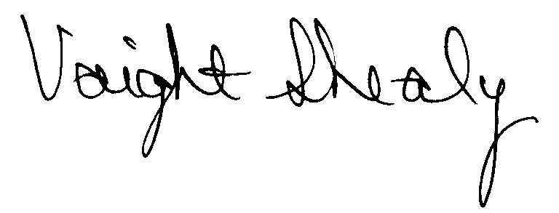
R. Voight Shealy
Materials Management Officer

/jl

SOUTH CAROLINA STATE ETHICS COMMISSION
PROCUREMENT AUDIT REPORT
JULY 1, 1999 - JUNE 30, 2001
TABLE OF CONTENTS
PAGE
Transmittal Letter 1
Introduction 3
Scope 4
Results of Examination 5
Conclusion 6
Commission Response 7
Follow-up Letter 8

STATE OF SOUTH CAROLINA
State Budget and Control Board
OFFICE OF GENERAL SERVICES
JIM HODGES, CHAIRMAN  GOVERNOR  GRADY L. PATTERSON, JR.  STATE TREASURER  JAMES A. LANDER  COMPTROLLER GENERAL |  | HUGH K. LEATHERMAN, SR.  CHAIRMAN, SENATE FINANCE COMMITTEE  ROBERT W. HARRELL, JR.  CHAIRMAN, WAYS AND MEANS COMMITTEE  FRANK FUSCO  EXECUTIVE DIRECTOR
GEORGE N. DORN, JR.
DIRECTOR

MATERIALS MANAGEMENT OFFICE
1201 MAIN STREET, SUITE 600
COLUMBIA, SOUTH CAROLINA 29201
(803) 737-0600
Fax (803) 737-0639

R. VOIGHT SHEALY
MATERIALS MANAGEMENT OFFICER

July 30, 2026

Mr. R. Voight Shealy
Materials Management Officer
Office of General Services
1201 Main Street, Suite 600
Columbia, South Carolina 29201
Dear Voight:
We have examined the procurement policies and procedures of the South Carolina State Ethics Commission for the period July 1, 1999 through June 30, 2001. As part of our examination, we studied and evaluated the system of internal control over procurement transactions to the extent we considered necessary.
The evaluation was to establish a basis for reliance upon the system of internal control to insure adherence to the Consolidated Procurement Code, State regulations and the Commission’s procurement policy. Additionally, the evaluation was used in determining the nature, timing and extent of other auditing procedures necessary for developing an opinion on the adequacy, efficiency and effectiveness of the procurement system.
The administration of the State Ethics Commission is responsible for establishing and maintaining a system of internal control over procurement transactions. In fulfilling this responsibility, estimates and judgments by management are required to assess the expected benefits and related costs of control procedures. The objectives of a system are to

provide management with reasonable, but not absolute, assurance of the integrity of the procurement process, that affected assets are safeguarded against loss from unauthorized use or disposition and that transactions are executed in accordance with management's authorization and are recorded properly.
Because of inherent limitations in any system of internal control, errors or irregularities may occur and not be detected. Also, projection of any evaluation of the system to future periods is subject to the risk that procedures may become inadequate because of changes in conditions or that the degree of compliance with the procedures may deteriorate.
Our study and evaluation of the system of internal control over procurement transactions, as well as our overall examination of procurement policies and procedures, were conducted with professional care. However, because of the nature of audit testing, they would not necessarily disclose all weaknesses in the system.
The examination did, however, disclose conditions enumerated in this report that we believe need correction or improvement.
Corrective action based on the recommendations described in these findings will in all material respects place the South Carolina State Ethics Commission in compliance with the Consolidated Procurement Code and ensuing regulations.

Sincerely,
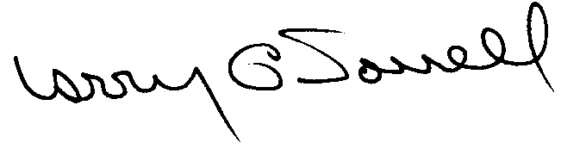
Larry G. Sorrell, Manager
Audit and Certification
INTRODUCTION
We conducted an examination of the internal procurement operating policies and procedures of the South Carolina State Ethics Commission, hereafter referred to as the Commission. Our on-site review was conducted July 11 - 12, 2001 and was made under Section 11-35-1230(1) of the South Carolina Consolidated Procurement Code and Section 19-445-2020 of the accompanying regulations.
The examination was directed principally to determine whether, in all material respects, the procurement system's internal controls were adequate and the procurement procedures, as outlined in the Internal Procurement Operating Procedures Manual, were in compliance with the South Carolina Consolidated Procurement Code and its ensuing regulations.
Additionally, our work was directed toward assisting the Commission in promoting the underlying purposes and policies of the Code as outlined in Section 11-35-20, which include:

(1) to ensure the fair and equitable treatment of all persons who deal with the procurement system of this State

(2) to provide increased economy in state procurement activities and to maximize to the fullest extent practicable the purchasing values of funds of the State

(3) to provide safeguards for the maintenance of a procurement system of quality and integrity with clearly defined rules for ethical behavior on the part of all persons engaged in the public procurement process
SCOPE
We conducted our examination in accordance with Generally Accepted Auditing Standards as they apply to compliance audits. Our examination encompassed a detailed analysis of the internal procurement operating procedures of the Commission and its related policies and procedures manual to the extent we deemed necessary to formulate an opinion on the adequacy of the system to properly handle procurement transactions.
We systematically selected samples from the period July 1, 1999 through June 30, 2001 of procurement transactions for compliance testing and performed other audit procedures that we considered necessary to formulate this opinion. Specifically, the scope of our audit included, but was not limited to, a review of the following.

(1) All sole source, emergency and trade-in sale procurements from the period July 1, 1999 through June 30, 2001

(2) Twelve payment transactions from the period July 1, 1999 through June 30, 2001 exceeding $1,500

(3) Surplus property procedures

(4) Minority Business Enterprise Plans and reports

(5) Information Technology Plans

- Internal procurement procedures manual

(8) File documentation for evidence of competition
RESULTS OF EXAMINATION
The Office of Audit and Certification performed an examination of the internal procurement operating policies, procedures and related manual of the Commission for the period July 1, 1999 through June 30, 2001.
Since our last audit, the Commission has maintained what we consider a professional, efficient procurement system. We did note the following item which should be addressed by management.

Procurements Without Competition
The following eight procurements were not supported by either solicitations of competition, sole source or emergency determinations, term contract references or classified as exempt items. The procurements were managed by the former procurement official.
Voucher Number | Date | Amount | Requisition Number | Description
8 | 7/07/00 | $ 2,059 | 324899 | Rental of postage meter and maintenance of accessories
2 | 7/01/99 | 1,845 | 324857 | Postage meter rental and equipment maintenance
63 | 9/20/00 | 1,983 | -- | Copier maintenance
21 | 7/21/99 | 2,336 | -- | Office supplies
13 | 7/13/00 | 2,783 | 316827 | Office supplies
36 | 8/16/99 | 2,268 | -- | Chairs
97 | 10/9/00 | 4,300 | 316838 | Printing
114 | 11/6/00 | 3,386 | 316839 | Printing
Section 11-35-1510 of the Code lists the methods of source selection.
We recommend that the Commission adhere to the competition requirements of the Code when the potential value exceeds $1,500.
CONCLUSION
As enumerated in our transmittal letter, corrective action based on the recommendations described in this report, will in all material respects place the South Carolina State Ethics Commission in compliance with the Consolidated Procurement Code and ensuing regulations.
The Commission has not requested increased procurement certification above the basic limit of $5,000 allowed by the Code. Subject to corrective actions listed in this report, we will recommend the Commission be allowed to continue procuring all goods and services, consultants services, construction services, and information technology up to the basic level of $5,000 as allowed by the South Carolina Consolidated Procurement Code and accompanying regulations.

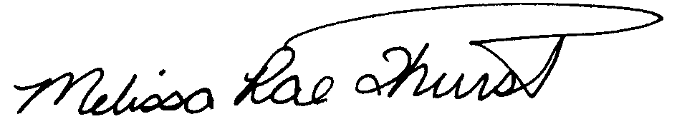
Melissa Rae Thurstin
Senior Auditor

Larry G. Sorrell, Manager
Audit and Certification
STATE OF SOUTH CAROLINA
State Budget and Control Board
OFFICE OF GENERAL SERVICES
JIM HODGES, CHAIRMAN  GOVERNOR  GRADY L. PATTERSON, JR.  STATE TREASURER  JAMES A. LANDER  COMPTROLLER GENERAL |  | HUGH K. LEATHERMAN, SR.  CHAIRMAN, SENATE FINANCE COMMITTEE  ROBERT W. HARRELL, JR.  CHAIRMAN, WAYS AND MEANS COMMITTEE  FRANK FUSCO  EXECUTIVE DIRECTOR
GEORGE N. DORN, JR.
DIRECTOR

MATERIALS MANAGEMENT OFFICE
1201 MAIN STREET, SUITE 600
COLUMBIA, SOUTH CAROLINA 29201
(803) 737-0600
Fax (803) 737-0639

R. VOIGHT SHEALY
MATERIALS MANAGEMENT OFFICER

August 31, 2001

Mr. R. Voight Shealy
Materials Management Officer
Materials Management Office
1201 Main Street, Suite 600
Columbia, South Carolina 29201

Dear Voight:

We have reviewed the South Carolina State Ethics Commission’s response to our audit report for July 1, 1999 – June 30, 2001. Also, we have followed the Commission’s corrective action during and subsequent to our field work. We are satisfied that the Commission has corrected the problem area and the internal controls over the procurement system are adequate.

Additional certification was not requested. Therefore, we recommend the Commission be allowed to continue procuring all goods and services, construction services, information technology and consulting services up to the basic level of outlined in the Code.

Sincerely,
Larry G. Sorrell, Manager
Audit and Certification

LGS/jl

Total Copies Printed 25
Unit Cost - . .18
Total Cost - $4.50

