STATE OF SOUTH CAROLINA

State Budget and Control Board

PROCUREMENT SERVICES DIVISION
MARK SANFORD, CHAIRMAN  GOVERNOR  CONVERSE A. CHELLIS III, CPA  STATE TREASURER  RICHARD ECKSTROM, CPA  COMPTROLLER GENERAL | 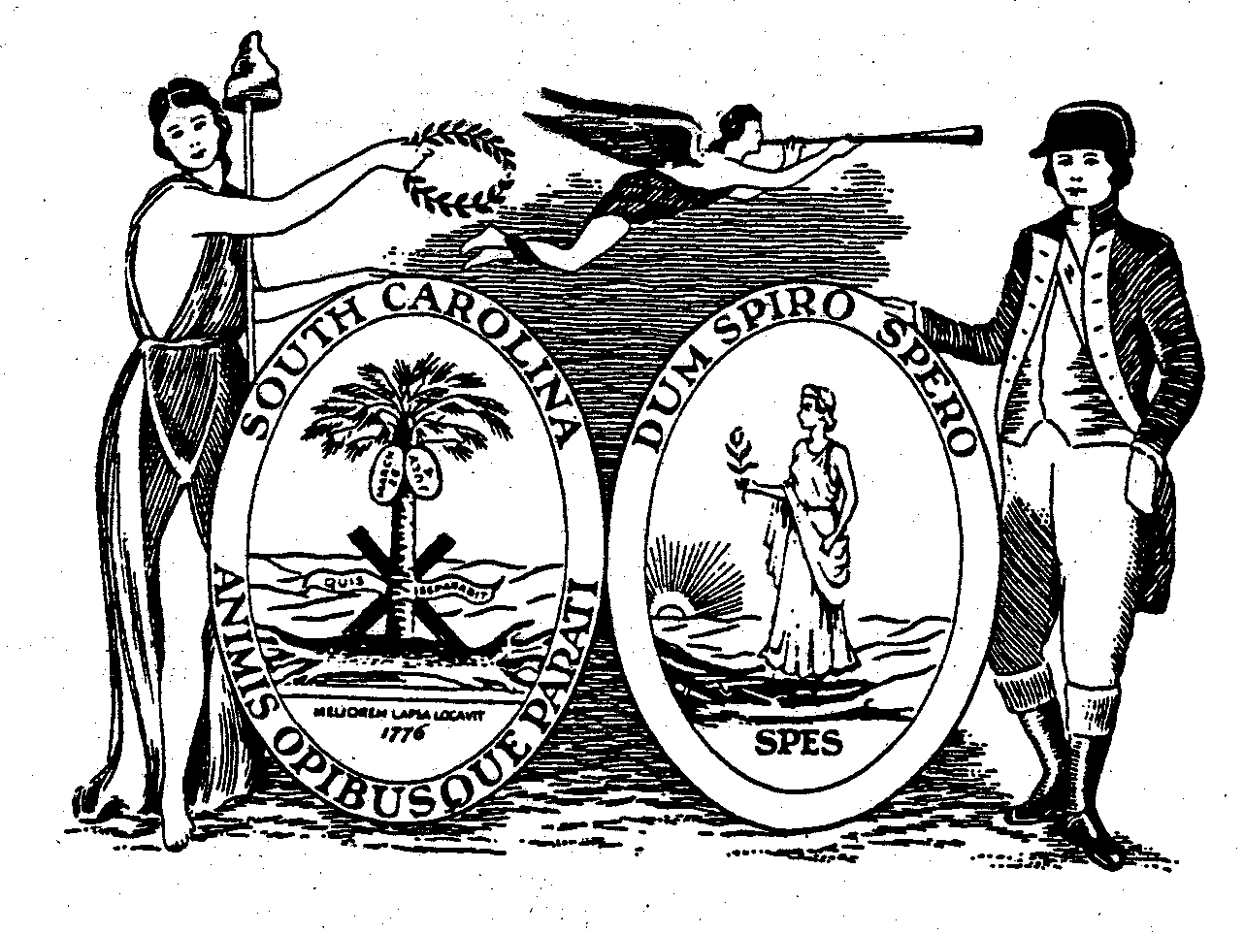 | HUGH K. LEATHERMAN, SR.  CHAIRMAN, SENATE FINANCE COMMITTEE  DANIEL T. COOPER  CHAIRMAN, WAYS AND MEANS COMMITTEE  FRANK W. FUSCO  EXECUTIVE DIRECTOR
DELBERT H. SINGLETON, JR.
DIVISION DIRECTOR
(803) 734-2320

MATERIALS MANAGEMENT OFFICE
1201 MAIN STREET, SUITE 600
COLUMBIA, SOUTH CAROLINA 29201
(803) 737-0600
Fax (803) 737-0639

R. VOIGHT SHEALY
MATERIALS MANAGEMENT OFFICER

To: South Carolina Procurement Card Customers
From: R. Voight Shealy, CPM

Date: January 12, 2009

Re: Update to the Procurement Card Program for the State of South Carolina

A recent review of the operation of the Procurement Card program has found that the process for managing Merchant Category Codes (MCC) has not always been followed as specified in the state’s contract with Bank of America. These codes govern where the cards may be used. The intent of the Procurement Card program has always been that for “Group A” agencies, changes to the list of authorized MCCs will be centrally controlled by the Office of the Comptroller General. This is intended to make sure that only vendors appropriate to the needs of a public agency are allowed to accept Procurement Cards.

This memorandum is to notify South Carolina governmental customers of updates to the Procurement Card Program, and, in particular, agencies described as “Group A” (defined as those who process invoices through the Office of the Comptroller General).

At the end of December 2008, the Office of Comptroller General (OCG) and the Budget and Control Board, Materials Management Office (MMO), instructed the current contractor, Bank of America (BOA), to immediately implement the attached updated master blocked Merchant Category Code (MCC) list for all Group A agencies. The action was critical to insure that necessary controls are in place and for the State to comply with its IRS 1099 reporting requirements.

Updates to the master blocked MCC list have been implemented by BOA centrally tying all active procurement cards issued to the Group A agencies to the updated list. Unless approved through the OCG, all of the types of vendors shown on the attached list as “blocked” (designated by “x”) have been blocked by BOA preventing use by any cardholder in the Group A agency listing. If a Group A agency administrator wants specific MCC code(s) for specific cards unblocked for a stated purpose and time frame, BOA will obtain written authority from the OCG (Sandra Pratt and/or Jennifer Muir) to unblock the MCC code(s) for use by that agency. Group A agency requests to unblock MCC code(s) must be directed in writing to the OCG. The OCG will give prompt attention and full consideration to all requests from agencies concerning MCC access.

A similar list of blocked codes was engaged when the p-card program was initiated in the late 1990’s, but recent developments caused us to revisit the list. Thank you for your continued support of the Procurement Card program in South Carolina.

