PUBLIC MEETING NOTICE

Meeting of the Request for Proposal Evaluation Committee

Solicitation Number: 54000267823
Solicitation Description: GSSM Admissions & Enrollment CRM

A meeting of the Request for Proposal Evaluation Committee for the above-referenced solicitation will be held Tuesday, August 27, 2024 at 2:30 AM ET.

This meeting will be held at virtually via Microsoft Teams. Contact Kristen Rabon at khrabon@mmo.sc.gov for access credentials.

AGENDA

Regular Session
- Open meeting
Executive Session
- Demonstrations
- Proposal discussions
Regular Session
- Proposal scoring
Close Session

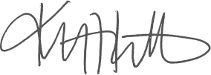
Kristen Rabon
Procurement Manager

