PUBLIC MEETING NOTICE

Meeting of the Request for Proposal Evaluation Committee

Solicitation Number: 5400027744
Solicitation Description: SCDJJ Electronic Health Records

The charging meeting of the Request for Proposal Evaluation Committee for the above-referenced solicitation will be held Thursday, July 16, 2026 at 10:00 am.

This meeting will be held virtually. Please contact Kristen Rabon at khrabon@mmo.sc.gov for access credentials.

AGENDA

Regular Session
- Open meeting
- Overview of process
Executive Session
- Distribution of proposals
Close Session

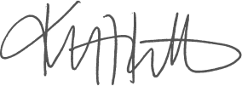
Kristen Rabon
Procurement Manager

