PUBLIC MEETING NOTICE

Meeting of the Request for Proposal Evaluation Committee

Solicitation Number: 5400024844
Solicitation Description: SCPRT Central Reservation System

A meeting of the Request for Proposal Evaluation Committee for the above-referenced solicitation will be held Monday, June 10, 2024 at 9:00 AM ET.

This meeting will be held at:
1205 Pendleton Street
Edgar Brown Building - Room 252
Columbia, SC 29201

AGENDA

Regular Session
- Open meeting
Executive Session
- Demonstrations
Regular Session
- Phase II Scoring
Close Session

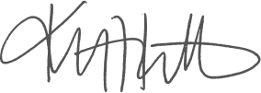
Kristen Rabon
Procurement Manager

