PUBLIC MEETING NOTICE

Meeting of the Request for Proposal Evaluation Committee

Solicitation Number: 5400024844
Solicitation Description: SCPRT Central Reservation System

A meeting of the Request for Proposal Evaluation Committee for the above-referenced solicitation will be held Tuesday, June 25, 2024 at 10:00 AM ET.

This meeting will be held virtually. Please contact the procurement officer at khrabon@mmo.sc.gov for access credentials.

AGENDA

Regular Session
- Open meeting
Executive Session
- Phase II proposal discussions
Regular Session
- Proposal scoring
Close Session

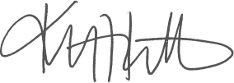
Kristen Rabon
Procurement Manager

