PUBLIC MEETING NOTICE

Meeting of the Request for Proposal Evaluation Committee

Solicitation Number: 54000267823
Solicitation Description: GSSM Admissions & Enrollment CRM

A meeting of the Request for Proposal Evaluation Committee for the above-referenced solicitation will be held Monday, August 12, 2024 at 1:00 PM ET.

This meeting will be held at:
401 Railroad Avenue, Room B-155
Hartsville, SC 29550

AGENDA

Regular Session
- Open meeting
Executive Session
- Proposal discussions
Regular Session
- Proposal scoring
Close Session

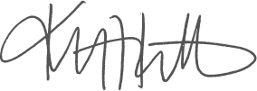
Kristen Rabon
Procurement Manager

