PUBLIC MEETING NOTICE

Meeting of the Request for Proposal Evaluation Committee

Solicitation Number: 5400028800
Solicitation Description: SCRFA Next-Generation 911

A meeting of the Request for Proposal Evaluation Committee for the above-referenced solicitation will be held Monday, May 18, 2026 at 10:00 AM.

This meeting will be held at:
South Carolina Revenue and Fiscal Affairs Office
1000 Assembly Street
Dennis Building, Suite 421
Columbia, SC 29201
Room #417, Bowers Conference Room

AGENDA

Regular Session
- Open meeting
Executive Session
- Proposal discussions
Regular Session
- Proposal scoring
Close Session

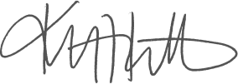
Kristen Rabon
Procurement Manager

