PUBLIC MEETING NOTICE

Meeting of the Request for Proposal Evaluation Committee

Solicitation Number: 5400027744
Solicitation Description: SCDJJ Electronic Health Records

Meetings of the Request for Proposal Evaluation Committee for the above-referenced solicitation will be held:
- August 18, 2026 at 10:00 AM on Microsoft Teams
- August 25-26, 2026 at 9:00 AM at 220 Executive Center Drive, Columbia, SC 29212 / Palmetto Room, Floor 1
- September 17, 2026 at 10:00 AM on Microsoft Teams

Please contact the Kristen Rabon at khrabon@mmo.sc.gov for access credentials to meetings held via Microsoft Teams.

AGENDA

Regular Session
- Open meeting
Executive Session
- Demonstrations
Regular Session
Close Session

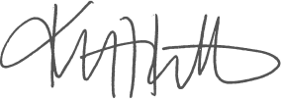
Kristen Rabon
Procurement Manager

