PUBLIC MEETING NOTICE

Meeting of the Request for Proposal Evaluation Committee

Solicitation Number: 5400028165
Solicitation Description: VA Referral Software Solution

A meeting of the Request for Proposal Evaluation Committee for the above-referenced solicitation will be held Wednesday, July 9, 2025 at 12:00 PM ET.

This meeting will be held virtually. For access credentials, contact Kristen Rabon at khrabon@mmo.sc.gov.

AGENDA

Regular Session
- Open meeting
Executive Session
- Demonstrations
- Proposal discussions
Regular Session
- Demonstration scoring
Close Session

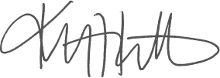
Kristen Rabon
Procurement Manager

